CONSIDER FOR TALK
9th Annual SEA-PHAGES Symposium Abstract
University of West Florida
Pensacola FL
Corresponding Faculty Member: Hui-Min Chung (hchung@uwf.edu)
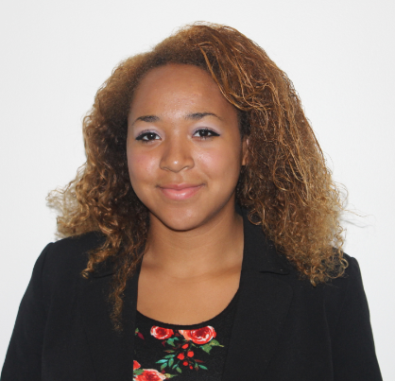
Amara Ejikemeuwa
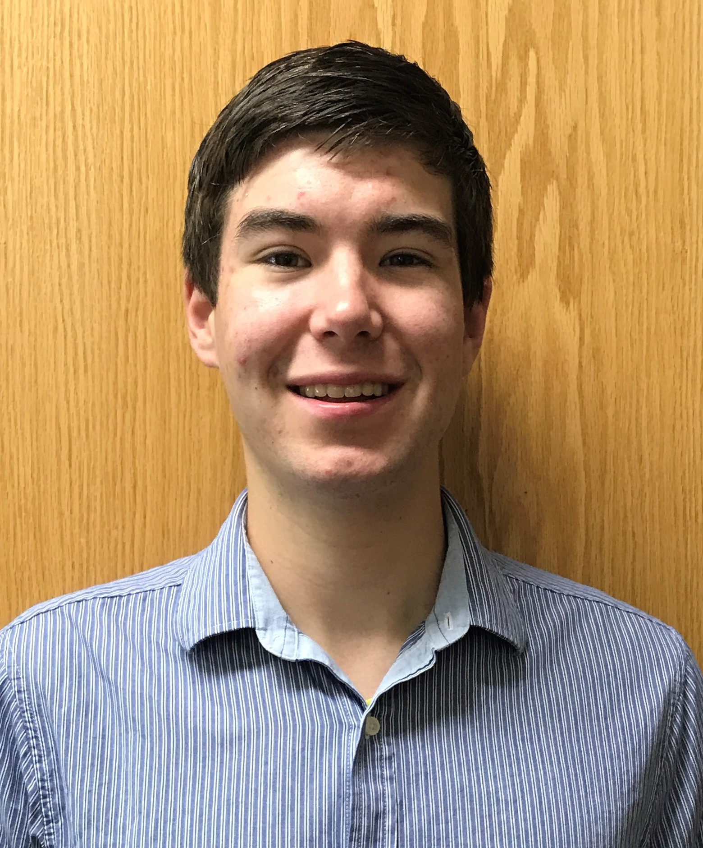
Brett Farran
King Solomon’s tale – exploring ways to increase phage-hunting success and find them homes.
Amara Ejikemeuwa, Brett Farran, Samuel Alvarado, Taylor Bowling, Molly-Catherine Brantley, Lydia Bricker, Courtney Butler, Carson Crist, Julia Dane, Sierra Hobbs, Michelle Lapak, Conner Lovell, Nicholas Ludergnani, Allison McMullen, Sohail Mirza, Hannah Perkins, Noah Thrift, Donald Vaughan, Grace Worley, May Zaw, Karen Barnes, Hui-Min Chung
Using M. smegmatis as the host bacteria, our phage hunting started with soil collected from sandy trail and from garden setting. While it was relatively easy to obtain phages from the garden soil, the hunting with sandy soil turned out to be really difficult. Suspecting phages in sandy soil might tend to stay in lysogenic cycles, we used several ways to induce lytic cycle by treating host cells with stress prior to the isolation step. These treatment included heat, hydrogen peroxide, pineapple juice, and UV exposure; among all, brief UV exposure seemed to be most successful. As a result, this year we isolated eight different phages: three phages from garden soil are Largelime, Kingsolomon and Nicholas, and five from sandy trail are Alectrona, Sunna, Badbeach, Tropica, and Argie. Based on the whole genome sequence information, Kingsolomon and Nicholas are L3 phages. Surprisingly these two phages share 99% identity on majority of their genomes, except Nicholas has extra 876 nucleotides in its 3’ end of the genome. Kingsolomon and Nicholas also share 99% similarity on their first forty thousand or so nucleotides with other L3 phages, such as Snenia (from South Africa), Lumos (from Stuart Florida), and Clautastrophe and MsGreen (from New Orleans). To determine the cluster categories of the other six phages isolated, we took the DOGEMS approach. With limited sequence information derived from the phage DNA mixture, we were able to design cluster-specific primers for PCR gene amplification and ID the six non-genome-sequenced phages. The results indicate phage Largelime isolated from garden soil is a L3, and phages Alectrona, Sunna and Badbeach are K3 phages, Tropica an A2 phage, and Argie a W phage. Alectrona, Sunna, Badbeach, and Argie tend to take long time to develop plaque, and their plaque size is in general small. All these 8 phages were able to infect a lysogen derived from phage Xeno of cluster N, making us thinking perhaps phages of these three clusters (A2, K3 and W) might be genetically distant from cluster N. In addition, 8 phages collected from last year, including a K1 phage Slimphazie, and Zanzibar, Marayla, Lexory, Kristannah, Xanthippeus, Phargo and Kindred of unknown clusters were also able to infect Xeno lysogen. In summary, we found the DOGEMS approach an effective way to categorize phages with limited sequence information. We highly recommend students using this approach to find their phages a home. In the future we would like to use the K3 phages (Alectrona, Sunna or Badbeach), and the W phage (Argie) to create lysogens as tools for further examining phage sensitivity and insensitivity in between different clusters.

