DO NOT CONSIDER FOR TALK
9th Annual SEA-PHAGES Symposium Abstract
Winthrop University
Rock Hill SC
Corresponding Faculty Member: Victoria Frost (frostv@winthrop.edu)
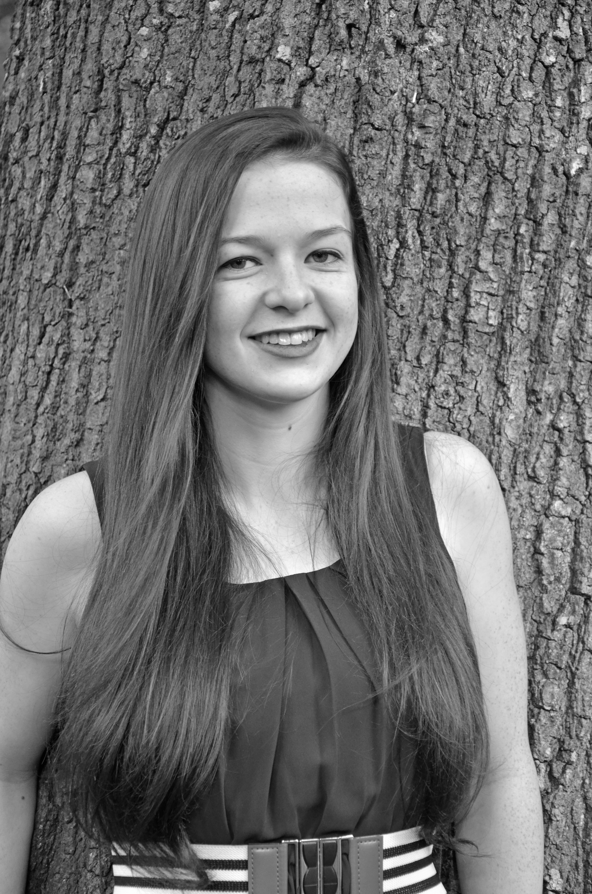
Melody C Iacino
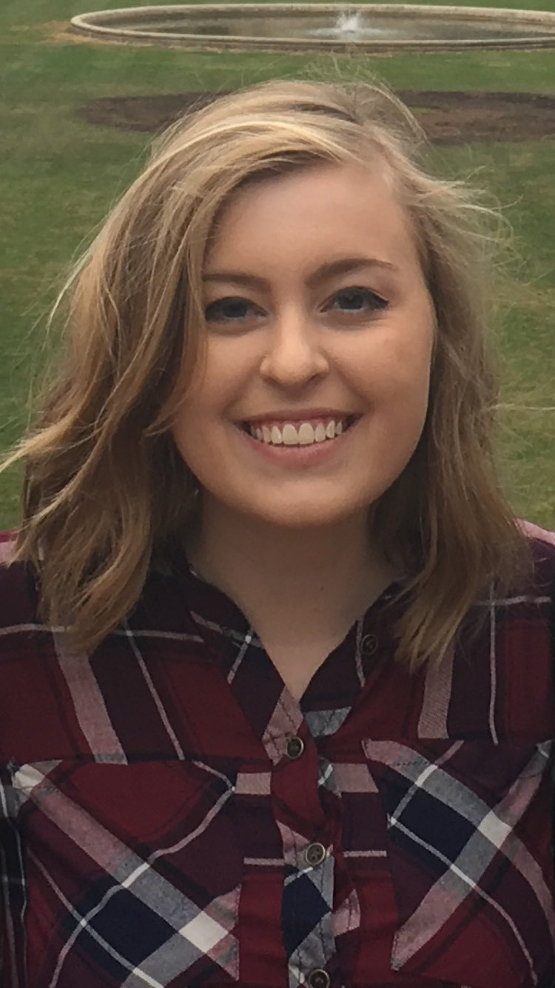
Hallie V Smith
Isolation and Characterization of Bacteriophages Asriel and HaiMas Found in the Soil at Winthrop University
Autumn S Brewer, Shelbie A Broach, Sierra T Davis, Sara P Dixson, Melody C Iacino, Emily A Katsos, David N Knight, Hallie V Smith, Madison A Workman, Adam C Zeitz
This was Winthrop University’s first year as part of the national HHMI sponsored SEA-PHAGES program. As freshman undergraduate students we isolated, purified, and characterized 11 bacteriophages found in the soil in and around Winthrop University, Rock Hill, South Carolina. Each phage was amplified in the bacterial host Mycobacterium smegmatis mc²155 and then characterized following DNA extraction using restriction enzyme digests and gel electrophoresis. Electron microscopy demonstrated that all eleven phages had long, flexible tails and belong to the Siphoviridae group of mycobacteriophages. After studying the electron micrographs, the digestion patterns, and quality of the DNA, two of the most potentially unusual phages, Asriel and HaiMas, were chosen to be sequenced at the University of Pittsburg. In the following semester, we continued our research by annotating both genomes using DNA Master Software and several homology search programs, including BLASTp and HHPred, to predict gene locations and determine gene function. Asriel is 74,594 bp in length, has approximately 142 predicted genes, and is a member of Cluster E. Similar to other Cluster E phages, the Asriel genome codes for two tRNAs, and a putative immunity suppressor protein. HaiMas is 68,296 bp in length, has approximately 99 predicted genes, and is a member of Cluster B1. Both genomes encode for integrase proteins which suggest a temperate lifestyle. The SEA-PHAGES research program is helping to expand our understanding of the genomic diversity of bacteriophages found in this region of South Carolina as well as successfully introduce a genuine research experience to students in their first year as undergraduates at Winthrop University.

