CONSIDER FOR TALK
9th Annual SEA-PHAGES Symposium Abstract
University of Maine, Farmington
Farmington ME
Corresponding Faculty Member: Tim Breton (timothy.breton@maine.edu)
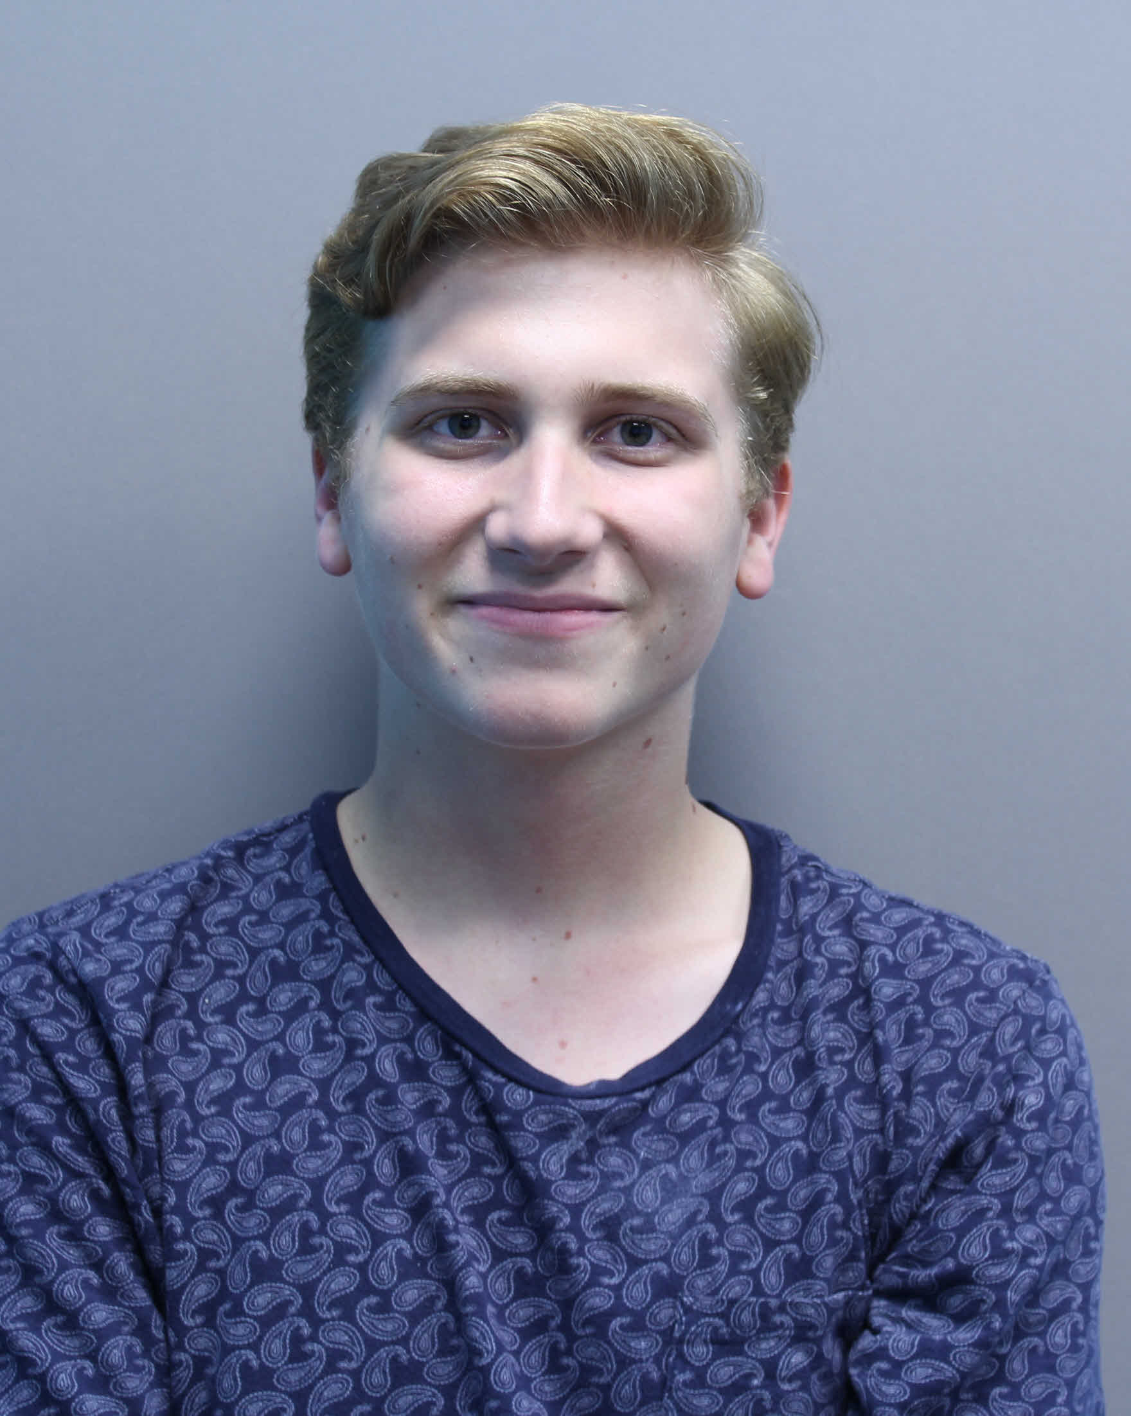
Eli E Michaud
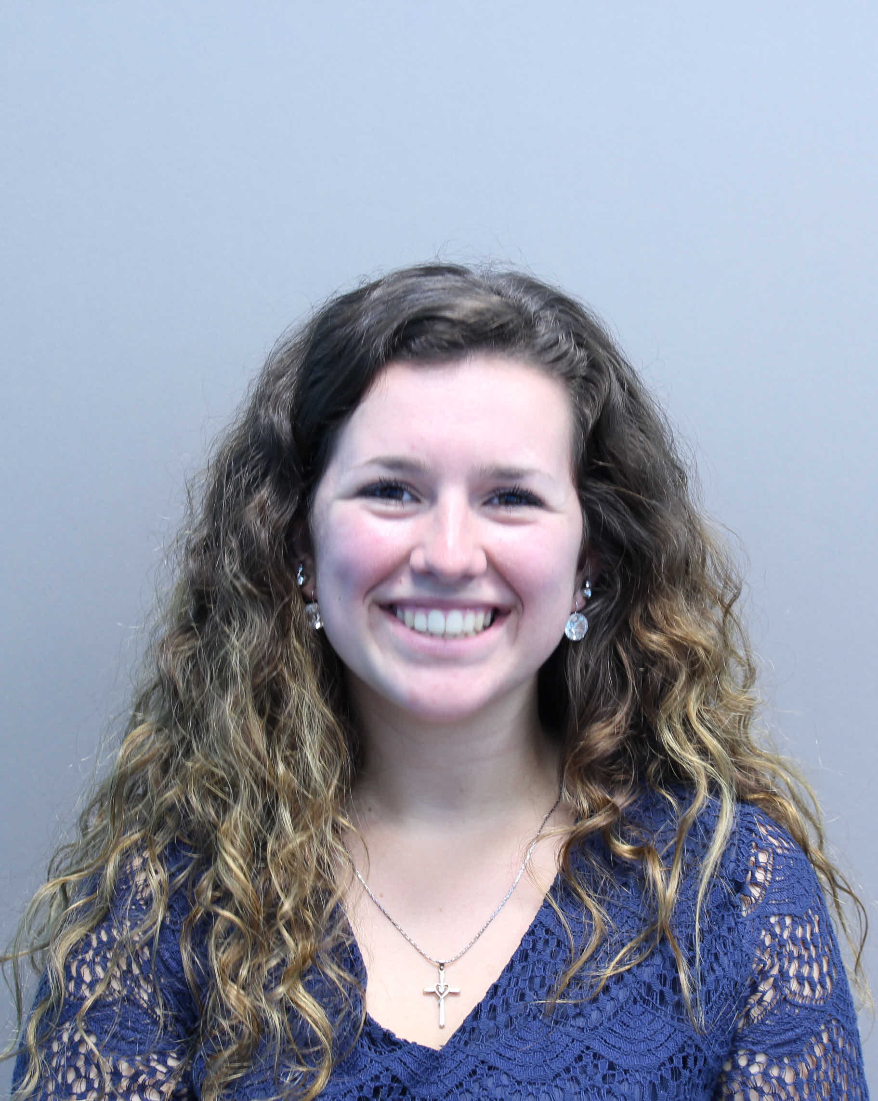
Bailey E Shevenell
The discovery, isolation, and annotation of the L2 cluster mycobacteriophage, Miley16
Eli E Michaud, Bailey E Shevenell, Liesel L Krout, Mia S Comis, Madison J Davick, Kaleb J Fletcher, Carlos Berdeja, Chelsey I Frank, Sarah E Stanley, Jacob R Montgomery, Jean A Doty, Timothy S Breton
Miley16 is a novel, cluster L2 mycobacteriophage isolated from an Abbott Park soil sample in Farmington, Maine, using the host Mycobacterium smegmatis mc2155. Miley16 consists of 76,653 bp, 58.9% GC content, 133 genes, and 12 tRNAs. Miley16 is highly similar to most L2 phages (≥98%), but only 90% similar to Archie. A translational frameshift was identified between two tail chaperone sequences. Miley16 also contained several genes related to lysogeny maintenance and regulation, including an integrase (Y-int), an immunity repressor, excise, and CRO (control of repressor’s operator). The isolation, characterization, and genome annotation of Miley16 are discussed.

