CONSIDER FOR TALK
8th Annual SEA-PHAGES Symposium Abstract
Culver-Stockton College
Canton MO
Corresponding Faculty Member: Esa Seegulam (mseegulam@culver.edu)
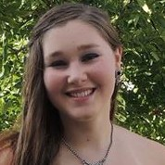
Julianna Hollman
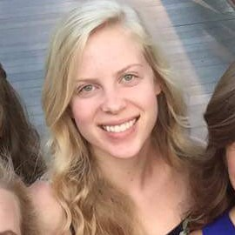
Anna Stock
Identification and Characterization of the Mycobacteriophage Baby16
Tara Bradley, Olivia Brown, Darby Brundage, Morgan Daly, Alfred Giudicy, Julianna Hollman, Anthony King, Grace Lancman, Lillian Oar, Baylee Reller, Cheyenne Roberts, Anna Stock, Noah Smith, Alyssa Thompson, Cassidy Thompson, Anna Williamson, Alexander Beeser, Muhammad Seegulam
A group of undergraduate students from Culver-Stockton College worked together to analyze the novel bacteriophage BABY16. It was first isolated and identified by Grace Lanceman in 2014, and discovery of eight new phages were made in 2015. In 2016, group members worked to annotate the BABY16 genome. Each phage discovery was obtained from a variety of soil samples in the Northeast Missouri region. The bacteriophage samples were subjected to enrichment which was performed by using the bacterial host Mycobacterium smegmatis mc2. Samples were then subjected to several rounds of purification in order to achieve a homogenous phage population. Lysates prepared from this phage sample were sent to the Donald Danforth Plant Science Center, located in St. Louis, MO, for analysis by electron microscopy and for sequencing at the University of Pittsburgh. The BABY16 genome was found to be 51,383 base pairs in length and was assigned to cluster A, subcluster A4 by the public phage BLAST tool available on phagesdb.org. While a significant number of these genes reported no known function, others were successfully matched with functions. These included a terminase, portal proteins, major head and tail proteins, and minor head and tail proteins. The programs HHPred, Phamerator and Blastp at NCBI were all used to assign the proteins functions when possible.

