DO NOT CONSIDER FOR TALK

2025 SEA Faculty Meeting Abstract

Universidad Autonoma de Sinaloa

Culiacán

Corresponding Faculty Member: Jesús Ricardo Parra Unda (ricardoparraund@uas.edu.mx)

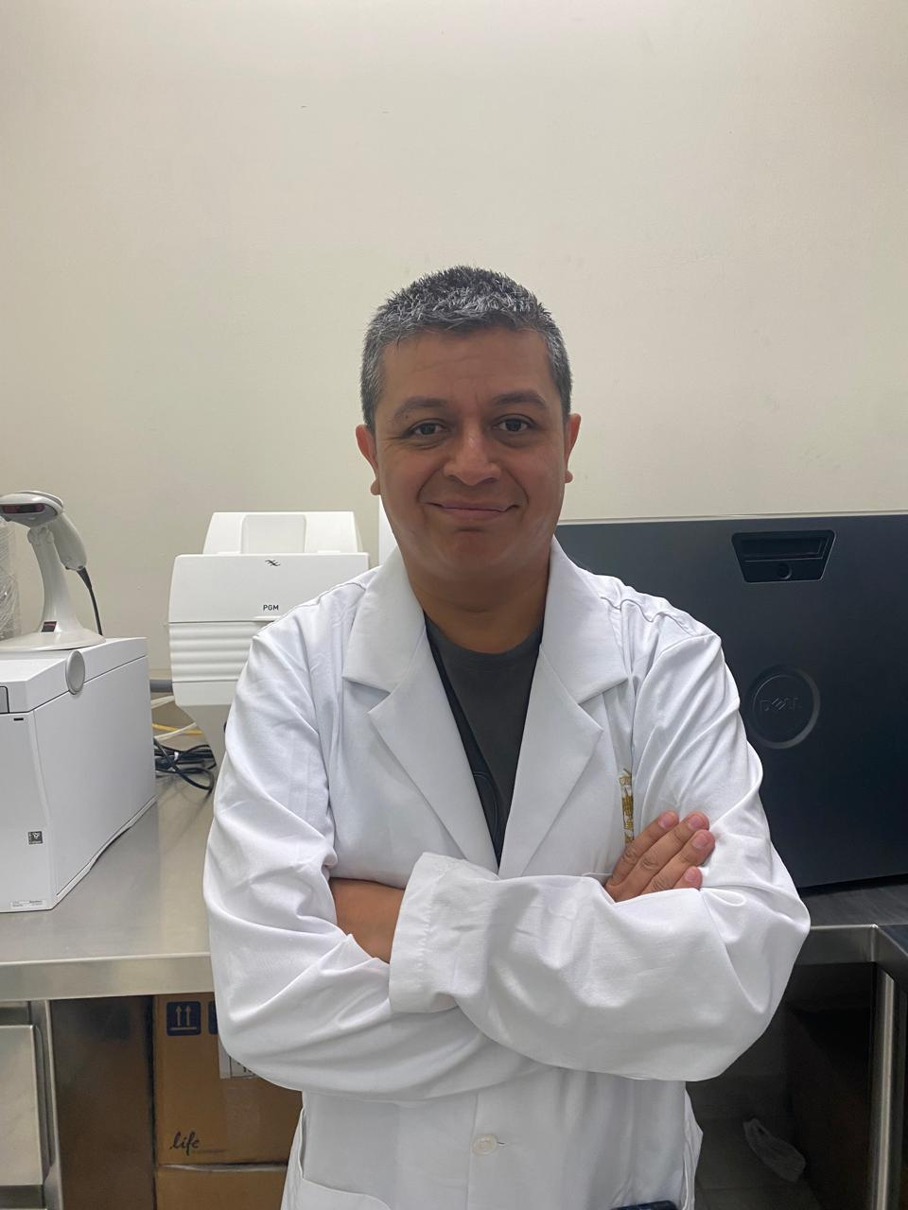

Ricardo R Parra Unda

Bacteriophages against multidrug-resistant bacteria

Andres A Borquez Castro, María Elena E E Baez flores, Yesmi Y Ahumada Santos, Daril Livan D Gonzalez Chiquete, Pedro Hiram P H Valenzuela Cortez, Ricardo R Parra Unda

Antimicrobial resistance occurs when pathogens no longer respond to antimicrobial medicines. Threatens human health and is one of the top global public health and development threats. Groups of bacteria can evade antimicrobial treatments. The diversity of the bacteriophages in the environment is unknown. Bacteriophages are one of the most promising treatments for the infection of MDR bacteria, due to their high specificity for their host and the ability to infect MDR bacteria.   
This study has the purpose of isolating different bacteriophages from the environment that can infect multidrug-resistant bacteria, and evaluating their morphology. As a result, a total of 11 bacteriophages were obtained. Six bacteriophages are from river samples, and five are from sewage samples. Four bacteriophages were active against K. pneumoniae, three against A. baumannii, and four bacteriophages against E. coli.