DO NOT CONSIDER FOR TALK

2025 SEA Faculty Meeting Abstract

University of Louisiana at Monroe

Monroe LA

Corresponding Faculty Member: Ann Findley (afindley@ulm.edu)

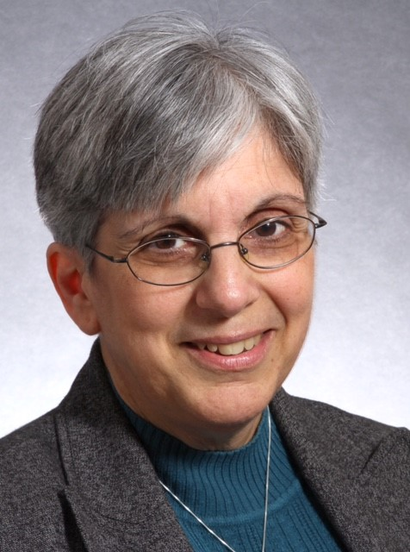

Ann M Findley

Branching Out: Extending SEA PHAGES Activities to Additional Laboratory Course Offerings

Ann M Findley

Due to staffing shortages at our university, we have developed an alternative strategy for the offering of the phage discovery portion of the SEA PHAGES Program during the fall 2025 semester. We will utilize students enrolled in our undergraduate independent research course to isolate novel phages using the enrichment protocol, perform spot tests, and do initial direct infections. Isolates will be turned over to the introductory microbiology laboratory for their purification and the development of high-titer lysates. Students in the genetics laboratory will then isolate phage DNA and perform restriction digestion analysis prior to the submission of DNA to the Pittsburgh Bacteriophage Institute for Illumina sequencing. DNA will also be sequenced in-house with our Nanopore system and the resultant FASTA files will be compared to those generated by Illumina sequencing. In the spring semester, students enrolled in the virology and biotechnology laboratory courses will annotate the sequenced genomes. Faculty teaching the lectures associated with these laboratory courses will provide necessary background information and communicate status updates to all students involved. We will also use this format to implement resources that provide visualization tools for core concepts (Chopping Up Plasmids, MathBench), reading of relevant literature (‘Going Viral’, ‘Phage Therapy’, The Scientist), expanded host-range studies, and identification of alternative restriction enzymes for cluster identification. Our overall objective is to bring the SEA PHAGES Program to additional undergraduate biology course offerings and recruit new faculty to carry on the Program at the university.