DO NOT CONSIDER FOR TALK

2025 SEA Faculty Meeting Abstract

Emory University

Atlanta GA

Corresponding Faculty Member: Nic Vega (nic.vega@emory.edu)

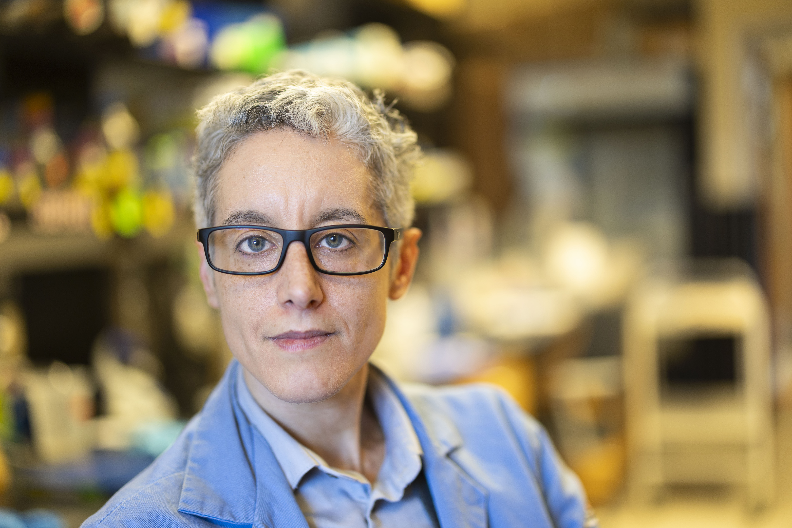

Nic M Vega

Lysogeny and prophage domestication in cluster AS3 phage Atlantica

Nic M Vega

Temperate phage in cluster AS have shown mixed success in generating "stable" lysogens (phage-secreting isolates with superinfection immunity). Here we describe isolation of phage-secreting and non-secreting lysogens of phage Atlantica (AS3) and demonstrate a PCR protocol for confirming integration at this phage's *attB* site in host *Arthrobacter globiformis*.