CONSIDER FOR TALK

2025 SEA Faculty Meeting Abstract

University of Ibadan

Ibadan

Corresponding Faculty Member: Olubusuyi Moses Adewumi (adewumi1@hotmail.com)

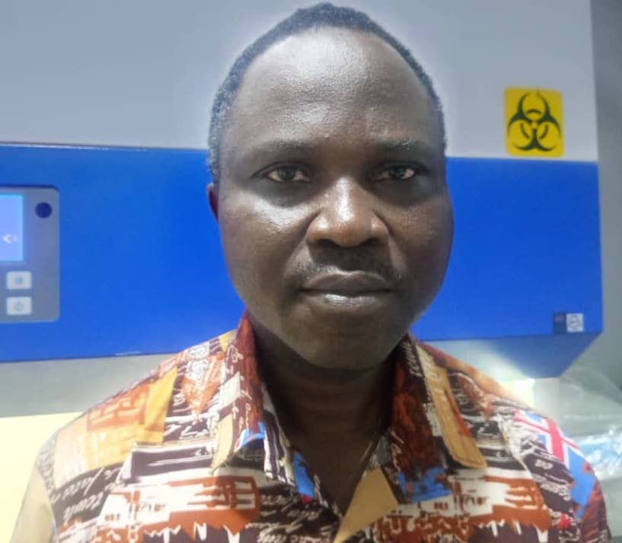

Olubusuyi M Adewumi

University of Ibadan SEA-Phages Team: A Review of 7-Year Impact on the Phage Community

Olubusuyi M Adewumi, Peace O Okunade, Oluwaseyi J Oludipe, Emmanuel O Adebayo, Oyindamola M Balogun, Ruqayyah A Bello, Saheed B Adedokun, Oyindamola A Adegoke, Mabel P Ariwajoye, Ridwan A Agboola, Adesubomi A Adegbite, Joseph A Odjirigho, Abuoma E Ejikeme, Abdulmuheed Balogun, Oluwadare Owolabi, Marufat O Hassan, Aisha O Adebiyi, Warith A Azeez, Valentina R Atayero, Damilola A Bakare, Adewale T Akintayo, Temiloluwa A Akintade, Anna M Ayeni, Kehinde D Omotoso, Victoria O Idowu, Adewale T Akintayo, Temiloluwa A Akintade, Anna M Ayeni, Kehinde D Omotoso, Victoria O Idowu, Adewale T Akintayo, Temiloluwa A Akintade, Anna M Ayeni, Kehinde D Omotoso, Victoria O Idowu, Adewale T Akintayo, Temiloluwa A Akintade, Anna M Ayeni, Kehinde D Omotoso, Victoria O Idowu, Daniel I Akintade, Christianah O Ilori, Abdulhakeem Bello, Muheez Oladimeji, Haleemat Sulaimon, Daniel I Akintade, Christianah O Ilori, Abdulhakeem Bello, Muheez Oladimeji, Haleemat Sulaimon, Daniel I Akintade, Christianah O Ilori, Abdulhakeem Bello, Muheez Oladimeji, Haleemat Sulaimon, Khadijat O Odunayo, Faith T Oyelade, Paul O Abodunrin, Emmanuel O Adesile, Muideen Raifu, Khadijat O Odunayo, Faith T Oyelade, Paul O Abodunrin, Emmanuel O Adesile, Muideen Raifu, Khadijat O Odunayo, Faith T Oyelade, Paul O Abodunrin, Emmanuel O Adesile, Muideen Raifu, Khadijat O Odunayo, Faith T Oyelade, Paul O Abodunrin, Emmanuel O Adesile, Muideen Raifu, Ini Adebiyi, Veronica I Ogunleye, Temitope O Faleye, Adeleye S Bakarey, John I Anetor, Ini Adebiyi, Veronica I Ogunleye, Temitope O Faleye, Adeleye S Bakarey, John I Anetor, Ini Adebiyi, Veronica I Ogunleye, Temitope O Faleye, Adeleye S Bakarey, John I Anetor, Ini Adebiyi, Veronica I Ogunleye, Temitope O Faleye, Adeleye S Bakarey, John I Anetor, Ini Adebiyi, Veronica I Ogunleye, Temitope O Faleye, Adeleye S Bakarey, John I Anetor, Ini Adebiyi, Veronica I Ogunleye, Temitope O Faleye, Adeleye S Bakarey, John I Anetor, Ini Adebiyi, Veronica I Ogunleye, Temitope O Faleye, Adeleye S Bakarey, John I Anetor, Ini Adebiyi, Veronica I Ogunleye, Temitope O Faleye, Adeleye S Bakarey, John I Anetor, Ini Adebiyi, Veronica I Ogunleye, Temitope O Faleye, Adeleye S Bakarey, John I Anetor, Ini Adebiyi, Veronica I Ogunleye, Temitope O Faleye, Adeleye S Bakarey, John I Anetor

Since inception in 2018, the SEA-PHAGES program at the University of Ibadan (UI) has pioneered early-career research in bacteriophage biology and computational studies for undergraduates. By adopting a student-driven, adventure-based learning model enriched with strong mentor-mentee relationships, the team has successfully broadened access to authentic research experiences within the institution.  
  
To date, over 60 undergraduates have been trained in phage biology and bioinformatics under four cohorts of student leaders. This commitment has earned both local and international recognition. Notably, the pioneer team leader received the ESCMID “30 under 30” Young Scientist Award and the ISVM/VOM Early Career Research Award. Three members won the AI4LS Hackathon organized by the University of Vienna and Gradient Zero in 2023. Members have also consecutively received the departmental "Researcher of the Year" award.  
  
The team hosted its first World Phage Week Webinar in 2020 and has sustained the event annually. The fifth edition, themed “Rethinking Antimicrobial Resistance: Bacteriophage Therapy and the One Health Paradigm,” held in October 2024, attracted over 250 participants from all over the globe. In 2024, the team also launched a YouTube channel to host and livestream events, now with over 100 subscribers and 200+ views of the 2024 webinar. Further, the team engages the public through X (formerly Twitter) Spaces. Three sessions have been held, including the most recent, “From Sequence to Insight: Trends in Bioinformatics for Phage Genome Annotation.   
  
In 2022, the team expanded its scope by establishing subgroups in metagenomics, cancer and transcriptomics research, and antimicrobial resistance studies, while also collaborating with other researchers. Over 15 students have been trained in computational research through these initiatives. To date, we have successfully annotated 11 novel phages.  
  
The team launched its official journal, PHAMILIA, now with two published editions that chronicled the group's efforts to advance phage research visibility in Nigeria. Members have actively participated in local and international conferences, including the International Symposium of SEA Researchers and the UNIBADAN Conference on Biomedical Research (UCBR). The team also participates annually in World Antimicrobial Awareness Week, raising awareness through educational e-flyers. The team recently resumed phage isolation activities after receiving new hosts from HHMI, submitted three annotated phage genomes, and initiated a study assessing awareness, perceptions, and knowledge of bacteriophage therapy among healthcare undergraduates at UI.   
  
The team continues to embody the spirit of innovation, collaboration, and student empowerment in phage research, and we remain committed to expanding its scientific contributions, fostering future scientists, and promoting the relevance of bacteriophage research in addressing global health challenges.