CONSIDER FOR TALK

2025 SEA Faculty Meeting Abstract

University of Ottawa

Ottawa

Corresponding Faculty Member: Adam Rudner (arudner@uottawa.ca)

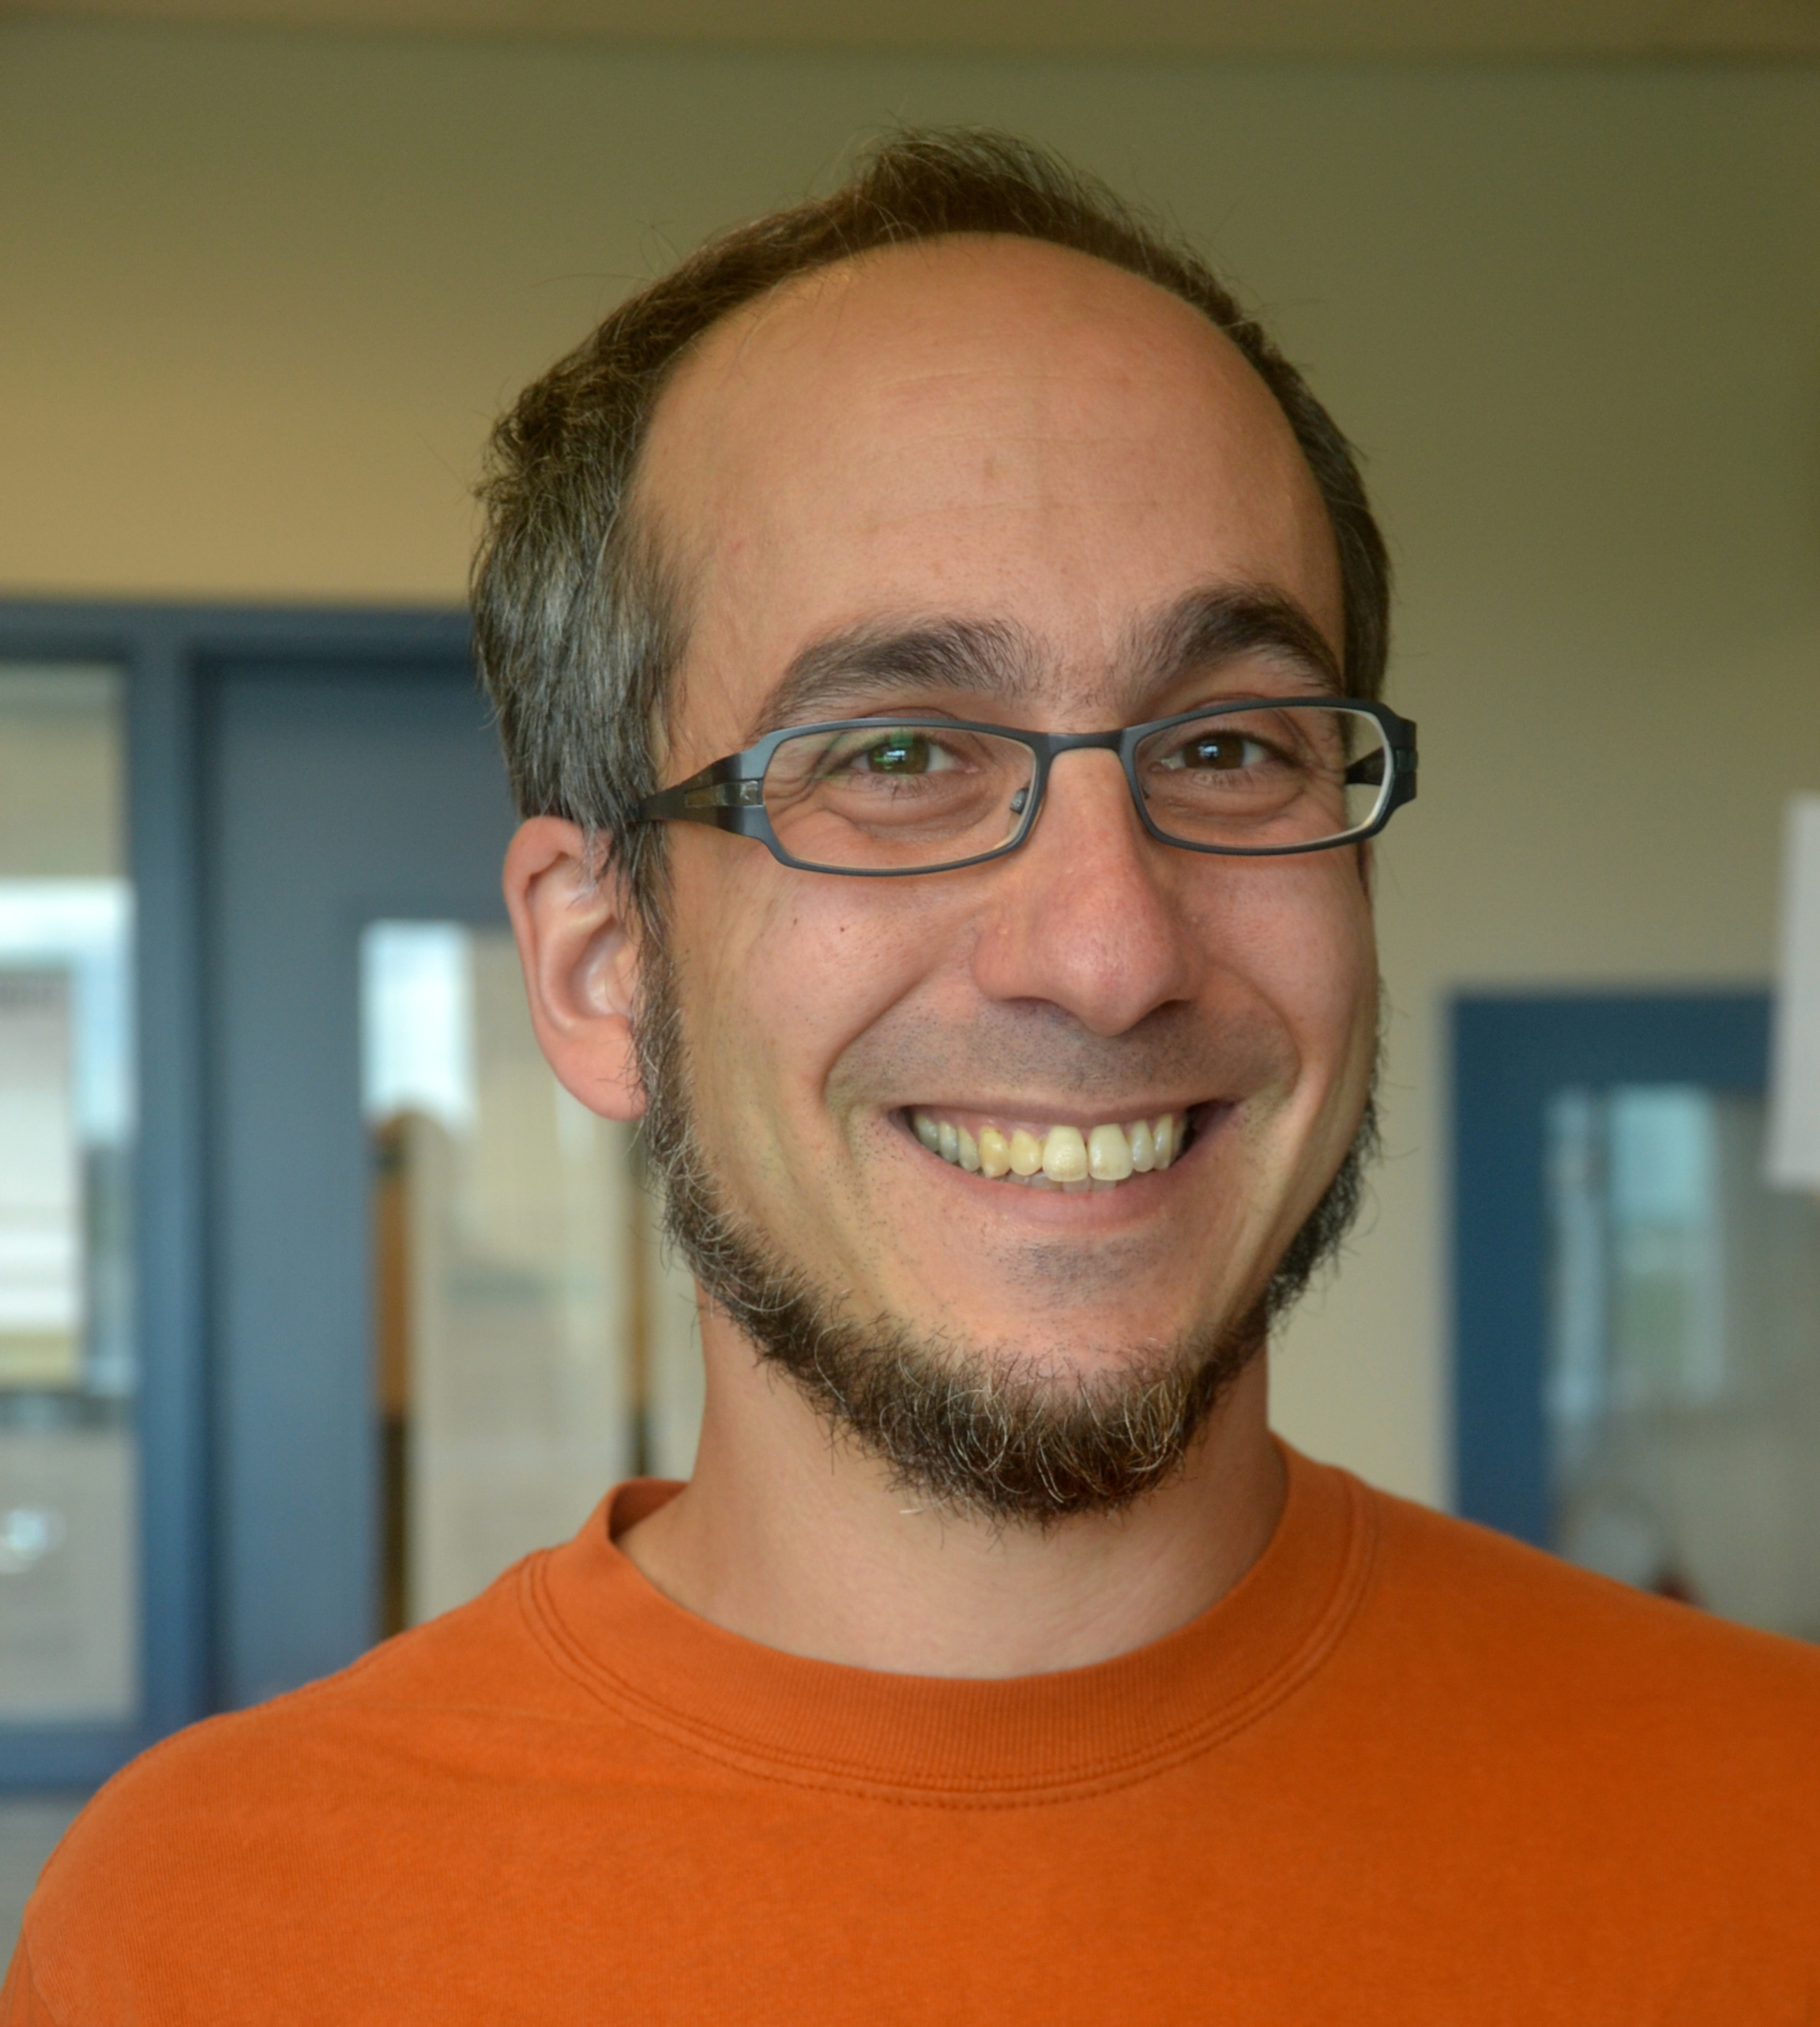

Adam D Rudner

Unlocking the Skin Microbiome: Isolating and Characterizing Skin-Sourced Bacteriophages for Phage Therapy

Emily Wood, Celina Tanbari, Ali Issa, Liam McCarthy, Elizabeth Williams, Adam D Rudner

Medical device-associated infections are among the most common type of hospital-acquired infections and represent a major challenge in modern healthcare. Periprosthetic joint infections (PJIs), occurring after joint replacements, are a common and particularly destructive implant-associated infection. *Staphylococcal* species, and in particular *Staphylococcus epidermidis*, are responsible for more than 50% of hip and knee PJIs. *S. epidermidis* is the most abundant bacterial species found on skin and mucous membranes, and while typically harmless, it can become pathogenic when it forms biofilms on implanted medical devices, causing destructive infections. Biofilm formation is the primary virulence factor of *S. epidermidis* and the complex structure of the biofilm allows evasion of host-immunity and antibiotics. The antibiotic-resistant nature of bacterial biofilms highlights an urgent need for alternative treatments and phage therapy (PT) is a promising option.   
  
In February 2024, Dr. Marisa Azad, at the Ottawa Hospital, successfully treated a patient with an antibiotic resistant PJI caused by *S. epidermidis* using a single phage. Sourcing this phage was challenging because of limited collections of *Staphylococcal* phages, highlighting the need for more research into *Staphylococcal* phage diversity and the development of a repository of phages with the potential for use in PT  
  
My laboratory and a section of our SEA-PHAGES discovery course have isolated 36 novel bacteriophages from human skin swab samples on several laboratory strains of *S. epidermidis*. We have purified 25 genomes, analyzed them by restriction digest, and imaged the phages by transmission electron microscopy (TEM). Additionally, a subset has been genome sequenced by Nanopore long-read and/or Illumina sequencing and we are in the process of sequencing the entire collection.   
  
To further evaluate infectious activity of our collection, we are examining phage-host specificity evaluated through host-range assays on 12 laboratory *S. epidermidis* strains. Results of these assays demonstrate variable infectivity, with some phages exhibiting broad host-range activity against multiple *S. epidermidis* strains. Additionally, a subset displays strong infection against *S. succinus*, a related avirulent host that was used to amplify the phage used in the Ottawa Hospital PT trial. Our 12 *S. epidermidis* phage isolation strains all form biofilms efficiently, and we have shown that several phages successfully inhibit biofilm formation at an MOI of 0.1, suggesting their potential utility in treating biofilm-associated infections.   
  
Future directions will involve testing a diverse subset of our phage collection against clinical isolates from patients with persistent PJIs at The Ottawa Hospital. This will provide insights into the *in vivo* efficacy of these phages and their potential application in clinical PT settings.