DO NOT CONSIDER FOR TALK

2025 SEA Faculty Meeting Abstract

Illinois Wesleyan University

Bloomington IL

Corresponding Faculty Member: Rick Alvey (ralvey@iwu.edu)

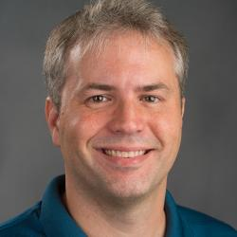

Richard M Alvey

The Weird Phages We’ve Found Using Alternative Hosts over 10 Years

Richard M Alvey

Over the last 10 years I have been running SEA lab using both a SEA-program host (either *Mycobacterium smegmatis* or *Microbacterium foliorum*) and a host of my own choosing – the aquatic alphaproteobacterium, *Rhodobacter capsulatus*. While phage hunting for *R. capsulatus* has proven to be more difficult than the SEA-program hosts, students working with me have managed to isolate an average of about 6 new RcPhages per school year. Using the same criteria applied to phages isolated on the SEA-program hosts we’ve been able to organize many of them into 7 clusters (RcA-RcG). Phages in our RcD cluster tend to be represented much more than others in the collection with about 40% of the ones we have found belonging to this group. Others are much rarer, with two clusters having only two members and four of our phages being singletons. Beyond simply being rare, several of these phages have notably unique features that make them stand out in the collection. These unique features will be highlighted.