CONSIDER FOR TALK

2025 SEA Faculty Meeting Abstract

Kansas State University

Manhattan KS

Corresponding Faculty Member: Martha Smith-Caldas (mscaldas@ksu.edu)

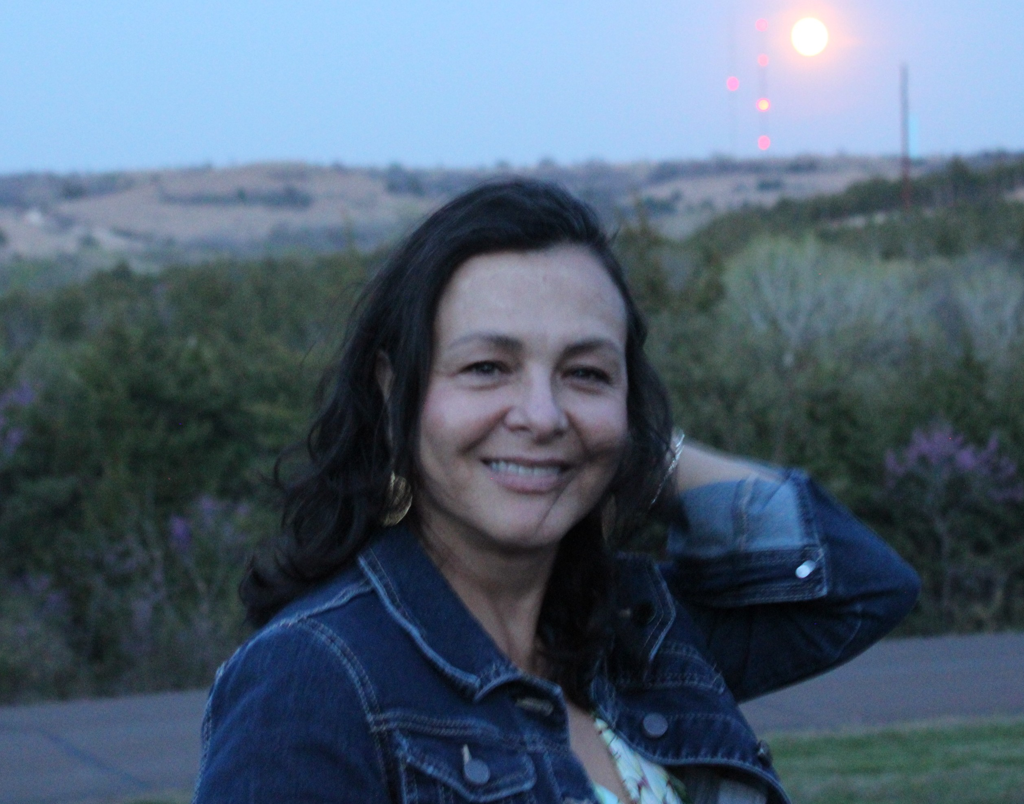

Martha Smith Caldas

Tips On How to Organize the Semester to Fit “Further Discoveries”

Martha Smith Caldas

Kansas State University is part of Cohort 8 of the SEA-PHAGES program. To date, we have isolated 192 bacteriophages and annotated 28 genomes. For a while, our primary goal was to provide the required end products of the phage discovery: phage lysates and phage DNA. While we consistently required our students to perform lysogeny tests, there was a general perception that conducting host range and sensitivity assays would demand additional resources, time, and commitment.   
However, a recent change in the team structure created an opportunity to revise the way we conduct the discovery portion of the course. Having the laboratory organized to perform the extra experiments was a major learning gain for the students, who could practice developing hypothesis, further practice laboratory techniques, and interpret results. If such “further discoveries” are done on phages’ genome that will be annotated, the SEA-PHAGES program gains valuable information about those archived phages.