DO NOT CONSIDER FOR TALK

2025 SEA Faculty Meeting Abstract

University of North Carolina at Charlotte

Charlotte NC

Corresponding Faculty Member: Ellen Wisner (EWisner@charlotte.edu)

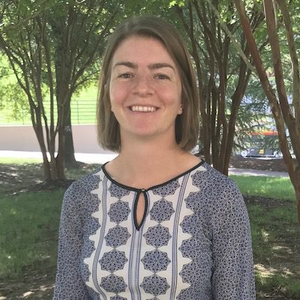

Ellen M Wisner

Riding the AI Wave: Where does Generative AI fit into SEA research?*

Tonya C Bates, Ellen M Wisner

Generative artificial intelligence (AI) usage is on the rise in higher education. As more and more students access this technology, it is important that they know how to properly use it and understand its limitations. Many journals now have AI policies. For example, microPublication Biology, where many of us publish genome announcements, follows the Council of Science Editors (CSE) guidelines for the use of AI in the research they publish. These guidelines stipulate that authors can use AI, but that they must indicate where and how it was used. In addition, they hold the authors responsible for the accuracy, proper citation, and the absence of plagiarism within the writing. In this interactive poster presentation we seek to gain feedback from across the SEA about where generative AI usage is appropriate within SEA research, more specifically in idea generation and communication of research findings. We are interested in how you train students in AI usage, in which parts of the research projects, presentations and publications you allow generative AI use, and where you have specific policies against the use of AI. Additionally, we seek to explore new generative AI tools that may be useful for students in their science communication.  
  
**Title ideas brainstormed using Microsoft Copilot.**