CONSIDER FOR TALK

2025 SEA Faculty Meeting Abstract

Austin Community College Eastview Campus

Austin TX

Corresponding Faculty Member: Kissaou Tchedre (kissaou.tchedre@austincc.edu)

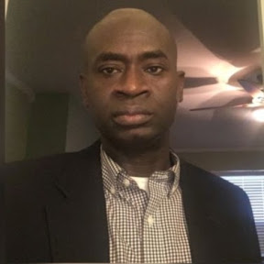

kissaou Tchedre

Student Reflections on the SEA-PHAGES Discovery Experience: Spring 2025 Cohort at Austin Community College

kissaou Tchedre

In Spring 2025, students enrolled in BIOL 1406 (Cell and Molecular Biology) at Austin Community College's Eastview campus participated in the SEA-PHAGES Discovery program. Alongside the Student Persistence in the Sciences (PITS) assessment, an anonymous in-class survey was conducted to gather students' personal impressions and experiences with the course. Results indicated overwhelmingly positive feedback regarding the course structure, methodology, and overall learning experience. Students reported enhanced engagement and satisfaction with the hands-on research opportunity. During the program, students successfully isolated and identified eight unique mycobacteriophages: Rocha, Pereira, Gachnar, Seraphin, LookingGlass, BarryBBerson, Multan, and Holton, which were submitted to the PhagesDB database.