CONSIDER FOR TALK

2025 SEA Faculty Meeting Abstract

University of Michigan-Flint

Flint MI

Corresponding Faculty Member: Maeve McLaughlin (maevemcl@umich.edu)

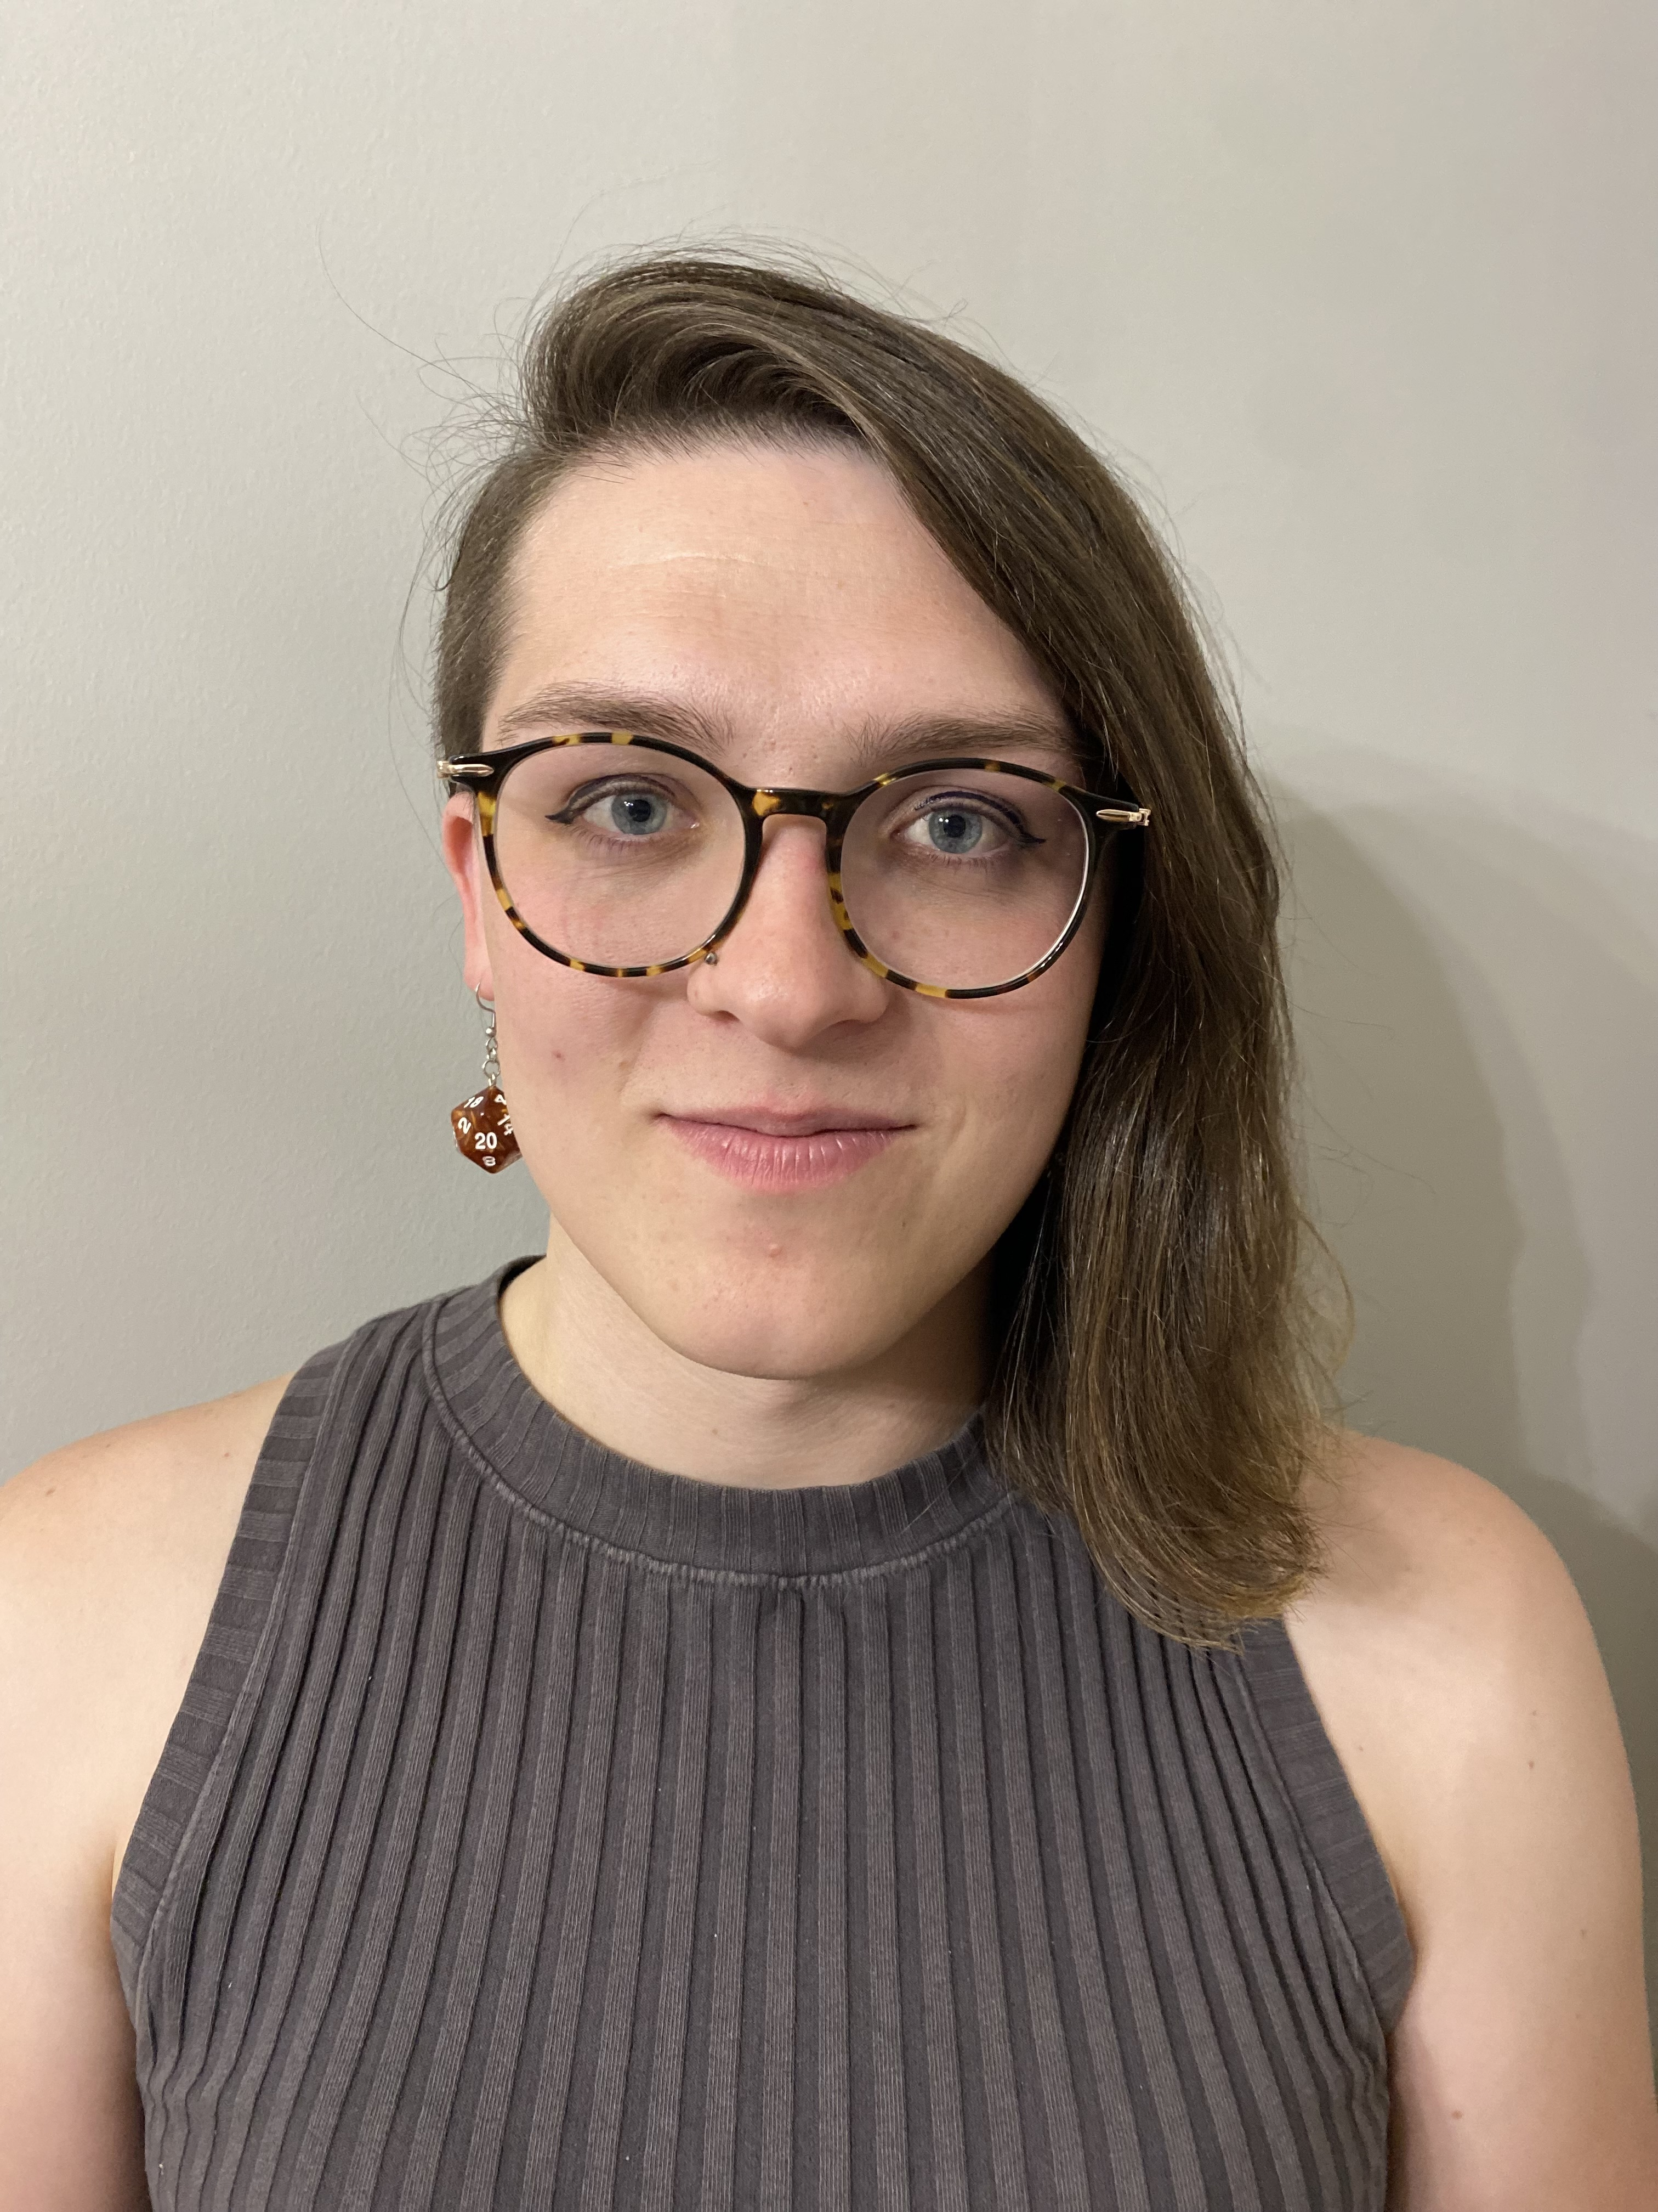

Maeve McLaughlin

Characterizing a novel N4-family Caulophage

Maeve McLaughlin

Bacteriophage or phage (i.e. viruses that infect bacteria) are the most abundant organisms with ~10^31 phage on the planet. Phage will bind, infect, and replicate in their bacterial hosts before lysing them to release the phage progeny into the environment. Due to rising antimicrobial resistance rates, phage are increasingly being used as an alternative treatment for recalcitrant bacterial infections and biofilms. It is therefore critical to examine identify and characterize new phage in order to better understand the interactions between bacteria and phage. We have recently isolated a novel phage from a local, freshwater lake (Lake Lansing) that infects the model organism *Caulobacter crescentus*. Genomic analysis of this phage, hereby named Circe, indicates that it is an N4-like *Schitoviridae* family phage that encodes a dsDNA genome that is 73,793 bp with 106 predicted ORF and 2 tRNA. Phage Circe encoded all seven of the hallmark genes for N4-like phage, including a large, viral RNA polymerase. To identify putative receptors for the phage, we performed BarSeq experiments in which we infected a barcoded transposon library with phage Circe and examined fitness throughout the course of infection. Mutants with disruptions in genes that are known or predicted to control smooth lipopolysaccharide (LPS) biosynthesis were observed to have increased fitness during infection. Consistently, we observed that deletion of genes identified from the BarSeq experiments made strains resistant to phage infection. Together, this suggests that smooth LPS plays a critical role in infection of *C. crescentus* by the N4-like phage Circe.