DO NOT CONSIDER FOR TALK

2025 SEA Symposium Abstract

University of Ottawa

Ottawa

Corresponding Faculty Member: Adam Rudner (arudner@uottawa.ca)

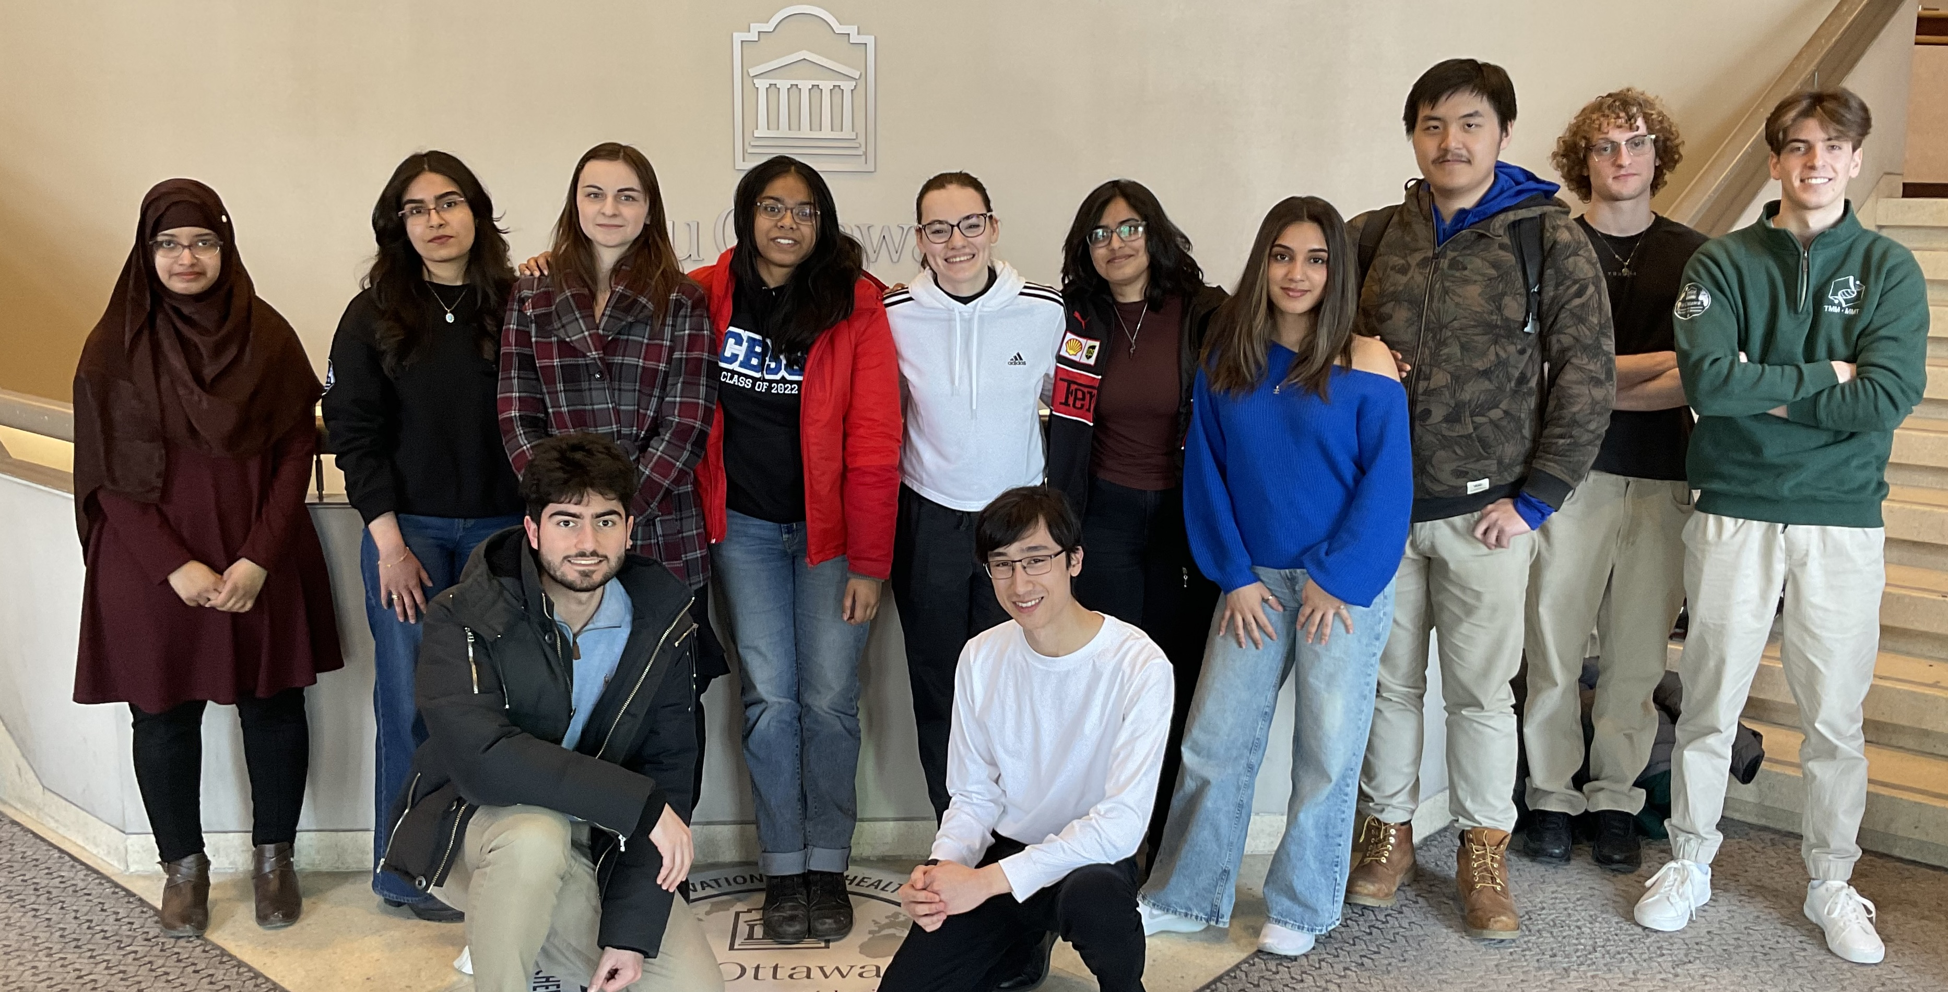

Bushra Pathan

Digging Deeper: Unearthing the AU Cluster Phages Zippen and Chlochlo from Soil Samples

Bushra Pathan, Jean-Paul Azzi, Ammi Paul, Barry Ngo, Bayan A Mehrem, Catherine Waghorn, Elliot Jackson, Isra Omar, J.P. Doyle, Mattheo Fakhouri, Moumita Dutta, Nika Abedian, Samantha Kiraly, Chloé Mcallister, Kushi Rathod, Valeria Vasilyeva, Sabrina Gregoire, Victoria Gilchrist, Ilham Mekkioui, Katie Dale, Elizabeth C Williams, Kin Chan, Kieran Furlong, Adam D Rudner

Bacteriophages (phages) are viruses which infect specific bacteria. In 2024, students in the SEA-PHAGES program at the University of Ottawa discovered and characterized two AU cluster bacteriophages named Chlochlo and Zippen. Chlochlo was isolated from soil collected in a roadside flowerbed and Zippen was recovered from soil in a raised concrete plant bed.   
  
Their DNA was sequenced using Illumina technology at the University of Pittsburgh. The genome of Phage Zippen is 58,117 bp in length, with a GC content of 51.5%. A total of 93 genes were identified with 60 (64.5%) encoding proteins of unknown function. Similarly, the genome of Phage Chlochlo is 57,374 bp long, with a GC content of 50.3%. It contains 91 genes, with 60 (65.9%) having an unknown function.  
  
Their genomes were annotated at the University of Ottawa using Starterator, NCBI BLAST, HHPRED, Glimmer, GeneMark, and PECAAN. Both phages belong to the Siphoviridae family and target the Gram-positive bacterium *Arthrobacter globiformis*, but they infect different strains: Chlochlo infects the NRRL B-4225 strain, while Zippen infects the NRRL B-2979 strain. Interestingly, the phages in the AU cluster infect 4 different *Arthrobacter* strains: *sp.* ATCC 21022, *globiformis* B-2979, *globiformis* B-2880, and *globiformis* B-4225. The minor tail protein of phages is known to be involved in host specificity.  
  
Zippen has 7 minor tail proteins in its genome, two of which are duplicates of each other. This is a distinct characteristic as phages usually have 2-6 minor tail proteins in their genome. Here we will evaluate the minor tail protein to see which one(s) are involved in host specificity. Also, in the minor tail protein region Zippen_gp16 has a function of NKF. Alphafold analysis shows a match to a minor tail protein and it forms a multimer with its neighbouring genes gp17 and gp18.   
  
Another interesting feature of Zippen and Chlochlo is their major tail proteins which are duplicated and in the same Pham. Of the 5,456 sequenced PhagesDB phages, only 180 (3%) have 2 major tail proteins which include phages Chlochlo and Zippen.   
  
Annotation of Zippen_gp43 (bp 32,875-33,276) has identified a potential new function for the SEA-PHAGES approved function list. This gene exhibits a strong structural relationship to dATP/dGTP diphosphohydrolase. This enzyme hydrolyzes dATP and dGTP into their monophosphate forms and is involved in making dZTP (2-aminoadenine deoxyribonucleotide triphosphate). Zippen may not have this DNA modification, but the gene may be involved in a defence mechanism.   
  
In conclusion, the characterization of Chlochlo and Zippen contributes valuable insights into the AU cluster bacteriophages. These findings not only enhance the SEA-PHAGES database but also provide a foundation for future research on phage-host interactions and their applications in combating bacterial resistance.