DO NOT CONSIDER FOR TALK

2025 SEA Symposium Abstract

Iowa State University

Ames IA

Corresponding Faculty Member: Nick Peters (ntpeters@iastate.edu)

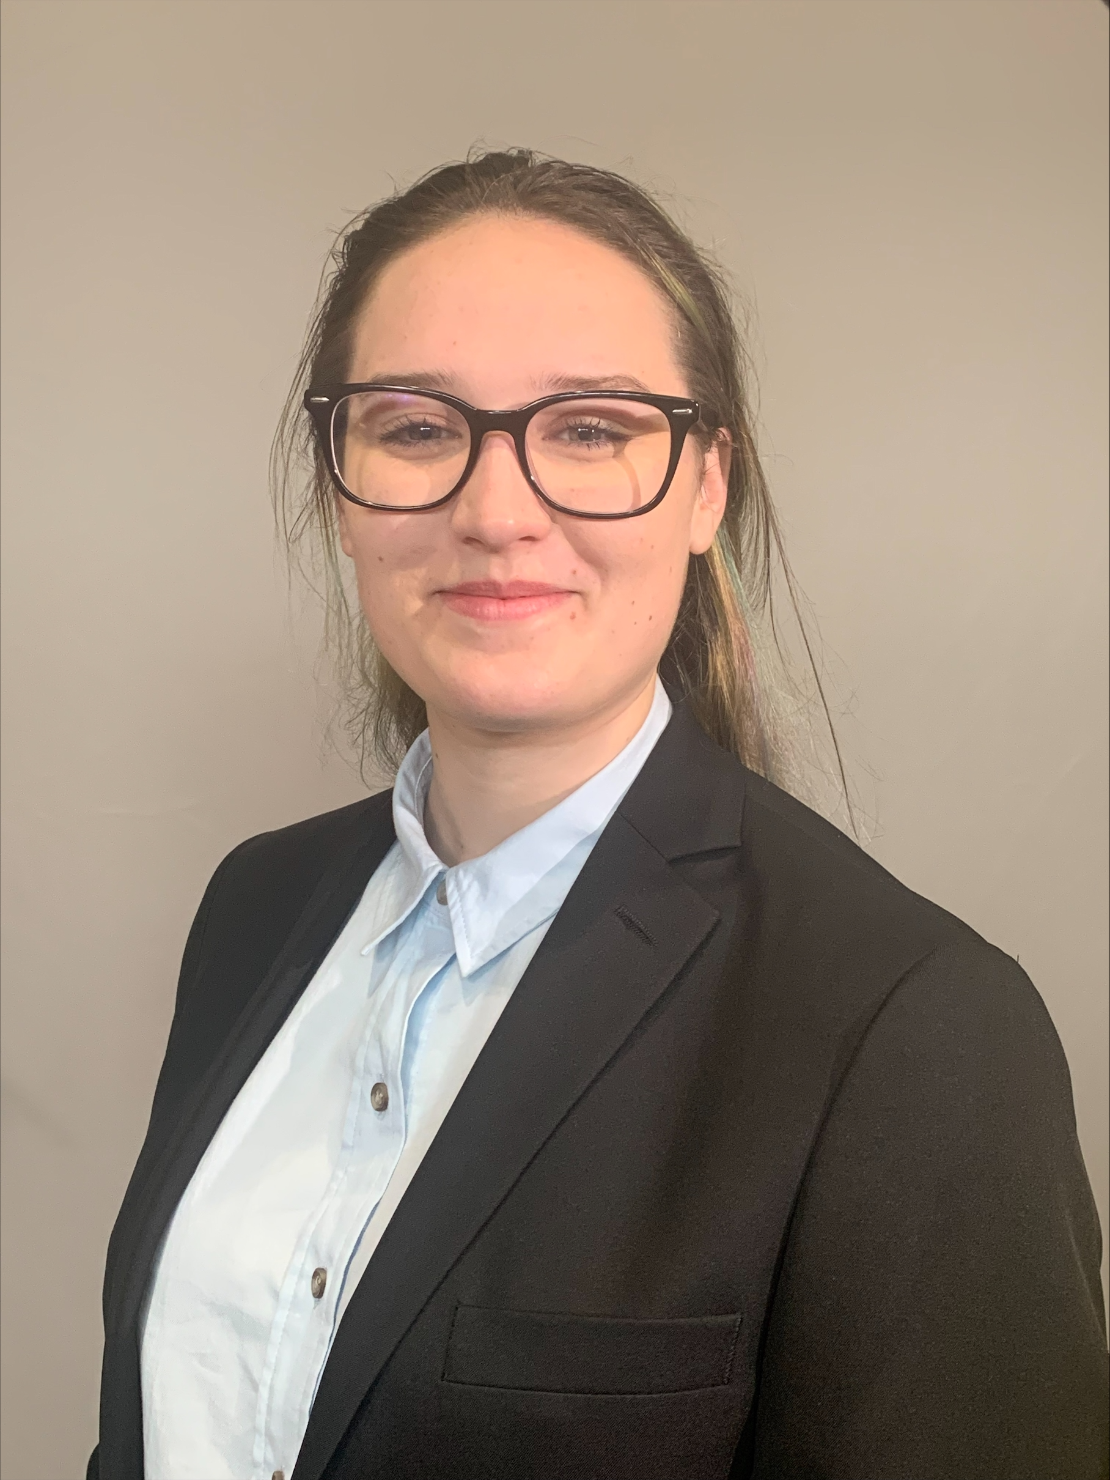

Haley MacBurney

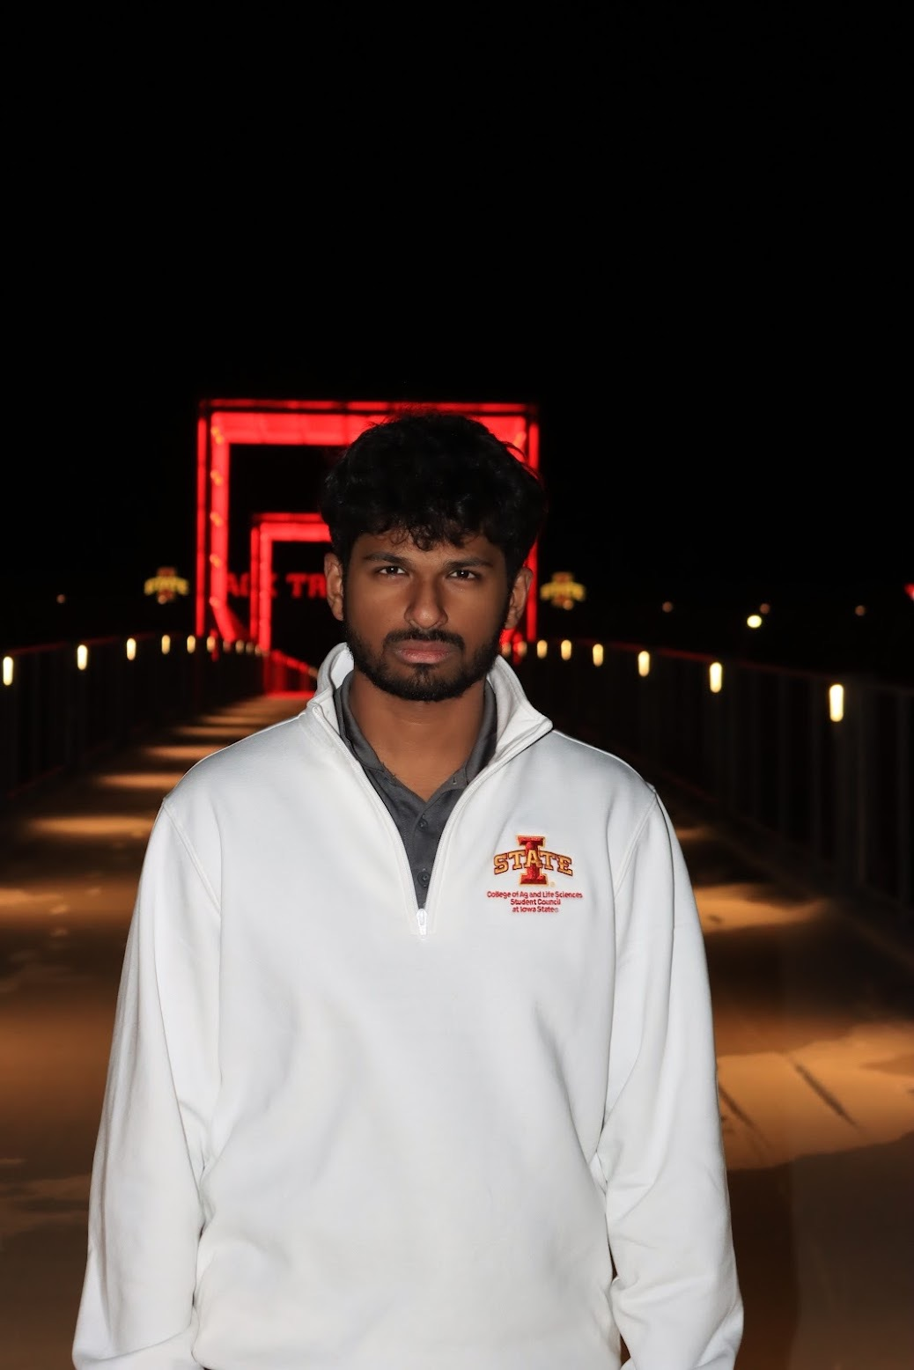

Abhishek Mohanty



Sofia Muniz-Ferrer



Faith Hansen



Ena Stojanovic

Annotation of Casablancas Using Alternative Online Resources

Haley MacBurney, Abhishek Mohanty, Sofia Muniz-Ferrer, Faith Hansen, Ena Stojanovic, Nick Peters

Annotation of phage genomes can be difficult due to the large number of genes of unknown function. We wanted to try some additional resources to get other perspectives for auto annotation of phage Casablancas. We tested BV-BRC and Phastest against the pipeline from the SEA. While there is some overlap, the SEA method gave us the most information for annotation of genes and was the most thorough. Phastest gave us solid structural protein predictions and was fast, easy, and had a nice graphical output. BV-BRC was the least informative, only calling a few gene functions and tRNAs. After going through all three methods, we feel the SEA method is the most comprehensive and likely the most accurate.