CONSIDER FOR TALK

2025 SEA Symposium Abstract

Maryville University of Saint Louis

St. Louis MO

Corresponding Faculty Member: Olga Lubman (olubman@maryville.edu)



Emilee A Kohler



Rafael A Millangue

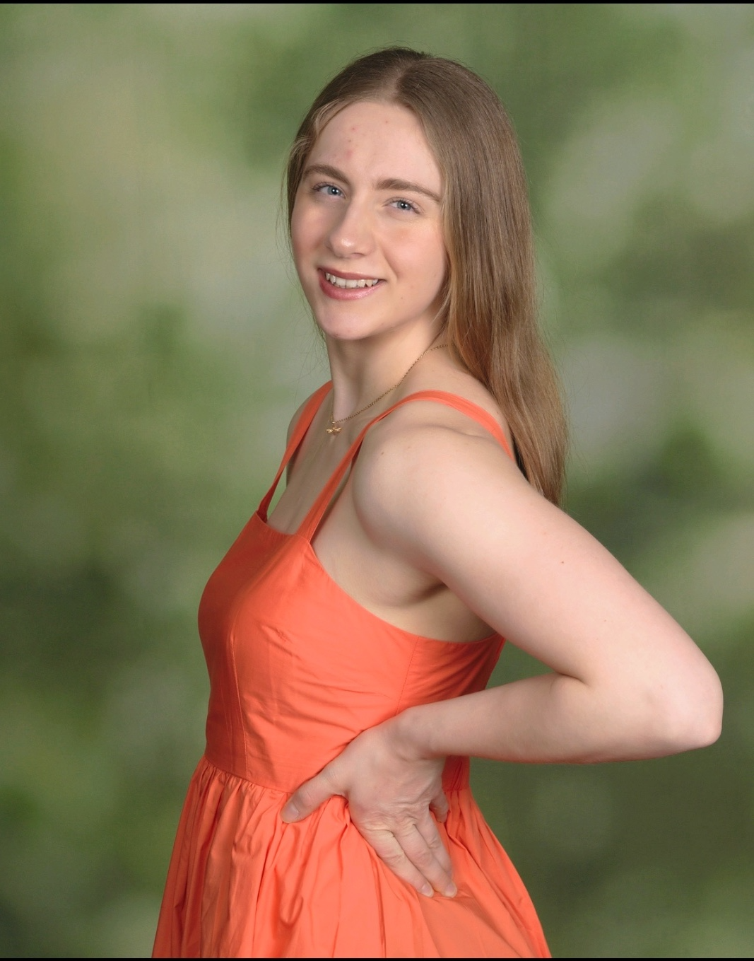

Sarah J Leardi

Isolation, Characterization and Genome Annotation of WaddleDee- Actinobacteriophage cluster FC phage from Saint Louis, MO

Emilee A Kohler, Rafael A Millangue, Sarah J Leardi, Ellie G Mitchell, Rachel L Nelson, Hailey E Scheuer, Anthony S Langanke, Vicky M Trejo, Ethan M Thier, Vessell E Chloe, Olga Y Lubman

Herein, we report WaddleDee, a novel phage of *Siphoviral* morphology assigned to the Actinobacteriophage cluster FC and discovered by direct isolation from the soil in Grant’s Trail, St. Louis, MO. The size of WaddleDee was determined to be 194,376 bp with 54.3% GC content and 16,181( 8.1%) bp of direct terminal repeats at the ends. WaddleDee encodes 328 protein-coding genes, of which 178 ORFs been assigned putative functions. The function of the remaining 117 ORFs remains unknown. WaddleDee encodes 33 tRNAs, collectively coding for 20 different amino acids. Consistent with other FC phages, we found no ORFs with identifiable integrase or repressor functions, suggesting that WaddleDee doesn’t form lysogens and is a lytic phage. Our phylogenetic Analysis suggests that FC cluster, despite only having 18 genomes, can be further subdivided into two distinct subclusters. The fold prediction algorithm PHYRE-2 suggests that WaddleDee gene #3 may function as the NusG family of anti-pausing transcription factors. WaddleDee contains eleven ORFs predicted to function as minor tail proteins coded by genes # 5, 39, 79-82, 177-179, 277, and 297.