DO NOT CONSIDER FOR TALK

2025 SEA Symposium Abstract

Xavier University of Louisiana

New Orleans LA

Corresponding Faculty Member: Harris McFerrin (hmcferri@xula.edu)



Jalayah Chatman

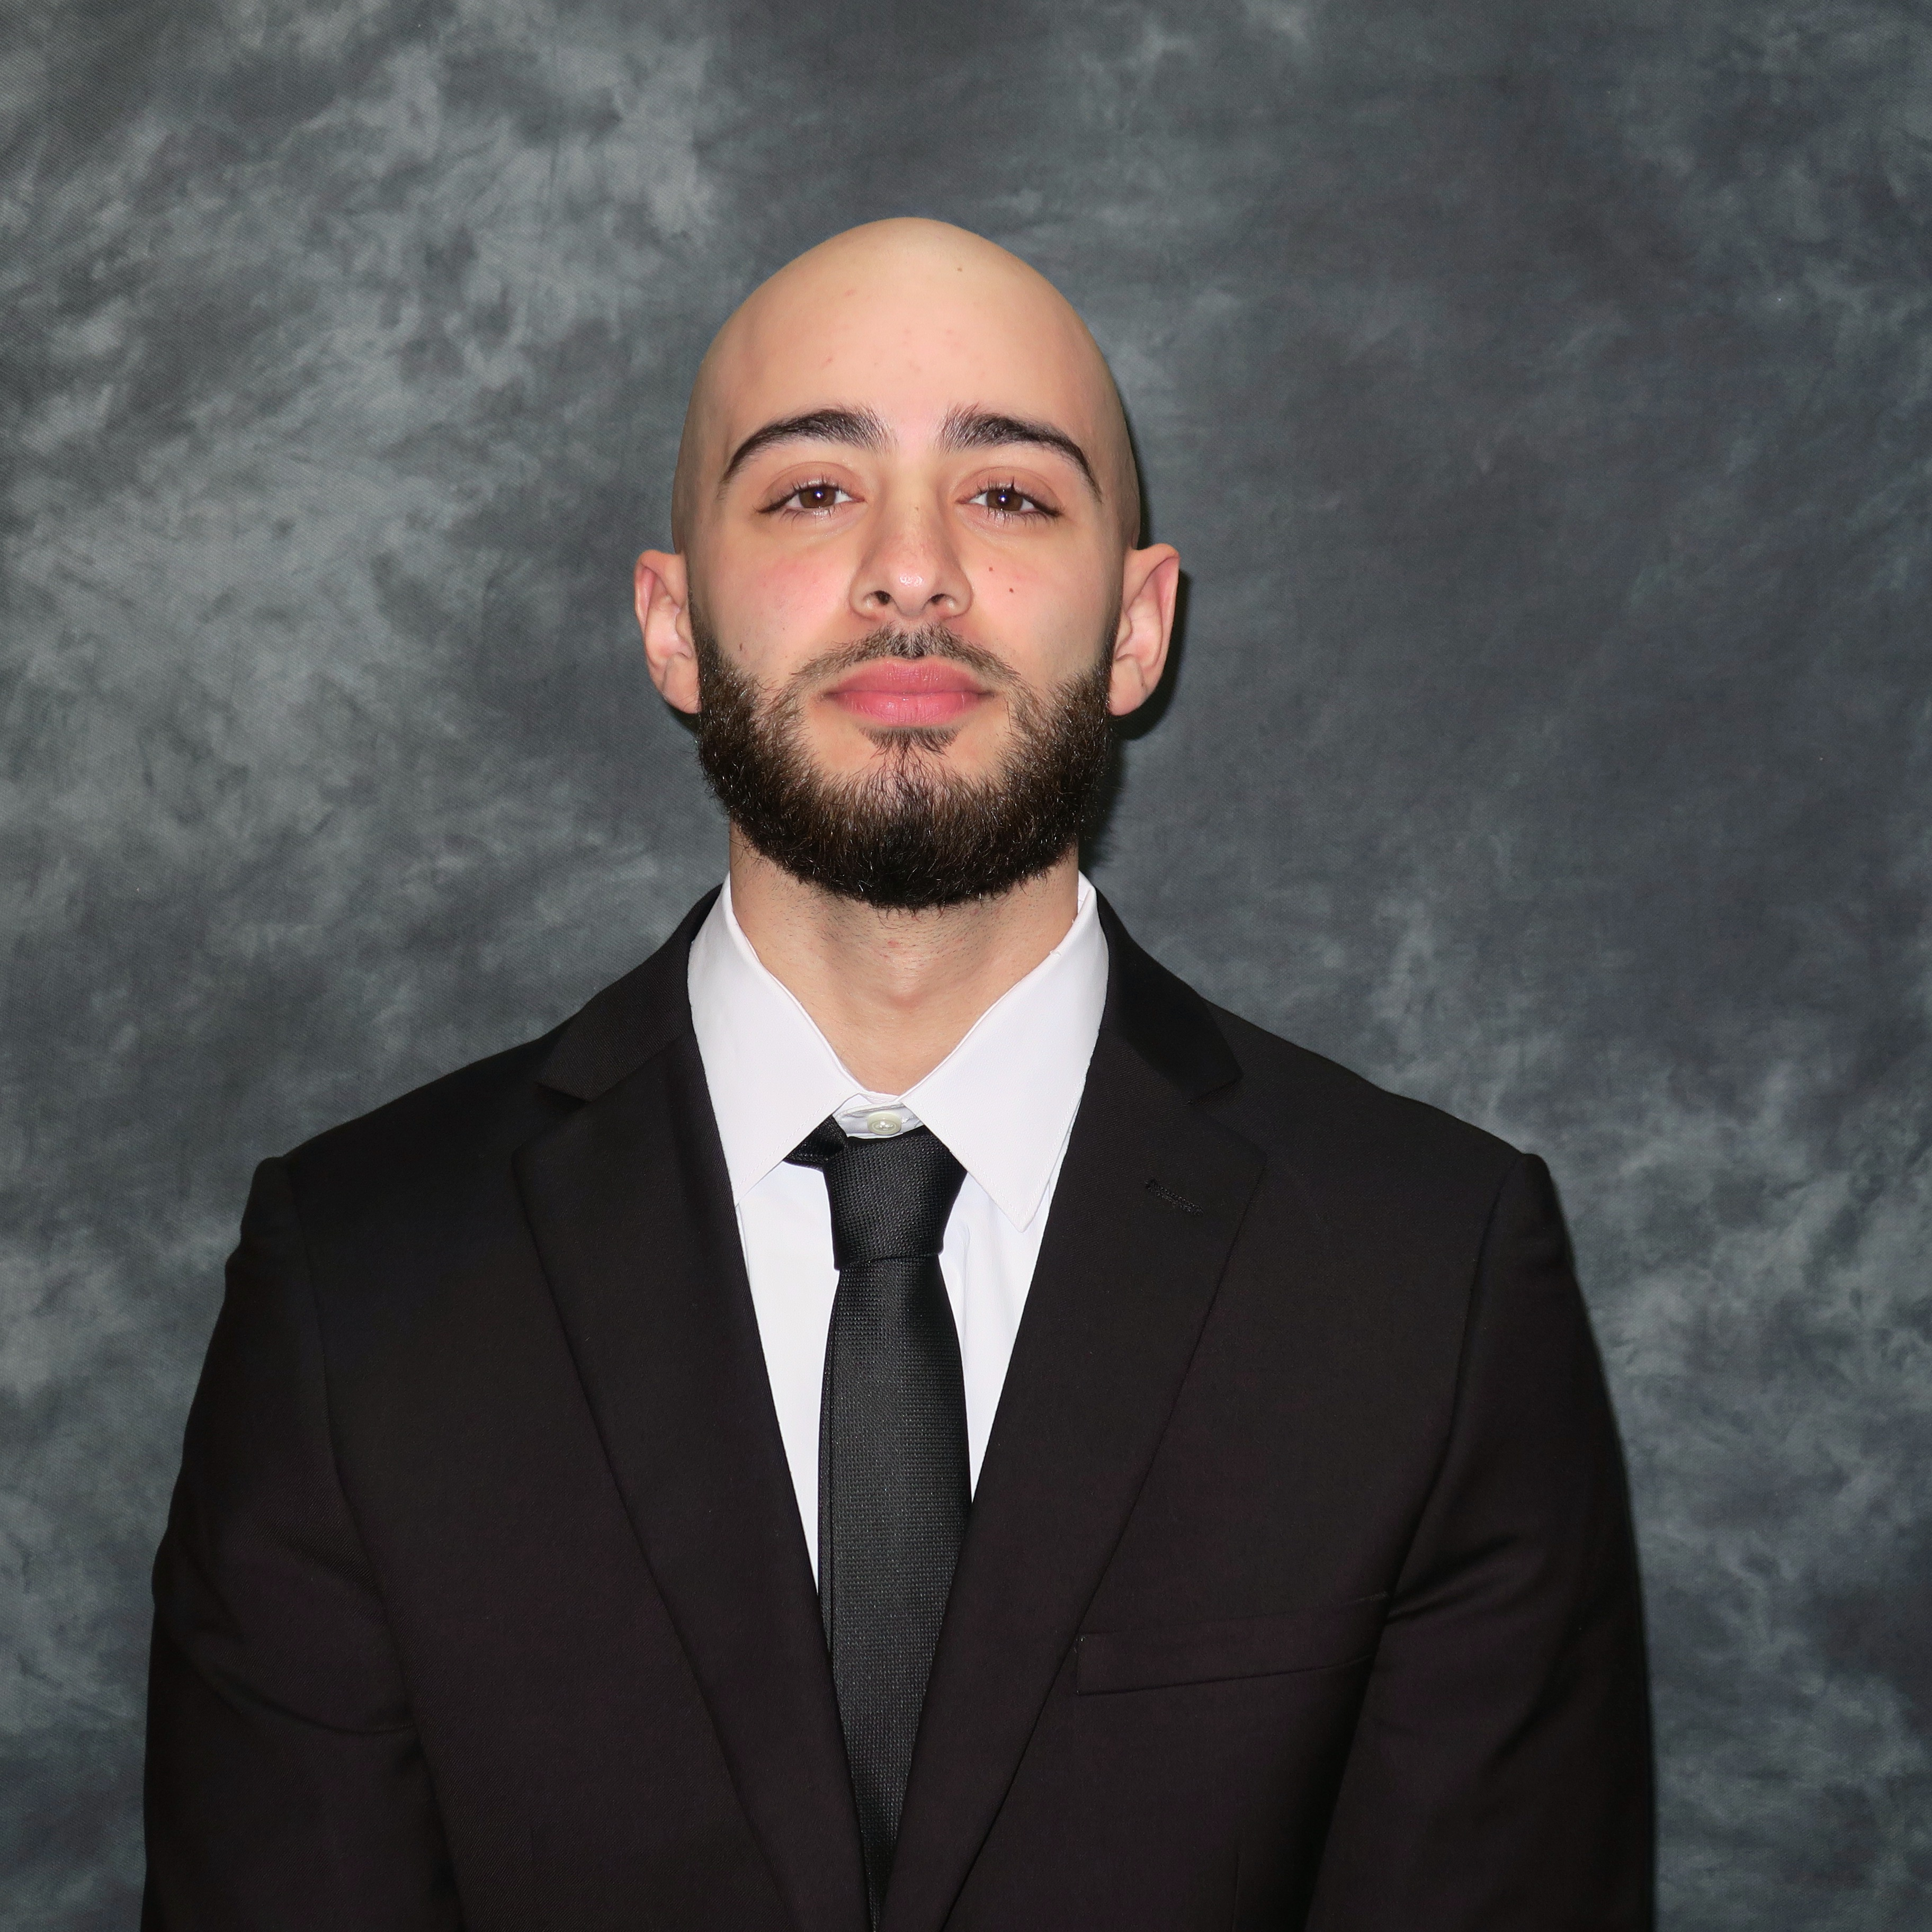

Mohammad Ibrahim

Genomic characterization of Mycobacteriophage BilboSwaggins

Jalayah Chatman, Mohammad Ibrahim

Bacteriophages are viruses that specifically target bacterial cells as hosts. Due to the wide diversity of bacteriophages, many are not discovered or annotated, forming a gap in literature. BilboSwaggins is morphologically characterized as a Siphoviridae virus that belongs to the E Cluster. It was found by students at Merrimack College in Massachusetts, and its genome was sequenced by the Hatfull Lab at the University of Pittsburgh. It was found that the genome consisted of 76,483 base pairs containing 140 putative genes by autoannotation. BilboSwaggins is a temperate phage, and its host is *Mycobacterium smegmatis*. In the annotation of the genome, several analytical software packages were utilized including HHPred, NCBI BLASTn and BLASTp, PECAAN, Genemark, Glimmer, Phamerator, tRNAscanSE, and Aragorn. Through comparative genomic analysis, gene locations were identified, gene starts were validated, and possible gene product functions were assigned to many genes. The annotation of BilboSwaggins is one step of many in expanding bacteriophage literature. Future analysis may allow for the discovery of additional protein functions and the extension of bacteriophage biomedical applications.