DO NOT CONSIDER FOR TALK

2025 SEA Symposium Abstract

University of Ottawa

Ottawa

Corresponding Faculty Member: Adam Rudner (arudner@uottawa.ca)

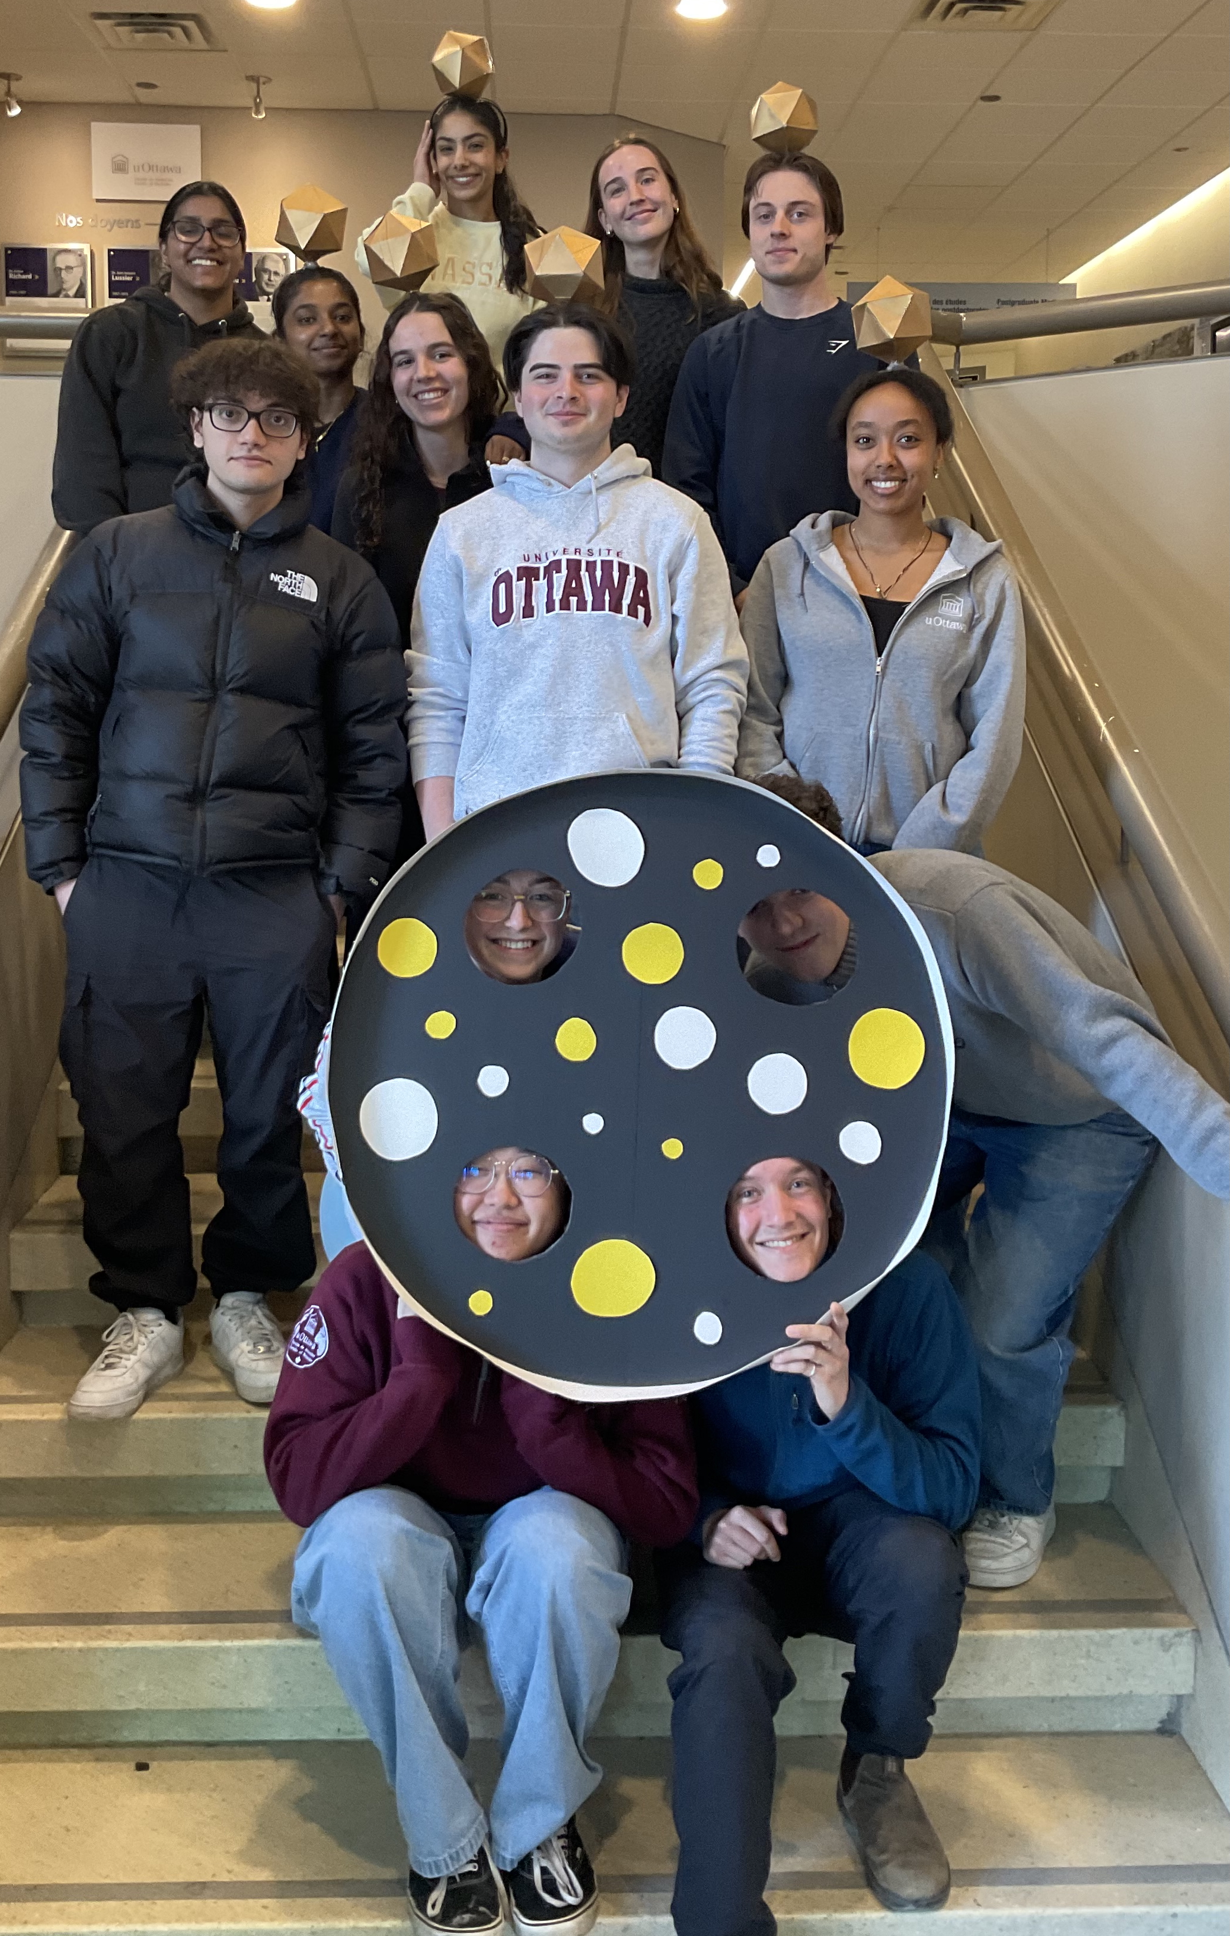

Sophia Guy

Scotia and Ball: Unlocking the Potential of Nature’s Bacterial Assassins

Induja Arulchelvam, Sophia Guy, Tanya Arora, Haimen Yezihalem, Nicholas Lafond, Kathleen Connolly, Rebecca Babu, James Humber, Salah H Aly, Katarina Lucke, Fynn Murphy, Justin Thanh Luan Nguyen, Barry Ngo, Catherine Waghorn, Ryan Tu, Valeria Vasilyeva, Kushi Rathod, Sabrina Gregoire, Kieran Furlong, Victoria Gilchrist, Ilham Mekkioui, Katie Dale, Elizabeth C Williams, Kin Chan, Zachary Mitchell, Adam D Rudner

In the fall of 2024, two bacteriophages, Scotia and Ball, were discovered by undergraduate students at the University of Ottawa. Scotia was found to infect *Arthrobacter globiformis* B-2979 host bacteria and forms small cloudy plaques with no clear border. Transmission electron microscopy (TEM) confirmed a *siphoviridae* morphology, given its long, non-contractile tail. Ball infects *Arthrobacter globiformis* NRRL B-4225 host bacteria and forms small turbid plaques. TEM imaging confirmed it also has a siphoviridae morphology. Both phages have narrow host ranges and only infect their isolated strain of Arthrobacter globiformis.  
  
Scotia was assigned to the FO cluster and used Aoka and JanetJ as comparator phages to support functional calls. Ball was found to be a singleton and was compared with Ryan and Nandita phages. Dot plots were produced to compare the genomic sequences of Scotia and Ball against their most similar phages. Annotations were done using PECAAN, Genemark, HHPred, NCBI Blast, PhagesDB and Starterator.  
  
While amplifying Ball, we noted the rare occurrence of clear plaques and have purified a clear plaque mutant which display a heritable change in plaque morphology, appears more virulent and is easily amplified. Consistent with this plaque morphology, we have shown that the clear plaque mutant is defective in forming lysogens. We have also isolated a lysogen of Ball, which shows strong super-infection immunity to re-infection by Ball. The Ball lysogen also maintains partial immunity against the clear plaque mutant, showing it may still be susceptible to repression by the annotated immunity repressor.   
  
We hypothesized that Gene 54 in Scotia has ribose modifying activity, specific to cytosine.  
After comparing the experimental restriction digest of Scotia genomic DNA with a virtual digest, there is a clear block in GC-rich restriction enzymes. Enzymatic activity of Gene 54 may prevent the GC rich restriction enzymes from binding by modifying the cytosine nucleotides. Pymol was used to measure how tightly the active site of the protein, obtained from Alphafold, interacts with purines and pyrimidines. Notably, CTP, is not available in Pymol, so we used the structurally similar structure, NAD, was used to represent pyrimidines. We have identified a predicted interaction between Gp54 and NAD, suggesting CTP may be the target of Gp54.   
  
Using AlphaFold3, we are working to understand the interaction between the two helix-turn-helix DNA binding proteins, both with structural homology to the CI immunity repressors, that are encoded on opposing strands in the Scotia genome. We are predicting their structures and the protein-DNA interactions with their respective promoter regions. Additionally, Scotia does not have an integrase and was not able to form stable lysogens.