DO NOT CONSIDER FOR TALK

2025 SEA Symposium Abstract

Brigham Young University

Provo UT

Corresponding Faculty Member: Don Breakwell (breakwell@byu.edu)

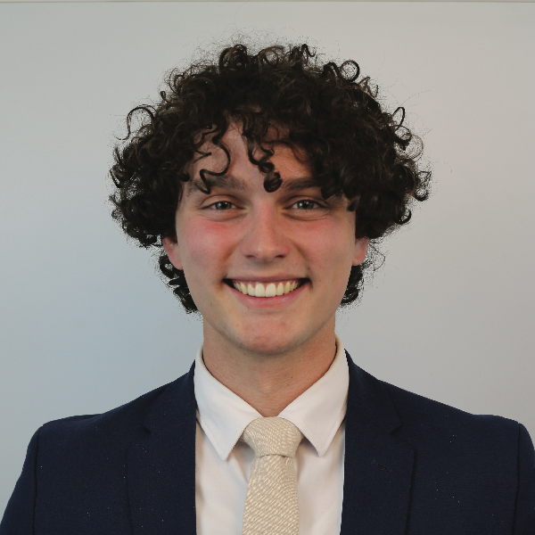

Bartel Van Oostendorp

Bigger, Phatter, More Audacious Phage Project

Bartel Van Oostendorp, Christopher C Harrell, Austin M Johnson, Jayden S Longhurst, Payson C Danielson, Natalie A Olsen, Jensen T Berquist, Truman D Stohl, Seth P Tower, Donald P Breakwell, Brett E Pickett

Our goal for the 2024-2025 BYU Phage Hunters class was for each student researcher to find a phage. We report the discovery of 21 bacteriophages infecting Mycobacterium smegmatis mc^2155. Following purification, high titer lysates (>10^8 pfu/ml) were prepared, and scanning electron micrographs were taken. Paired-end sequencing reads were generated using an Illumina platform, and the genomes were assembled. Data showed that the phage genomes belonged to clusters/subclusters A1, B1, F1, E, F2, K4, and J and ranged in size from 48,971-111,904 bp with an average length of 60,601 bp. Of the 30 phages imaged, all displayed siphovirus-like morphology. 18 of these genomes have been manually evaluated and 22 have been computationally annotated. This effort represents an unprecedented number of bacteriophages sequenced at one time in this program at BYU and the widest level of subcluster diversity.