DO NOT CONSIDER FOR TALK

2025 SEA Symposium Abstract

Lehigh University

Bethlehem PA

Corresponding Faculty Member: Vassie Ware (vcw0@lehigh.edu)



Chelse Owate

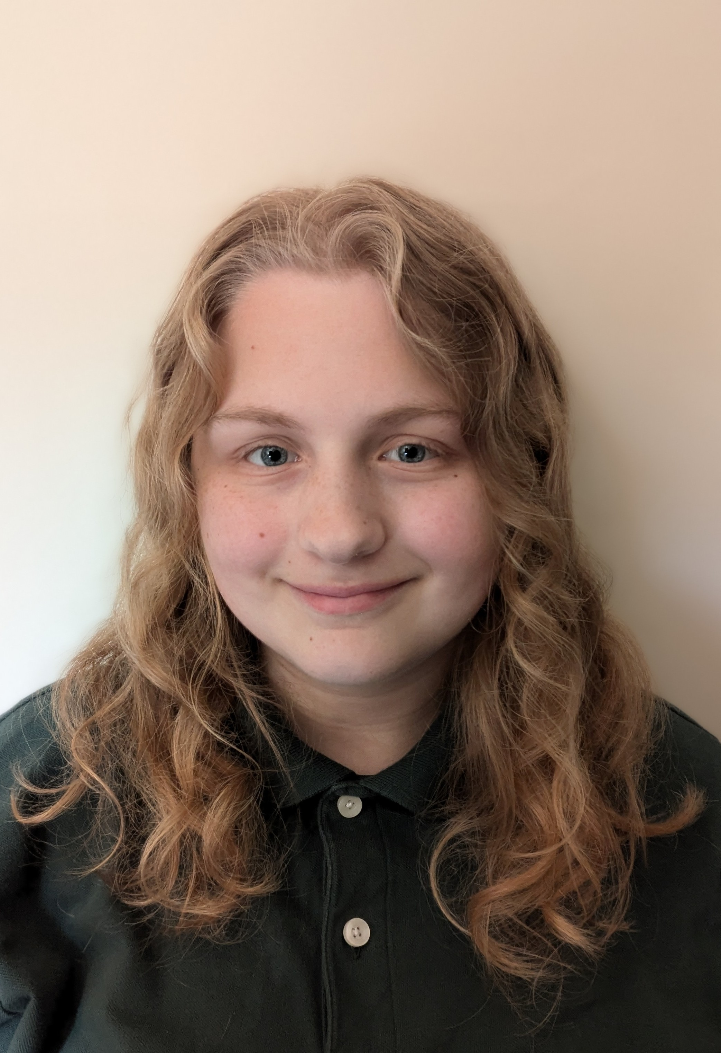

Claire Wilson

Beyond the First SEA: Advanced Phage Research Explorations at Lehigh University

Chelse Owate, Claire Wilson, Ella Billman, Odinakachukwu Dibor, Makenzie Lehman, Mokhinur Kodirova, Sruthvika Kandru, Megan Thomas, Leah Stern, Liana Woo, Nabeel Rifai, Matthew Diaz, Mia Miranda, Lake V Palmeri, Nikki Pastercyzk, Dagmara Jakubowska, Stephen Mensah, Vassie C Ware

Lehigh’s SEA-PHAGES and SEA-GENES programs provide opportunities for first year and advanced undergraduates to extend their discoveries and investigations about Actinobacteriophage biology in several courses throughout their academic career. Advanced phage research students are involved in a diverse set of projects, including mycobacteriophage genome annotations and comparative genome analyses, investigations of phage gene functions and phage-host interactions, and exploring immunity mechanisms governed by prophage-mediated gene expression primarily within cluster N lysogens. Projects included are: **I. Annotation of Mycobacterium smegmatis phages Doughnut (K2) and Etoile (P)**, sequenced as part of DOGEMS 2022 and 2023 samples, and identified from among over 30 phage candidates using contig-specific primers, PCR, and Sanger sequencing. **II. Investigation of Mycobacterium phage Kumao (singleton) lysogen establishment, and identification of roles of Kumao genes as putative immunity repressors in defense assays.** Kumao gene functions are under investigation in Lehigh’s SEA-GENES Program. Kumao forms a lysogen; a serine integrase (Kumao_CDS_95) has previously been annotated, but no immunity repressor has been functionally identified. We propose that a Kumao gene of current unknown function serves the role as immunity repressor. Based on functional annotation updates of Kumao, gene candidates (genes *3*, *4*, and *97*), cloned into pExTra for overexpression in *M. smegmatis*, will be tested in defense assays and analyzed for the efficiency of infection by Kumao. **III. Comparative immunity analyses for cluster N phages Journey, Smurph, and Charlie.** Mutational analysis of Journey gene *32* will test its role in prophage-mediated defense against Island3 and other cluster I1 phages. **IV. Lysogen production and immunity analyses for newly discovered M. smegmatis phages Volley227, EvieBunny, and Espoir.** **V. Analysis of M. smegmatis phage Lil75 from the DOGEMS 2024 pool** to determine its relationship to G cluster phage genomes identified in the pool. **VI. Investigation of Taptic gp29 as a putative ribosomal protein component in E. coli and M. smegmatis ribosomes.** **VII. Confirmation of cytotoxicity of cluster W Taptic genes** as a prelude to initiating bacterial two-hybrid analyses to uncover host protein interactors. **VIII. Functional analysis of cluster N phage Kevin1 genes 30 and 31** (details of this work are described on Lehigh poster entitled “Exploring the Function of Cluster N Mycobacteriophage Kevin1 genes *30* and *31* as a Putative Toxin-Antitoxin Gene Cassette”). Collectively, these ongoing research projects highlight research engagement by advanced phage research students at Lehigh University.