CONSIDER FOR TALK

2025 SEA Symposium Abstract

University of Ottawa

Ottawa

Corresponding Faculty Member: Adam Rudner (arudner@uottawa.ca)

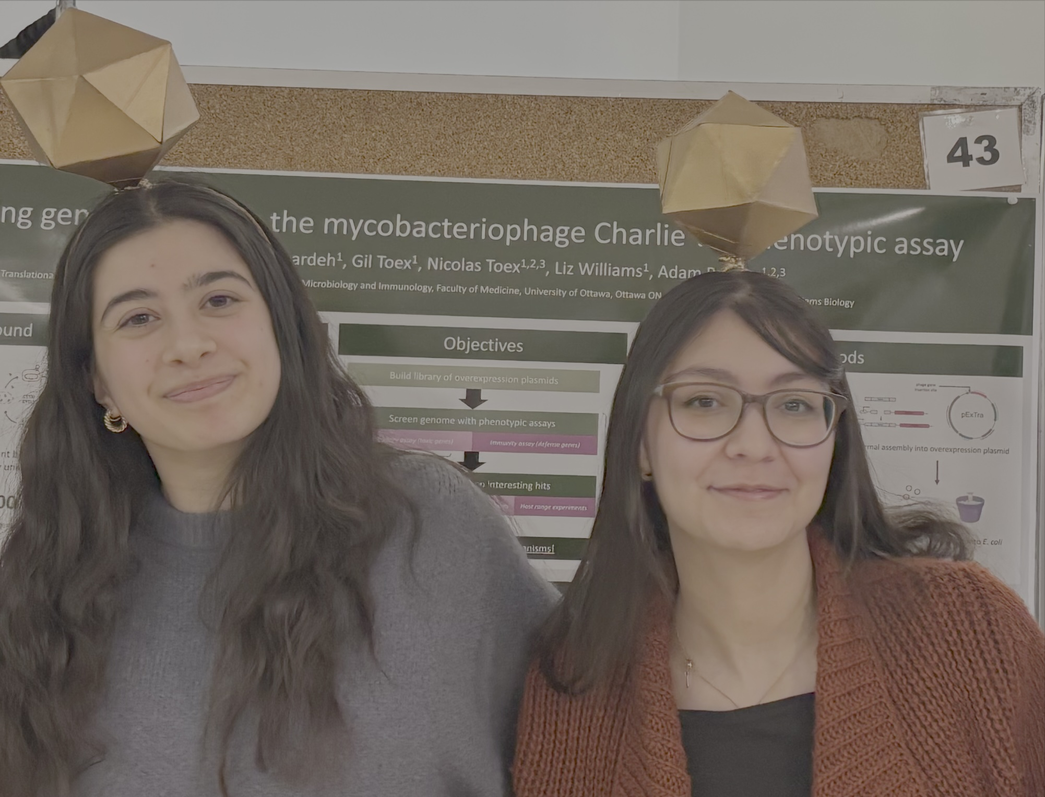

Emily Wood

Unlocking the Skin Microbiome: Isolating and Characterizing Skin-Sourced Bacteriophages for Phage Therapy

Emily Wood, Celina Tanbari, Ali Issa, Elizabeth C Williams, Adam D Rudner

Medical device-associated infections are among the most common type of hospital-acquired infections and represent a major challenge in modern healthcare. Periprosthetic joint infections (PJIs), occurring after joint replacements, are a common and particularly destructive implant-associated infection. *Staphylococcal* species, and in particular *Staphylococcus epidermidis*, are responsible for more than 50% of hip and knee PJIs. *S. epidermidis* is the most abundant bacterial species found on skin and mucous membranes, and while typically harmless, it can become pathogenic when it forms biofilms on implanted medical devices, causing destructive infections. Biofilm formation is the primary virulence factor of *S. epidermidis* and the complex structure of the biofilm allows evasion of host-immunity and antibiotics. The antibiotic-resistant nature of bacterial biofilms highlights an urgent need for alternative treatments, with phage therapy (PT) emerging as a promising option. Bacteriophages (phages) are viruses that infect bacteria and are specific to the bacteria they infect; thus, specificity is crucial to PT success, and therapeutic phages are often matched to a specific pathogenic bacterium. Although 200 *Staphylococcal* phages have been reported, only ~10% can infect *S. epidermidis*.  
  
The long-term aim of this study is to generate a biorepository of *S. epidermidis* bacteriophages with potential for use in PT. Our work follows three aims:  
  
Aim 1) Phage hunting and genome characterization. We have isolated 36 novel bacteriophages from human skin swab samples on several laboratory strains of *S. epidermidis*. We have purified 25 genomes, analyzed them by restriction digest, and imaged the phages by transmission electron microscopy (TEM). Additionally, a subset has been genome sequenced by nanopore long-read sequencing and/or Illumina sequencing and we are in the process of sequencing the entire collection.  
  
Aim 2) Host-range and activity against biofilms. To further evaluate infectious activity of our collection, we are examining phage-host specificity evaluated through host-range assays on 12 laboratory *S. epidermidis* strains. Results of these assays demonstrate variable infectivity, with some phages exhibiting broad host-range activity against multiple *S. epidermidis* strains. Additionally, a subset displays strong infection against a *S. succinus* species. Our 12 *S. epidermidis* phage isolation strains form biofilms efficiently, and we have shown that several phages successfully inhibit biofilm formation at varying MOI’s of 0.1 to 100, suggesting their potential utility in treating biofilm-associated infections.   
  
Aim 3) PT characterization. Future directions will involve testing a diverse subset of our phage collection against clinical isolates from patients with persistent PJIs at The Ottawa Hospital. This will provide insights into the in vivo efficacy of these phages and their potential application in clinical PT settings.