DO NOT CONSIDER FOR TALK

2025 SEA Symposium Abstract

Saint Leo University

Saint Leo FL

Corresponding Faculty Member: Iain Duffy (iain.duffy@saintleo.edu)



Juan Jimenez

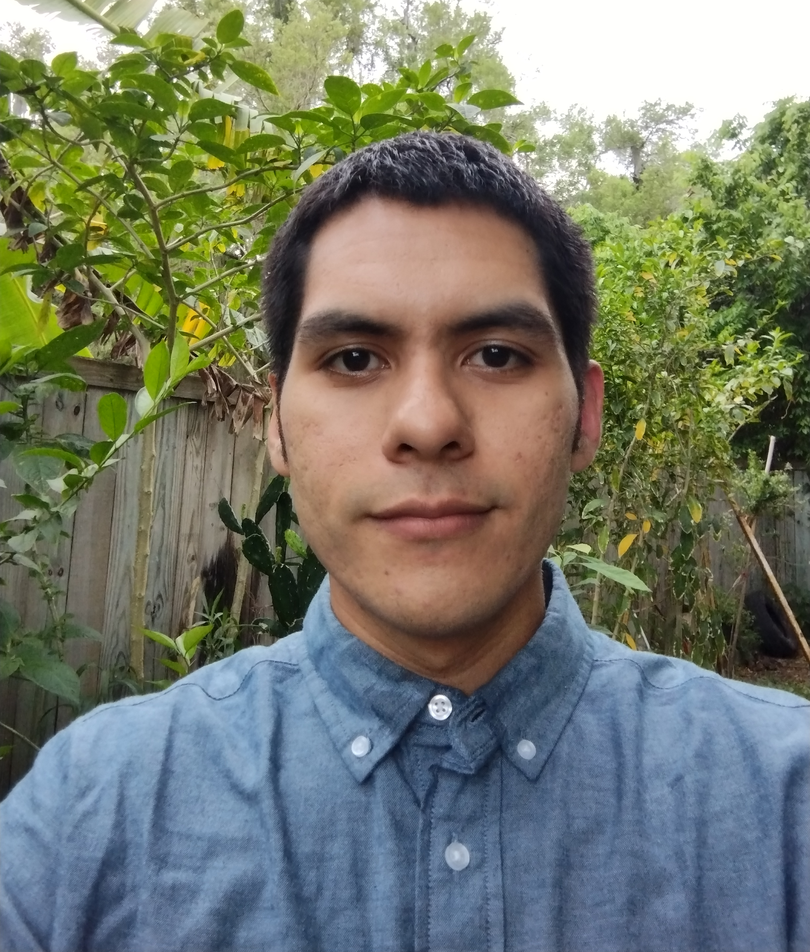

Luis Gomez

Genomic Characterization of Novel Actinobacteriophages Related to the EL Cluster

Juan Jimenez, Luis Gomez, Michael Tracey, Miranda Galaviz, Isabell Colon, Estrella Hernandez, Dalia Morales, Malak Aly

Bacteriophages play a crucial role in microbial ecology and evolution, yet many remain uncharacterized. Here, we report the isolation and genomic analysis of novel phages infecting Actinomycetia bacteria. Phages were recovered from soil samples using enrichment in Pyca broth, filtration, and subsequent infection assays on a panel of twenty-eight closely related bacterial hosts. Plaques were purified, and genomic DNA was extracted for sequencing using the Oxford Nanopore MinION MK1B, following library preparation with a Native Barcoding Kit. Genomic sequences were analyzed via the Galaxy platform, and taxonomic classification was performed using BLAST. Among the phages identified, they exhibited high similarity to the EL cluster, a rare group with only four previously sequenced representatives in the PhagesDB database. Comparative genomic analysis revealed key similarities and differences between our isolates and known EL cluster phages, expanding our understanding of their diversity and evolutionary relationships. Our findings provide insights into the genomic composition of EL-like phages and their potential roles within microbial communities.