DO NOT CONSIDER FOR TALK

2025 SEA Symposium Abstract

Drexel University

Philadelphia PA

Corresponding Faculty Member: Alison Moyer (aem442@drexel.edu)

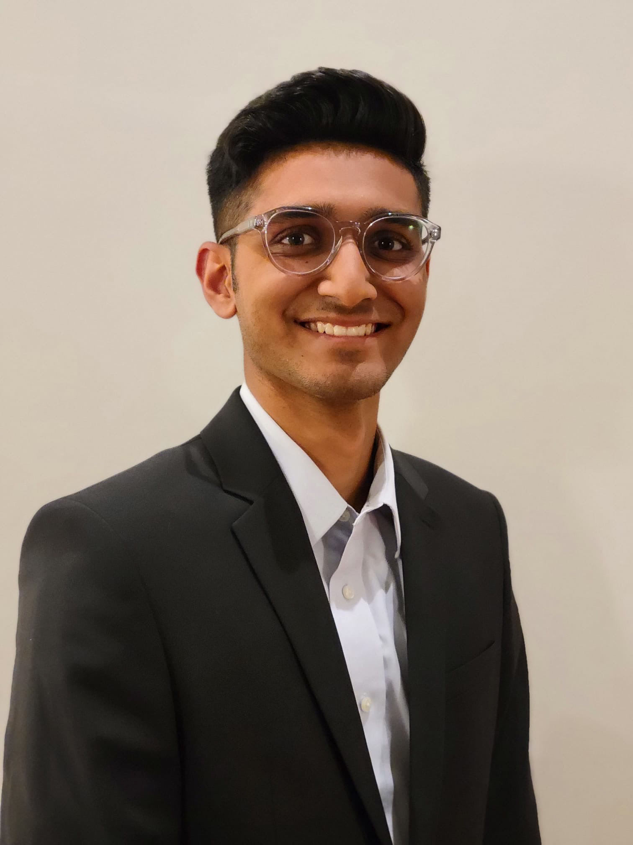

Neil Patel

Annotation Announcements: Investigation into Pham 187115 Proteins Leads to Request for Updated Function Call

Neil Patel, Harshitha Aikolanda, Harshika Aleti, Jack Andolsen, Pranav Arora, Saloni Bansal, Sreya Bhattacharyya, Rohan Biswas, Addy Borhade, Fiona Chen, Ryan Deng, Dylan Dolan, Winnie Dong, Karen Ejikonye, Ben Elder, Amiri Ettinger-Finley, Manija Fazliddinova, Suhas Ghatti, Talha Ghumman, Kaleigh Gillis, Jordyn Goss, Keshav Gurushankar, Logan Hays, Alina Hernandez, Sabrina Huang, Jeslynne Jayady, Aditi Jayanth, Ty Jozefick, Manvita Kakarla, Maydha Kanchrakuntla, Sanjana Karthik, Vansh Kaur, Jerome Kim, Julia Kim, Andrew Luisi, Kaitlin Mackaravitz, Mitra Mahadevan, Jia Majumder, Riddhi Mallela, Anjana Manicka, Samarth Mannikeri, Rhea Masand, Tara McHale, Jyoti Mehta, Lunisa Muzhaqi, Geethalakshmi Nurani Venkattaraman, Madison O'Brien, Ram Rishi Pagadala, Ananya Paladugu, Keya Patel, Khushi Patel, Nanea Perales, Bao Khoa Phan, Nguyen Phan, Rohan Potla, Khushi Ramteke, Samadhi Ranaweera, Meghan Reisbord, Medha Rudraraju, Elisha Salik, Shravan Sekhar, Nicole Simmons, Anush Singh, Kaushik Sivakumar, Kendall Skeete Ridley, Nicholas Teixeira, Sehaj Verma, Nishi Vyas, Jae Walsh, Joyce Zheng, Ashleigh Browne, Julia Kovalski, Nina Mallalieu, Deana Mancuso, Laura Duwel, Matthew McDonald, Alison Moyer

This year students at Drexel University discovered 37 novel bacteriophages using Microbacterium foliorum NRRL B-24224 as a host. These phages were isolated and purified from soil samples collected near Drexel’s Philadelphia campus but also included samples from Philadelphia suburbs in Pennsylvania and New Jersey. Six of these novel Microbacterium phages were sequenced by the Pittsburgh Bacteriophage Institute: one from the EA4 subcluster (RenegadeRaider), two from the GA cluster (Phingu and PhillyJawn), and one from the EB cluster (PhigPhack), one from the EC cluster (PhedwardCullen), and one from the EF cluster (Artiphact). All six produced lytic plaques but the GA cluster life cycle is unknown. All exhibit siphoviridae morphology determined by TEM. Bioinformatics analysis of these six genomes revealed high similarity to previously characterized phages in their respective clusters, with no distinguishing features identified to-date. However, during annotation students noted some of the gene products in PhillyJawn and Phingu, both members of the GA cluster, required more in-depth analysis to assign a function. To date, the GA cluster includes 17 phages, 8 of which are still drafts. Upon initial annotation, PhillyJawn_9 and Phingu_11 (both Pham 187115) were called as Hypothetical Proteins, following synteny with other members of the GA cluster. Other GA members call these genes MuF-like minor capsid protein, which has since been removed from the official function list. Further investigation into the potential protein function of the genes utilized information from the official forums at seaphages.org, including pertinent HHPred hits, and similarity to the homologous gene 5 in the DZ cluster phage Morgana (host Gordonia rubripertincta NRRL B-16540). In Morgana this gene was assigned as a capsid maturation protease and is situated between the portal protein and scaffolding protein. Upon collection of similar data compared to Morgana_5, genes PhillyJawn_9 and Phingu _11 were also assigned as capsid maturation protease. This research calls for extra attention while annotating the functions of genes in Pham 187115, particularly in Clusters GA and DZ.