CONSIDER FOR TALK

2025 SEA Symposium Abstract

University of North Texas

Denton TX

Corresponding Faculty Member: Lee Hughes (lhughes@unt.edu)

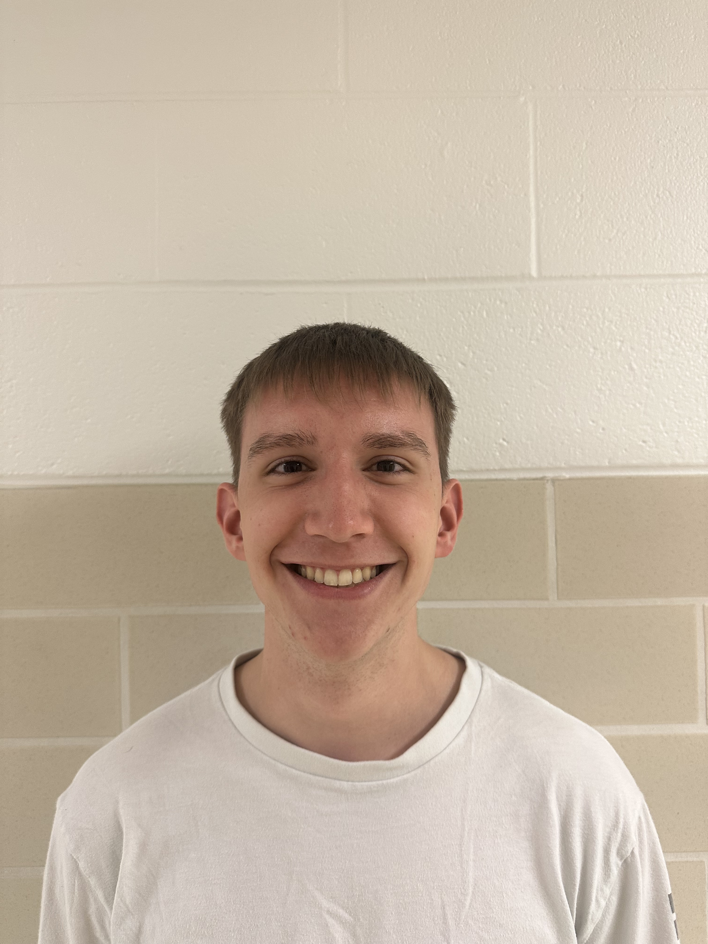

Everett Kugler



Kirrily Carver

Genomic and Biological Characterization of Bacteriophage Lishka, a Subcluster BC3 Streptomyces Phage

Everett Kugler, Kirrily Carver, Ahmad Sulaiman, Lee E Hughes

Bacteriophages (phages) are viruses that infect bacteria. In this study, bacteriophage Lishka was isolated using *Streptomyces antibioticus* UNT16F3 as the host. Lishka was from a soil sample in Denton, TX, producing clear, circular plaques approximately 1 mm in diameter. It was processed following the Streptomyces Phage Discovery Guide (2017), including isolation, purification, amplification, and DNA extraction. Lishka did not exhibit lysogeny and successfully infected 3 out of 8 Streptomyces strains in host range analysis. Lishka’s genome was sequenced using Illumina NextSeq 1000 at the Pittsburgh Bacteriophage Institute. It was classified as a temperate phage within the Siphoviridae family and assigned to subcluster BC3. Its genome is 36,221 bp long, with a GC content of 72.6%, characteristic of BC3 phages. Annotation conducted using PECAAN, GeneMark, Glimmer, HHPred, NCBI BLAST, PhagesDB BLAST, Phamerator, Starterator, and Deep TMHMM, identified 53 genes with no tRNA.This study contributes to the expanding catalog of Streptomyces phages, providing insights into their diversity, genomic features, and host interactions.