DO NOT CONSIDER FOR TALK

2025 SEA Symposium Abstract

University of Maryland, Baltimore County

Baltimore MD

Corresponding Faculty Member: Steve Caruso (scaruso@umbc.edu)

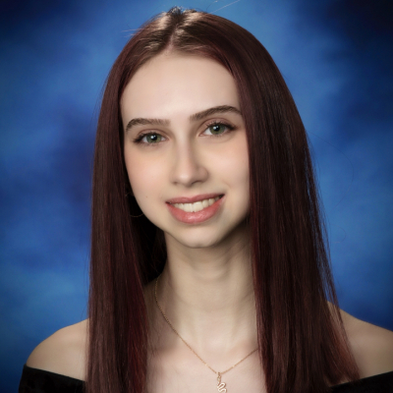

Alena I Sagalovsky



Aniket Camarushi



Abdullah Shahzad



Nicholas D Nguyen



Daniel Mirahmadian



Gilbert Hernandez

Characterization and Genomic Analysis of Bacteriophage Riptide: A Novel Siphovirus with a Potential Ribosomal Protein Homolog

Alena I Sagalovsky, Aniket Camarushi, Abdullah Shahzad, Nicholas D Nguyen, Daniel Mirahmadian, Gilbert Hernandez, Elana L Frazier, Steven M Caruso

Bacteriophages are integral to bacterial evolution, host-pathogen interactions, and biotechnology. In this study, we isolated and characterized the bacteriophage Riptide from a flowerbed soil sample collected in Odenton, Maryland, as part of the SEA-PHAGES program at UMBC in Fall 2024. Transmission electron microscopy (TEM) identified Riptide as a siphovirus, characterized by a long, noncontractile tail and a distinct head morphology. Plaque morphology analysis revealed that Riptide forms round, slightly turbid plaques with an average diameter of 2 mm, suggesting a potential lytic life cycle. Host range testing across multiple *Streptomyces* strains indicated broad infectivity, suggesting diverse bacterial surface receptor mechanisms. To further investigate its genetic composition, Riptide’s genome was sequenced at the Pittsburgh Bacteriophage Institute and annotated using BLAST, HHPred, and DNAMaster at UMBC. Genomic analysis revealed 238 protein-coding genes and 39 tRNA genes. Notably, we identified a novel gene encoding a potential protein with structural similarity to Cryo-EM structure of *Thermococcus kodakarensis* 70S ribosomal protein. BLAST and HHPred analyses demonstrated similarity with bacterial ribosomal proteins, with sequence identity percentages ranging from 25–35%, suggesting a possible functional role in translation-related processes. While ribosomal-associated genes are rare in bacteriophages, their presence raises intriguing questions about phage-host interactions and potential phage-mediated translational regulation. Further investigation into its structural properties and potential interactions may contribute to understanding phage-host dynamics and ribosomal-associated processes.