DO NOT CONSIDER FOR TALK

2025 SEA Symposium Abstract

Southern Connecticut State University

New Haven CT

Corresponding Faculty Member: Nicholas Edgington (EdgingtonN1@SouthernCT.edu)

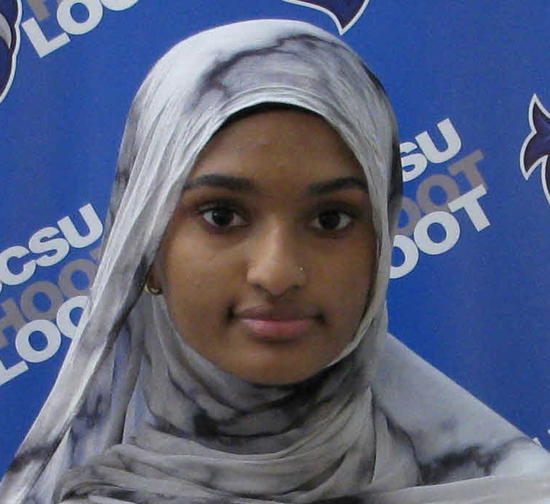

Safeya Abdulla



Yasmin Williams

A review of a temperate Cluster FA phage 'Pucara' from the host Arthrobacter, and a lytic Cluster EF phage 'Snakehole' that infects Microbacterium foliorum.

Safeya Abdulla, Yasmin Williams, Alam Mahir, Sydney Bennett, Erik Galvin, Johniece Jones, Pirnaaz Mekael, Arber Muca, Taylor Roberts, J.D. Starkey, Vanessa Tlalpan-Barrales

We will present the results of a thorough review of previous annotations of bacteriophages 'Pucara'(Cluster FA) and 'Snakehole'(Cluster EF). We have collected genome-wide statistics to summarize the changes and improvements to the previously annotated phages from SCSU. A few interesting findings will also be presented.