DO NOT CONSIDER FOR TALK

2025 SEA Symposium Abstract

Coastal Carolina University

Conway SC

Corresponding Faculty Member: Daniel Williams (dwilliams@coastal.edu)

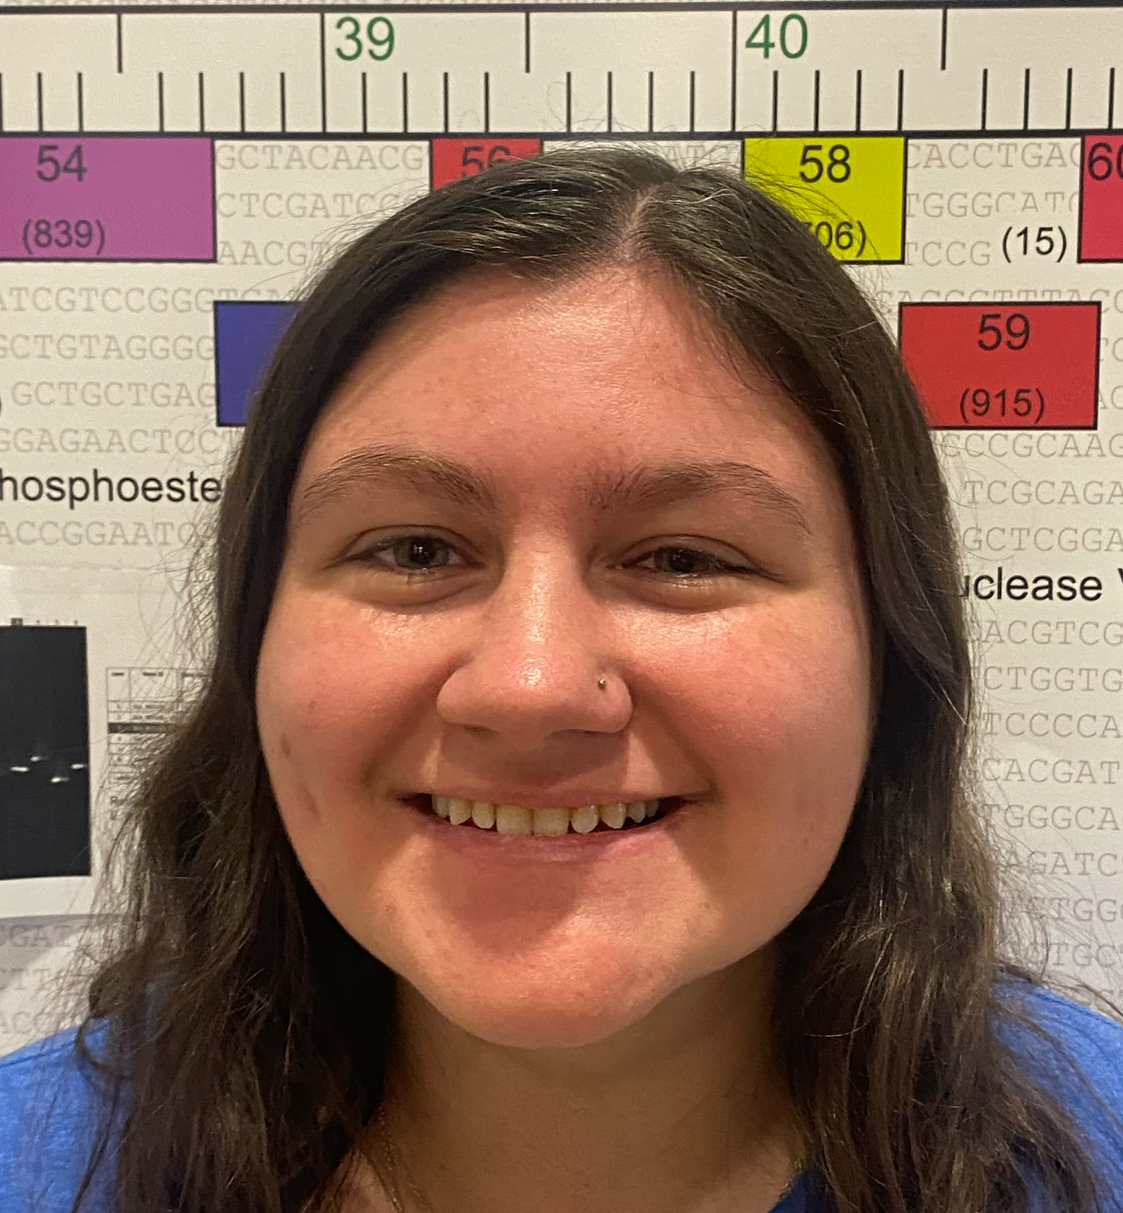

Brenna Adams

Discovery and Characterization of the B3 Lytic Phage SwainyDoc

Brenna Adams

SwainyDoc was discovered in Phage Discovery at Coastal Carolina University in the Fall of 2024. A soil sample was collected outside of Swain Hall and used for enriched isolation on *Mycobacterium smegmatis* as a host. SwainyDoc was subsequently purified by picking individual plaques and amplified by flooding webbed plates. Plaque assay of purified SwainyDoc resulted in uniform plaques sizes that were completely clear with regular borders, suggestive of a non-temperate phage. This was verified by preforming a spot test with high-titer lysate, which revealed lack of mesas that are consistent with a lytic phage. DNA was extracted from SwainyDoc high-titer lysates and treatment with BamHI, but not EcoRI or HindIII resulted in a large number of bands by agarose gel electrophoresis. SwainyDoc was visualized using electron microscopy and has Siphoviridae morphotype with a long flexible tail. Sequencing of SwainyDoc DNA revealed a genome of 68,881 base-pairs and a GC content of 67.5%. SwainyDoc is assigned to the B3, and phages of this subcluster are characterized as being lytic. Future research is aimed at genome annotation and comparison with other B3 phages.