CONSIDER FOR TALK
8th Annual SEA-PHAGES Symposium Abstract
Lincoln University
Lincoln University PA
Corresponding Faculty Member: David Royer (royer@lincoln.edu)
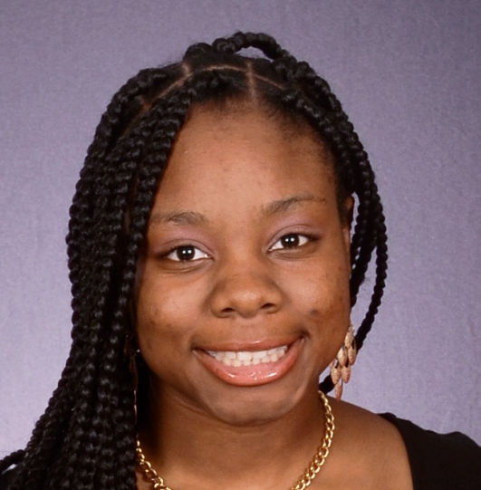
JorDonna A Frazier
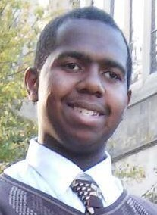
Jarrett A Brown
Jordennis, a newly annotated A6 subcluster bacteriophage
JorDonna A Frazier, Jarrett A Brown, Kelli V Davis, Audrey G Smylie, Anna K Hull, David F Royer
Jordennis, an A6 subcluster bacteriophage, was isolated from a soil sample collected in Upper Marlboro, Maryland as part of a Phage Hunters class offered during the 2015-16 academic year at Lincoln University (Pennsylvania). Jordennis is similar to other A6 subcluster phages in genome length, GC content and number of genes. It produces bulls-eye, polymorphic plaques. It is a member of the Siphoviridae with a characteristic long tail (125nm) and a head with a 62nm diameter. The annotation revealed 98 genes, of which 43 were assigned a putative function based on comparisons with other A6 mycobacteriophages using BLASTP assignments from both phagesdb.org and GenBank. Of the 43 genes assigned a function, 16 coded for structural proteins and 27 coded for functional proteins. A programmed translational frameshift involving genes 24 and 25, tail assembly chaperones, was identified. Three tRNA genes are present in the genome, specifying asparagine, glycine and tryptophan, and are found in all the other A6 subcluster phages that have been annotated.

