DO NOT CONSIDER FOR TALK
2025 SEA Symposium Abstract
Lehigh University
Bethlehem PA
Corresponding Faculty Member: Margaret Kenna (makg@lehigh.edu)
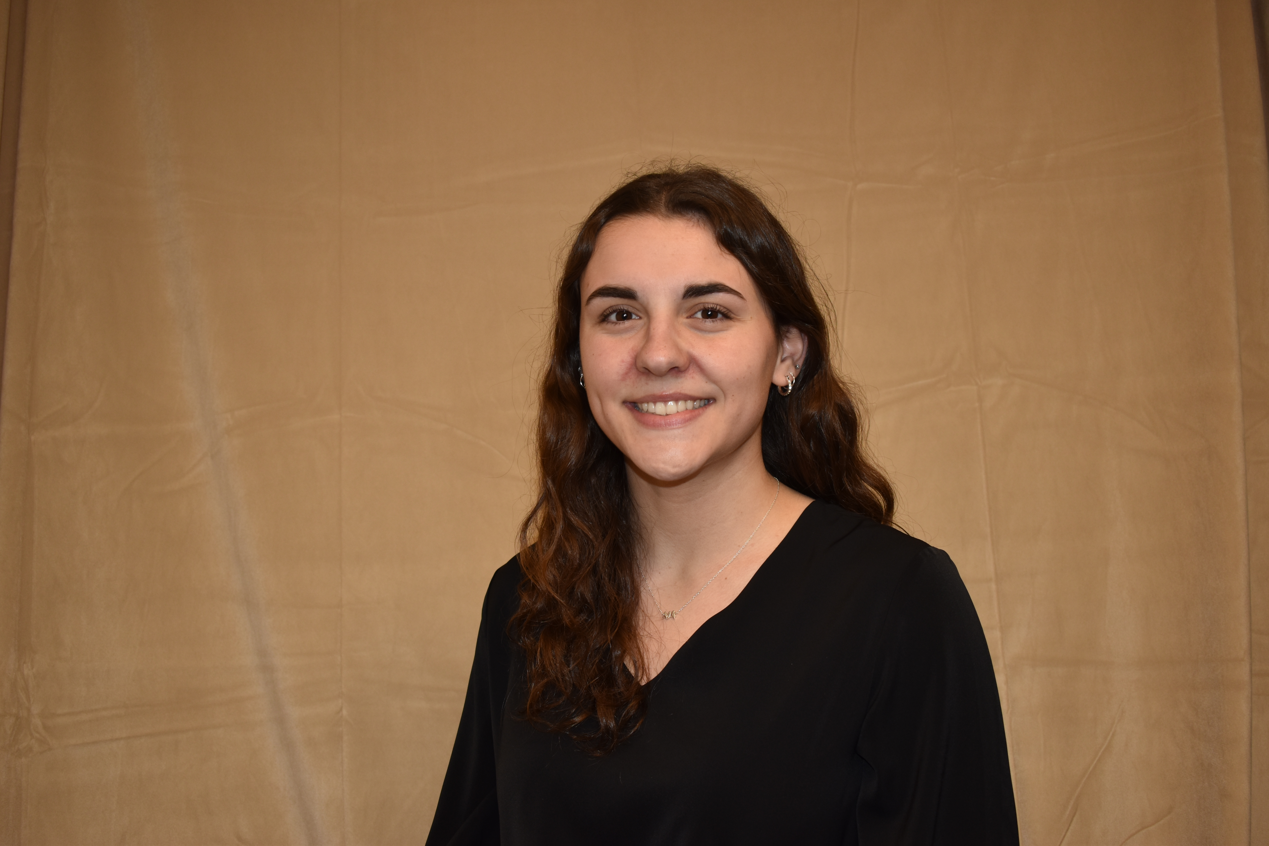
Ella Billman
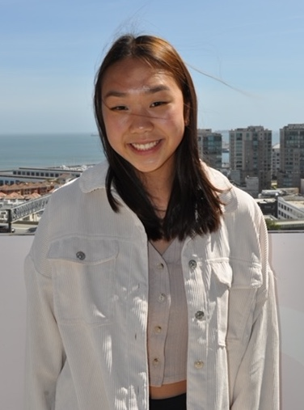
Chloe Chan
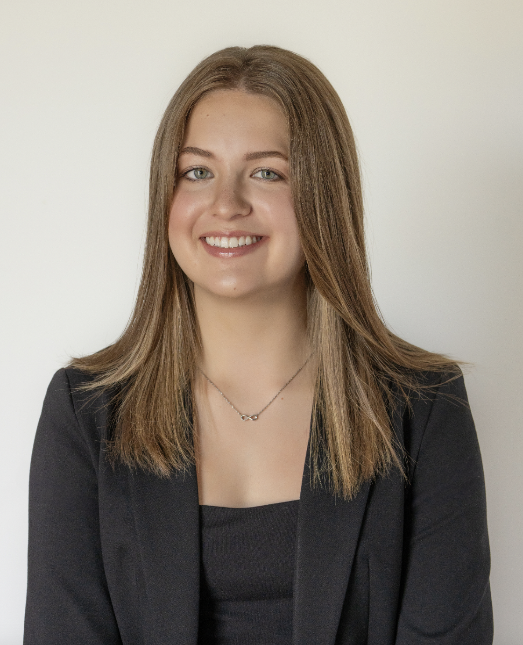
Megan Thomas
Investigating Mycobacteriophage Genomic Relationships and Immunity Patterns
Ella Billman, Chloe Chan, Emily Farely, Lei Helton, Megan Thomas, Aaron Colon, Kelsey Corbett, Henry Dabuo, Anthony Garcia, Hannah Golubchik, Natalie Kam, Miranda Lynch, Kenya Nava, Julianna Ouimette, Tiya Patel, Nabeel Rifai, Loba Salami, Jonathan Sferratore, Cyrilstan Sowah-Nai, Leah Stern, Braylon Ware, Liana Woo, Stephen Mensah, Kayli Silimperi, Margaret Kenna, Vassie Ware
In 2024, Lehigh University's SEA-Phages program (16th year) isolated and characterized 21 novel Mycobacterium smegmatis phages, including Hanako (N) and Vagabond (O), which were sequenced and annotated. Six Mycobacterium phages were identified as myoviridae based on their EM morphotype. DOGEMS sequencing from 2 separate pools of phages, identified 2 of the myoviridae, Chanfam4 and Gambett, as members of Cluster C1. DOGEMS sequencing also revealed two distinct G1 phages (from these same pools) that had previously been discovered by students at other institutions. Two phages from Lehigh, LegendLarry and Vaani, were found to be 100% identical to Peeb and Avrafan, respectively. Peeb- and Avrafan-specific primers were designed, and PCR analysis was performed to identify which lysates from the class matched Peeb and Avrafan. Preliminary results indicated that LegendLarry corresponds to Peeb and Vaani to Avrafan, with ongoing experiments to confirm or exclude other candidates with similar PCR results. Comparative genomics of Hanako and Vagabond will be presented. Temperate phages were identified by plaque morphologies, and bacterial lysogens were isolated through halo testing and supernatant release assays. Immunity relationships between phages were also explored, helping to refine cluster predictions for other phages.

