CONSIDER FOR TALK

2025 SEA Symposium Abstract

Coastal Carolina University

Conway SC

Corresponding Faculty Member: Daniel Williams (dwilliams@coastal.edu)



Ryan Albert

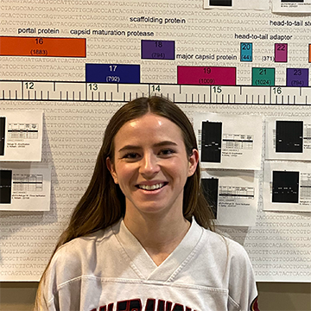

Madison Arno

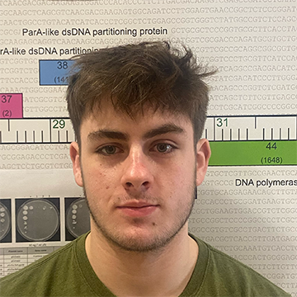

Brannon LaFrancis

Functional Characterization of the parABS Partitioning Cassette

Ryan Albert, Madison Arno, Brannon LaFrancis

Temperate phages are distinguished by whether prophage DNA is integrated into the host genome or exist as an extrachromosomal element that replicates and is maintained independent of the host genome. Many cluster A phages, including EmyBug and Refuge, are non-integrating temperate phages that encode a partitioning cassette, which facilitates stable inheritance of prophage DNA. Partitioning cassettes are comprised of tandemly oriented *parA* and *parB* protein encoding genes and a repetitive *parS* sequence immediately upstream *parA*. We are taking a molecular approach to better understand the functional significance and interaction of partitioning cassette components. First, we analyzed the cassette and assess its role in replication and propagation. The Refuge partitioning cassette was introduced into pExTra, replacing the canonical *M. smegmatis* origin of replication (*oriM*). Electroporation of this plasmid into *M. smegmatis* resulted in a similar number of transformants as pExTra, indicating the Refuge partitioning element can function as an origin of replication. Subsequent constructs were generated in which the Refuge partitioning cassette was inserted in the original pExTra. This plasmid, which contains both the partitioning cassette and *oriM*, was stably propagated in the absence of kanamycin antibiotic selection, Next, we placed partitioning cassette elements under control of the *Tet* promoter of pExTra to examine the effect phage gene expression on host cells. Expression of Refuge or EmyBug *parB* had no effect on cell growth, but expression of Refuge *parA* abolished cell growth. In addition, constructs which contain EmyBug *parA*, have been un-transformable, supporting the cytotoxic nature of *parA*. Plasmids with Refuge *parA-parB* are also cytotoxic. Significantly, cytotoxicity of Refuge *parA-parB* is abolished by addition of *parS* sequences and we have obtained transformants of EmyBug *parA-parB* that include a small part of *parS*. These results suggest *parS* and *parB* elements are critical for autoregulation of *parA*. Collectively these results demonstrate functional significance to partitioning cassettes and the generation of new molecular vectors for future heterologous expression studies.