DO NOT CONSIDER FOR TALK

2025 SEA Symposium Abstract

Western Kentucky University

Bowling Green KY

Corresponding Faculty Member: Rodney King (rodney.king@wku.edu)

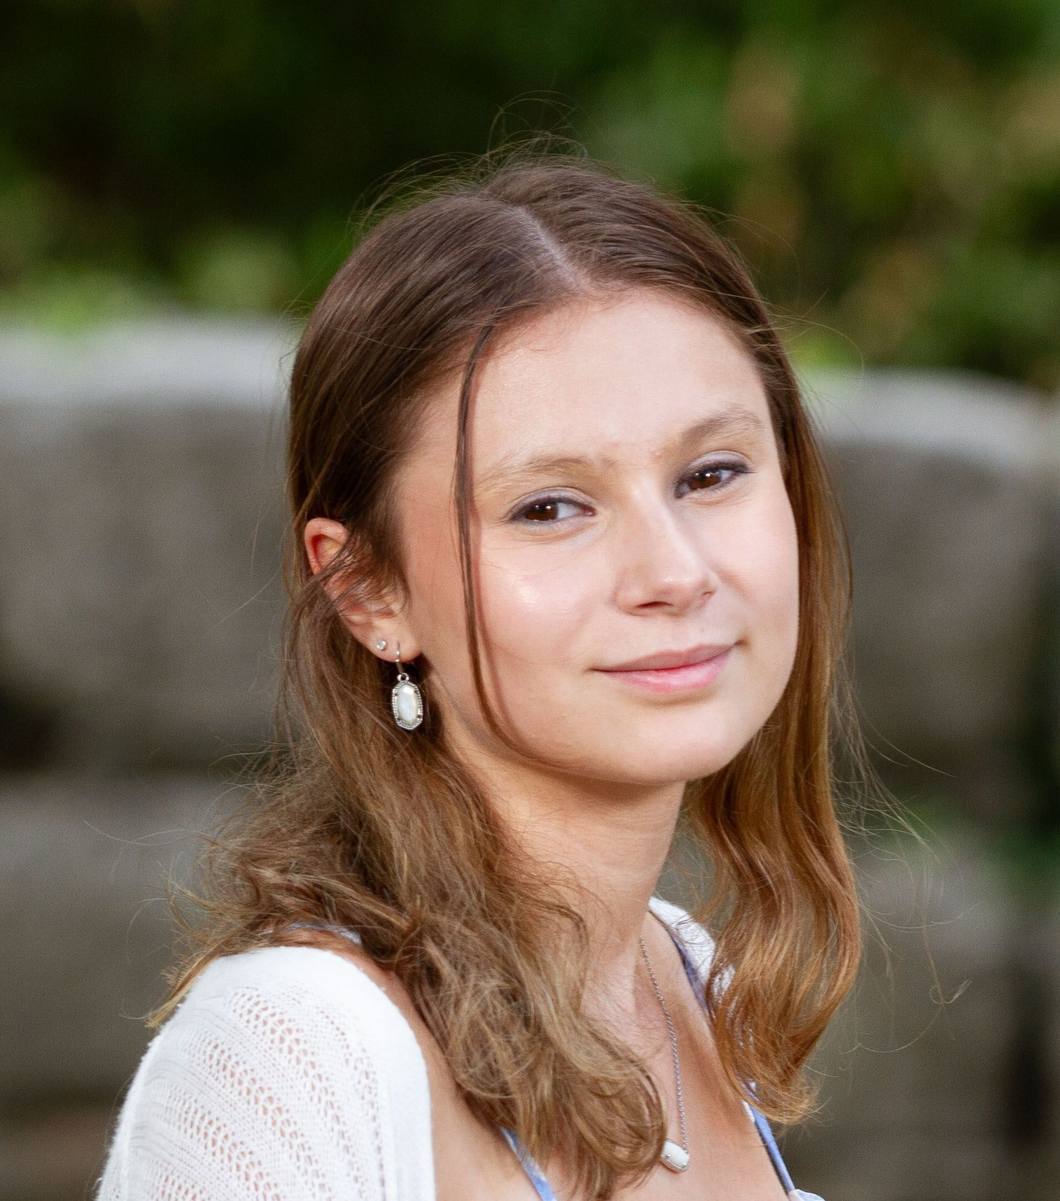

Alaina Arrollo

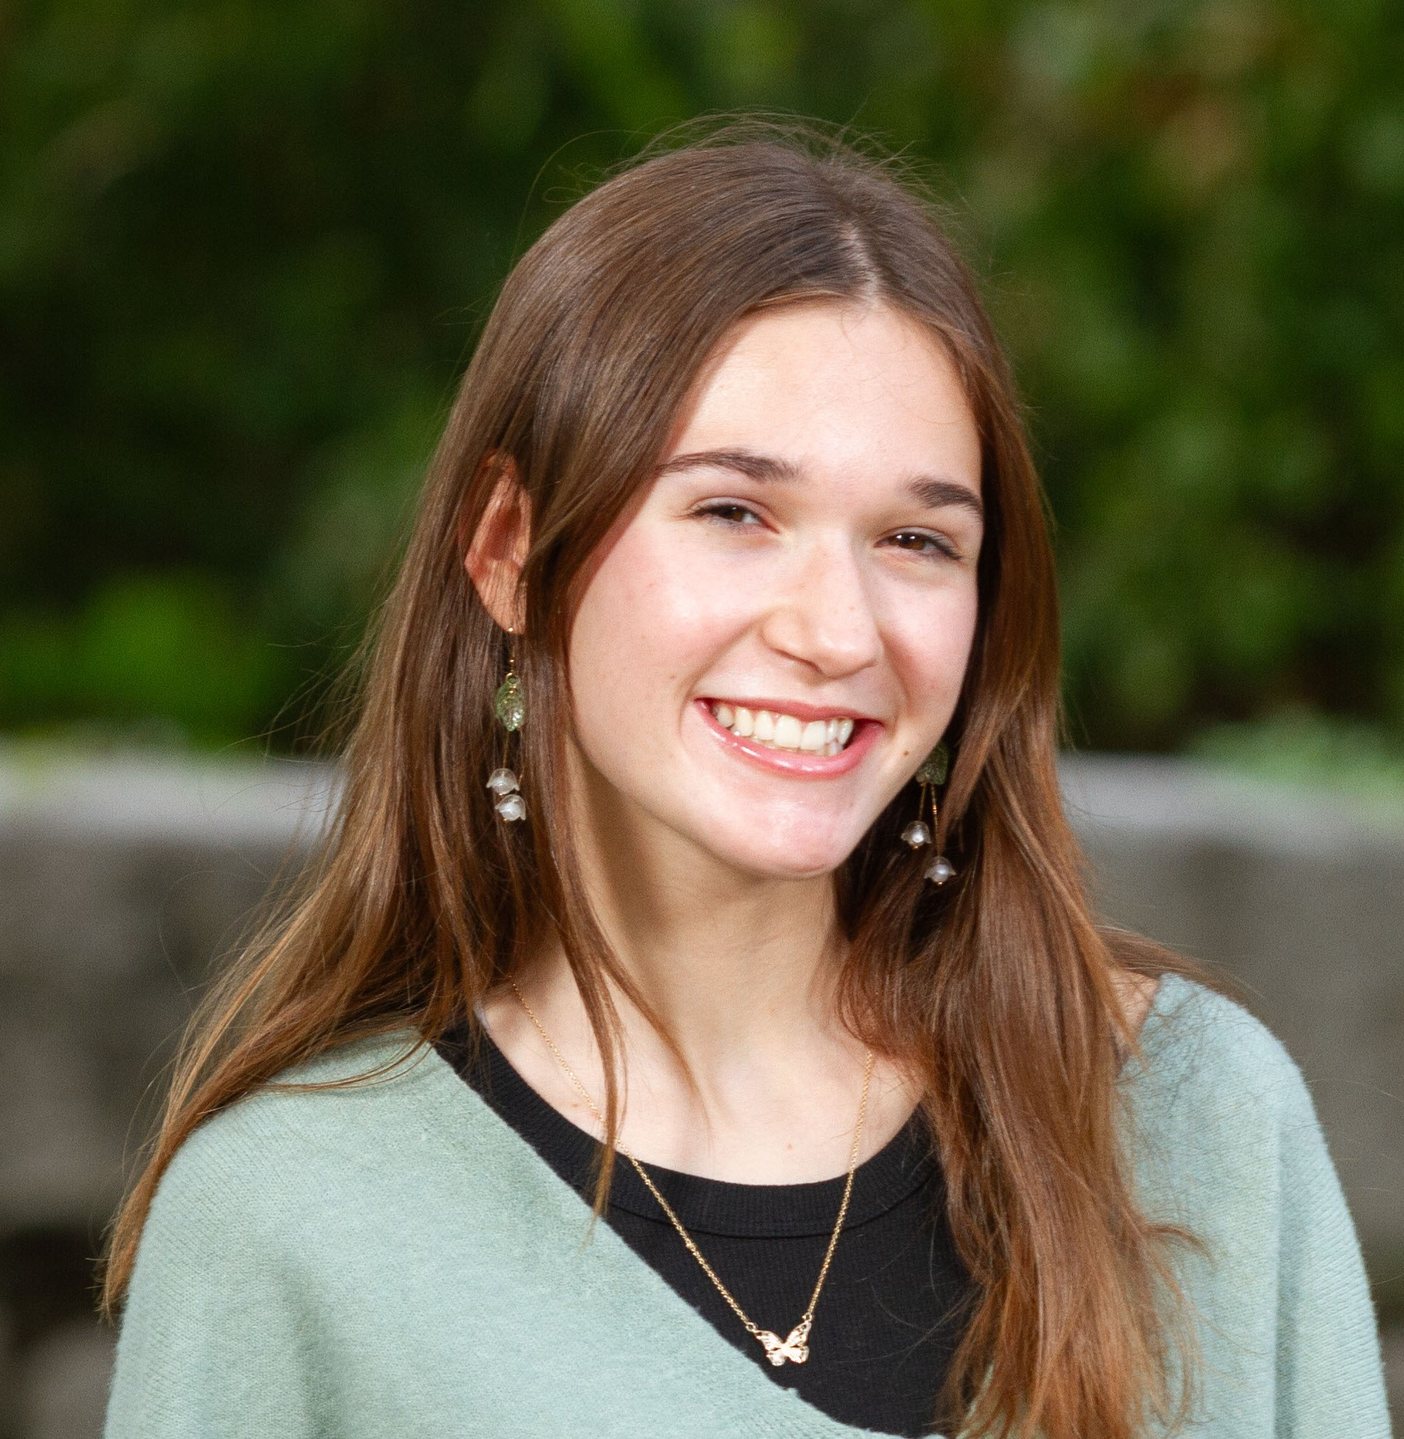

Lucy Gast

Genomic Analysis of Bacteriophage CallaLilly

Alaina Arrollo, Lucy Gast, Trisha Chhabra, Natalie Clark, Katie Clifford, Himani Gangumolu, Madison Gicale, Vidhi Grover, Sanam Krishnani, Logan Robinson, Ash Sheehan, Shelby Spencer, Nicholas Sugimoto, Ian Thoben, Sophia Thomas, Shadda Wood, Claire A Rinehart, Rodney A King

The largest reservoir of genetic information in the biosphere lies within the genomes of bacteriophages. Here, we describe the isolation and genomic characterization of bacteriophage CallaLilly, a phage isolated on the host bacterium Mycobacterium smegmatis (mc^2 155). CallaLilly produces plaques with clear centers and turbid halos after 48 hours of growth at 30oC. CallaLilly particles have a siphoviridae morphology with an average capsid diameter of 61 nm and an average tail length of 204 nm. The genomic sequence of CallaLilly was determined using the Illumina shotgun sequencing. The genome contains 59,631 base pairs of double- stranded DNA with a 11 bp 3’ overhang of (CTCGTAGGCAT) and a GC content of 66.5%. Based on sequence similarity with known mycobacteriophages, CallaLilly belongs to the K1 subcluster. The K1 subcluster of mycobacteriophages is composed of 115 members, with an average genome containing 59,930 bp, 95.3 genes, and 0.9 tRNAs. K1 subcluster phages are typically temperate and solely infect Mycobacterium hosts. The program PECAAN (Phage Evidence Collection and Annotation Network) was utilized for annotation. The databases and algorithms that PECAAN queries were used to help identify the function and start site of all potential genes. The CallaLilly genome is predicted to contain 95 genes and 1 tRNA. Forty-eight of the 95 genes have no known function. The presence of a tyrosine integrase gene supports the observed plaque phenotype and provides corroborating evidence that CallalLilly can form lysogens. This study extends our knowledge of the K1 subcluster and enriches the detail found in DNA sequence databases. Future research on individual phage proteins may allow their development as potential therapeutics that target antibiotic-resistant bacteria.