CONSIDER FOR TALK
8th Annual SEA-PHAGES Symposium Abstract
Calvin University
Grand Rapids MI
Corresponding Faculty Member: John Wertz (jwertz59@calvin.edu)
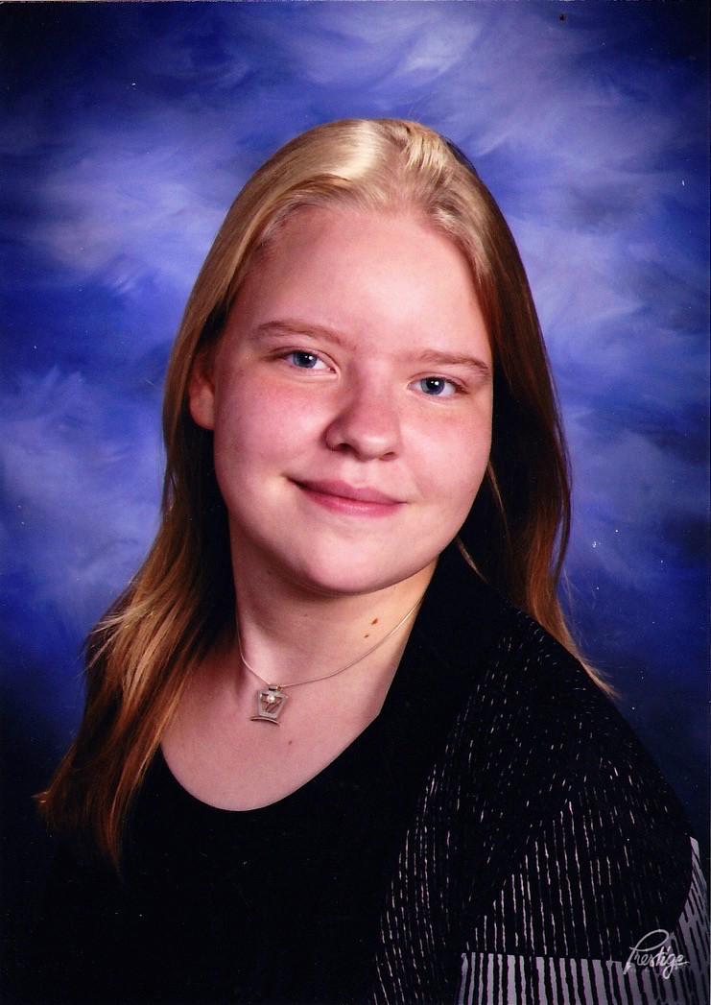
Gabrielle H Barthel
Mary R Horner-Richardson
Squashed and Soiled: Gordonia phage Cucurbita and continued discovery of enterobacteriophage novelty
Gabrielle H Barthel, Miranda F Bouwer, Maria L Emerson, Mary R Horner-Richardson, Hannah M Jasperse, Nathaniel L Johnson, Patrick B Jonker, Natalie A Knapp, Jamison L Koeman, Miles M Mason, Montana M Mason, Storm L Phillips, Harrison M Rice, Matthew D Rossler, Rachel E Scheeres, Amelia G Sterenberg, Samuel K VanderGriend, Kimberly A Vreugdenhil, Abigail M Stapleton, Randall J DeJong, John T Wertz
Using Gordonia terrae st. 3612 we isolated bacteriophage Cucurbita from soil that was heavily composted and covered by a squash plant (Cucurbita is Latin for squash). All enrichments from soil low in organic matter did not yield Gordonia terrae-infecting phages. Cucurbita has a capsid size of 80 nm and a tail length of 500 nm, and formed ragged-edged plaques of various sizes on PYCa agar. Cucurbita has a 93686 bp linear genome with a 10 nt 3’ overhang, is a member of the CQ cluster which contains Gordonia-only actinobacteriophages, and is most closely related to phage Bachita (99% identity). Of the 182 genes annotated in Cucurbita, 39 were functionally identified. Interestingly, three genes in Cucurbita are shared with the singleton Blueberry. One, a lysin, shares 84% nucleotide identity. The other two genes are found as a pair in both genomes (albeit in very different locations) and share 99.9% identity. BLAST and HHpred analysis reveal the genes are likely a pair of integrases/transposases, suggesting that Cucurbita may be a temperate phage. Gene sharing in two phages related solely by their host organism is highly suggestive of gene transfer between Gordonia phages. Furthermore, these integrase genes are rare in isolated phages, having been found in only 2 out of 267 sequenced Gordonia bacteriophages. Our Cucurbita annotation also contains eight tRNAs, two of which may be doubtful and the anticodon is undetermined. In addition to Cucurbita, we continue to isolate highly diverse enterobacteriophages from both soil and termite guts using the bacterial host Enterobacter st. D22. Phage Nephilim (termites) has the second largest phage genome annotated to date, at 388377 bp (including 16787 bp terminal repeat) and 697 genes. Its closest relative is phage Shasta (23% identity), isolated from soil at Calvin College in 2013. Phage Polynoma (soil and termites, 61928 bp, 76 genes) is most closely related to phage Sagirah (96% identity) isolated from termite guts, Calvin College, 2012. Phage Mundi (soil, 282182 bp, 318 genes) is most closely related to phage Smaug, from termite guts, Calvin College, 2013, with which it shares only 4 genes. Phage Scarn (soil, 260118 bp, 364 genes) is most closely related to Yersinia phage phiR1-37 (96%) isolated from sewage in Finland. Phage BAC-01 (soil, 62594 bp, 88 genes) has no matches in GenBank but is related to phage Ajabu (99%) from termite guts, Calvin College, 2014. Another measure of the diversity of these five phages is GC content, which ranges from 32.8% to 56.1%. Discovery of completely novel enterobacteriophages and placing additional phages within previously identified clusters provides insight into enterobacteriophage evolution and identifies those that are temporally conserved within the termite gut.

