CONSIDER FOR TALK

2025 SEA Symposium Abstract

Miami University

Oxford OH

Corresponding Faculty Member: Mitchell Balish (balishmf@miamioh.edu)

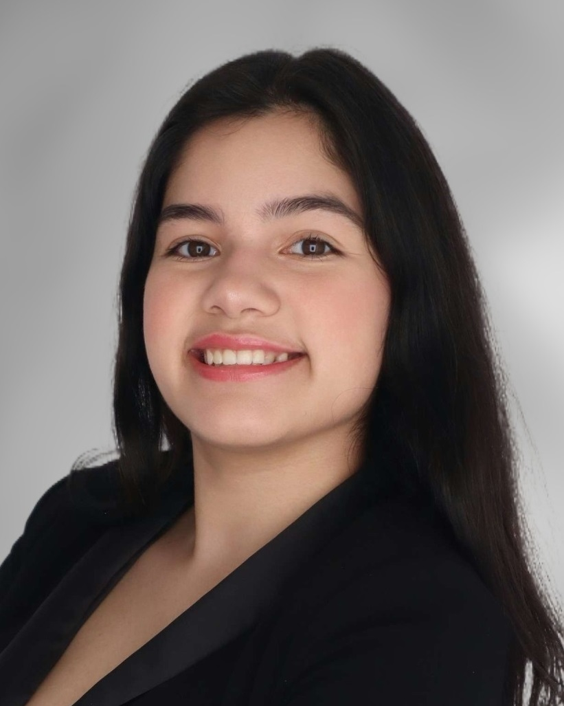

Michelle Arevalo Mira



Allison Day

Characterization of Microbacterium foliorum bacteriophages JimmyPG and KillerQueen from subclusters EK2 and EG

Madelynn Sharp, Charlotte DeLong, Michelle Arevalo Mira, Nishka Avunoori, Allison Day, Emily Ganz, Laia Guil Rodriguez, Emily Harris, Ashley Hartman, Natalie Kiepert, Grace Louderback, Gabriel Norton, Grace Obert, Arabella Shell, Isabelle Reitz, Vanessa Polster, Bailey King, Elyse Levenda, Rebecca Balish, Rachael Morgan-Kiss, Mitchell Balish

Two genomes from phages infecting *Microbacterium foliorum* discovered by students in the Miami University Bacteriophage Biology class were successfully sequenced. One, JimmyPG, was a subcluster EK2 podovirus with a genome size of 54,855 bp. JimmyPG was isolated from soil covered in leaf decay and a decomposing log on a trail in Peffer Park in Oxford, Ohio. Preliminary efforts indicate that it is most closely related to phages Mazun and Moleficent, though the left half of the genome includes at least four gaps in the alignments, reflecting divergent sequences within certain genes. These include the genes encoding DNA polymerase I, a Cas4 exonuclease, and two hypothetical proteins. One of these hypothetical proteins is an orpham with BLAST similarity to other proteins only in its C-terminal half. Complete annotation of this phage by the Bacteriophage Genomics class is underway. The other genome was the sole assembled output from a DOGEMS project with the DNA from the rest of the phages discovered by the class. It is in cluster EG and is quite similar to other phages in that cluster. This phage, which has high similarity to other cluster EG phages overall, was identified by PCR of all samples as KillerQueen.