CONSIDER FOR TALK

2025 SEA Symposium Abstract

Lehigh University

Bethlehem PA

Corresponding Faculty Member: Vassie Ware (vcw0@lehigh.edu)

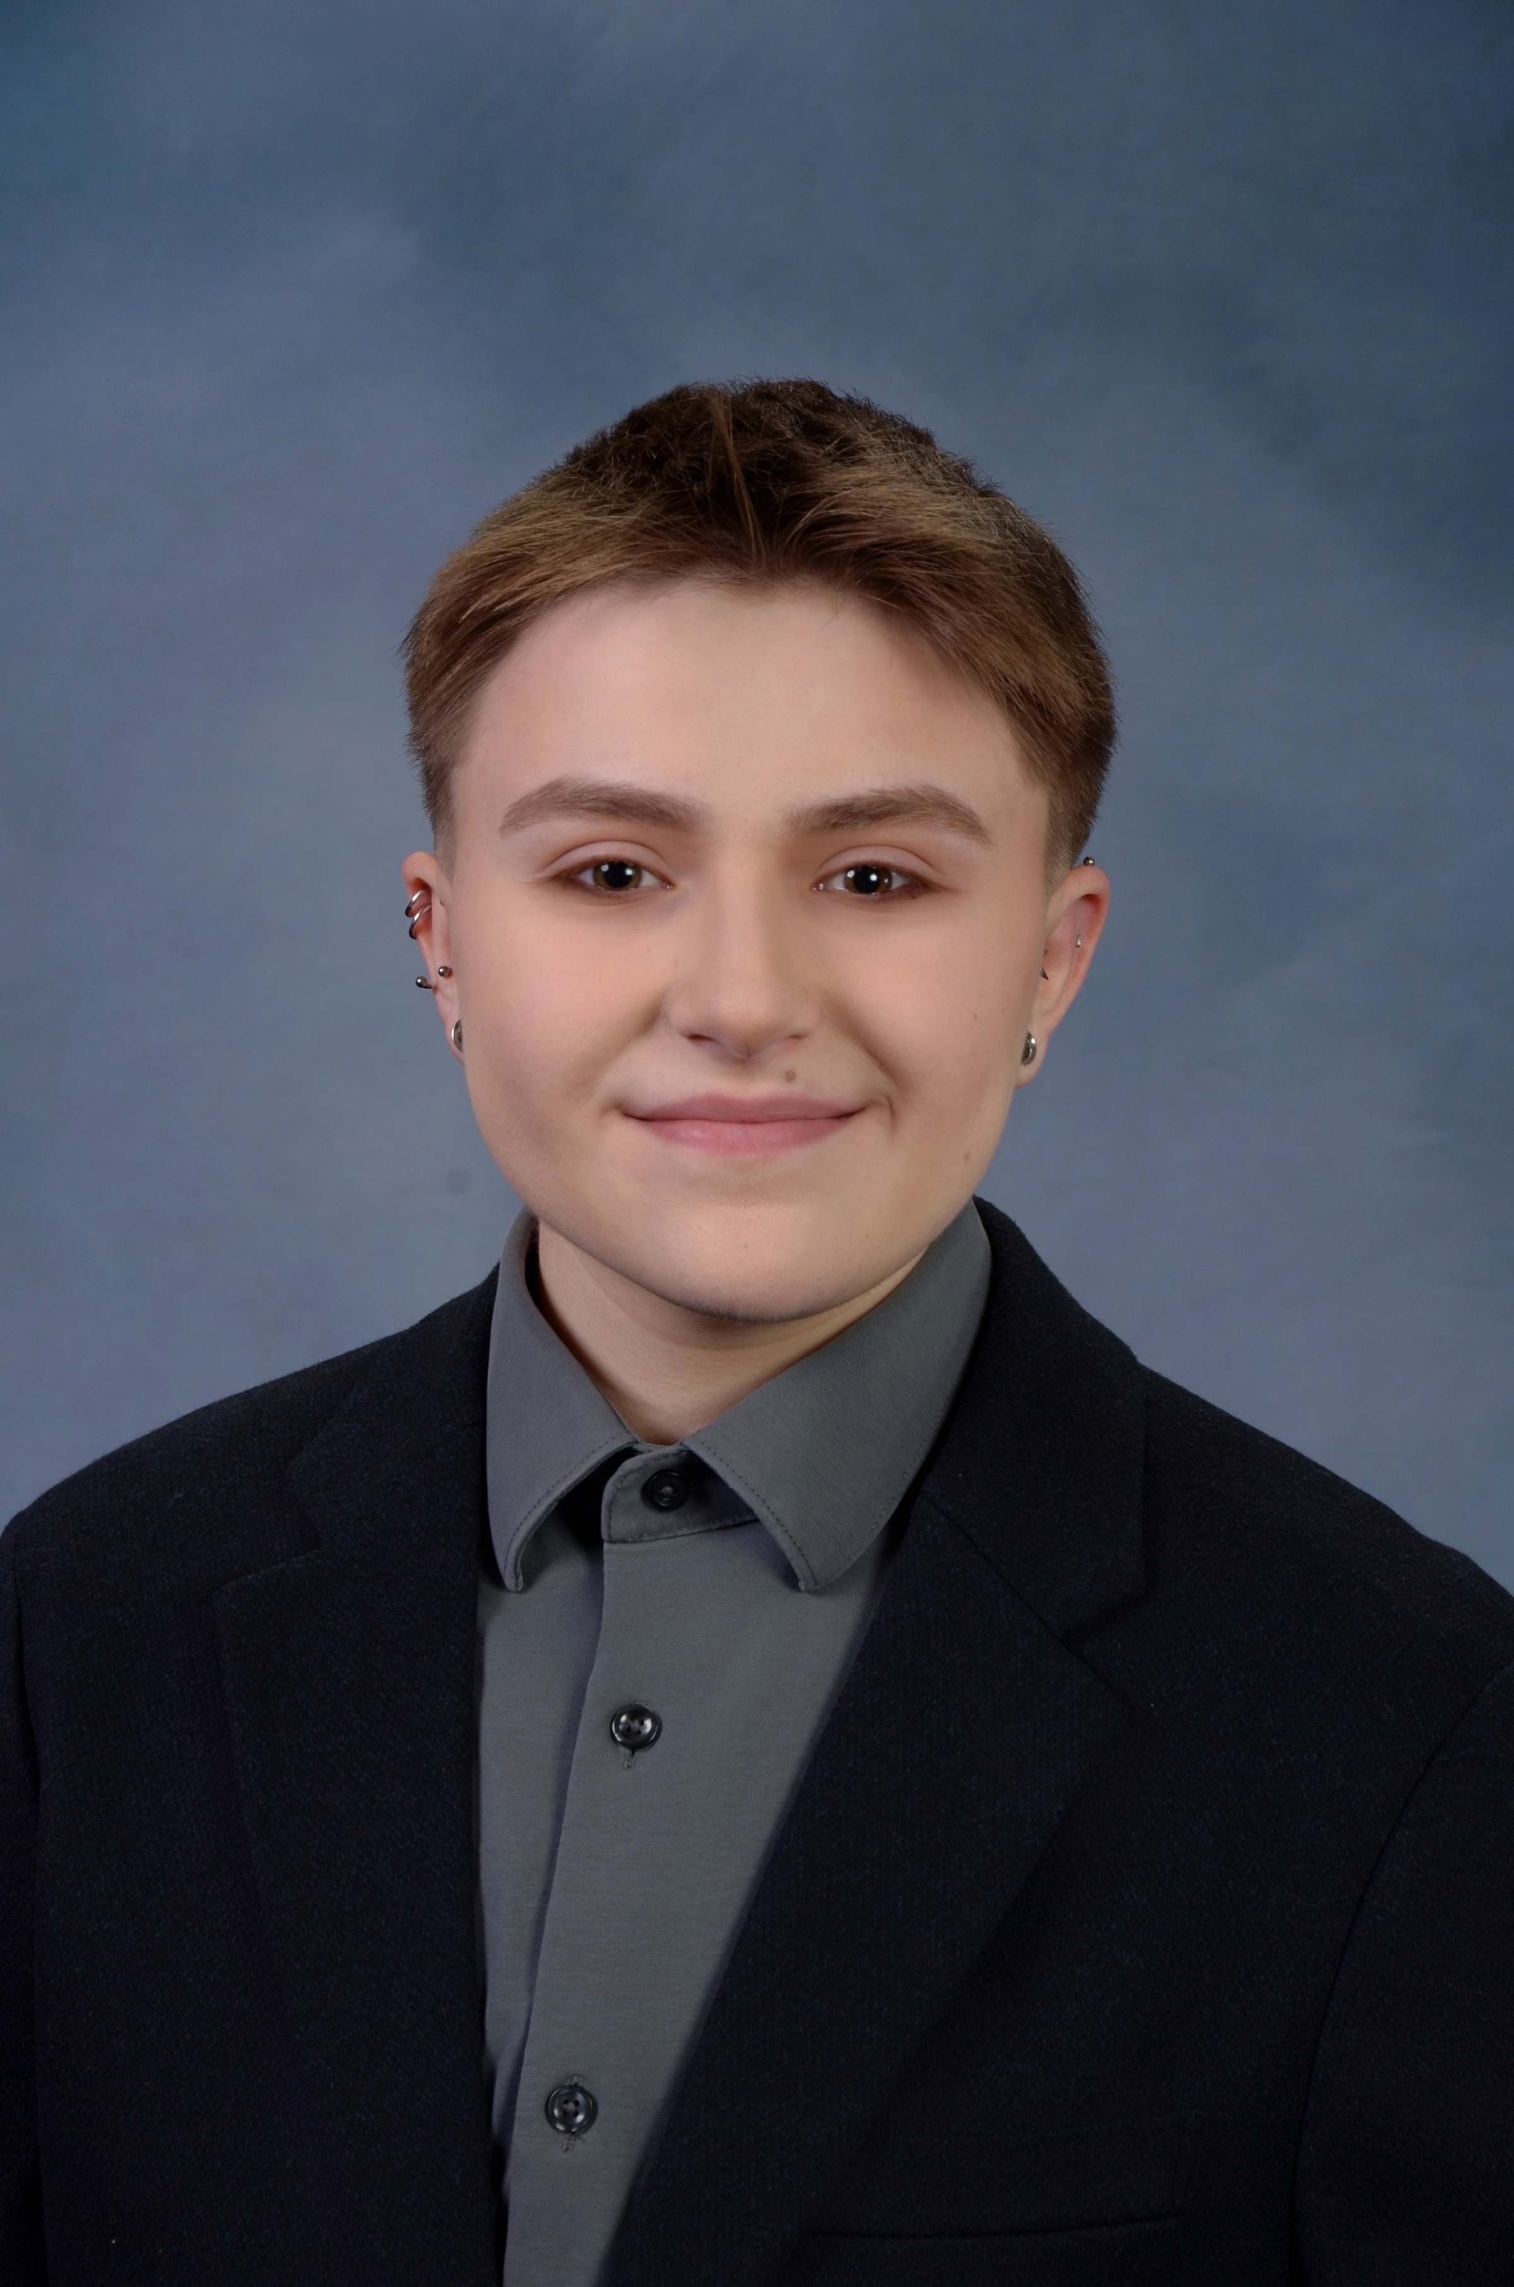

Lake V Palmeri



Nikki Pasterczyk

Exploring the Function of Cluster N Mycobacteriophage Kevin1 Genes 30 and 31 as a Putative Toxin-Antitoxin Gene Cassette

Lake V Palmeri, Nikki Pasterczyk, Kevser Dayi, Dagmara Jakubowska, Liana Woo, Rabeea Mansi, Courtney Cosgrove, Brianna Gipson, Julia Reisner, Stephen Mensah, Vassie C Ware

Advanced phage undergraduate researchers at Lehigh University are investigating host-phage interactions and immunity mechanisms within cluster N lysogens. Several studies have shown a pattern of cluster N prophage gene expression within lysogens from genes primarily located in the central variable region (CVR) of cluster N phage genomes (e.g., Dedrick *et al*., 2017). Specific prophage genes are implicated in defense mechanisms protecting lysogens from heterotypic viral infection. Of particular interest are Kevin1 genes *30* (a functionally annotated AAA-ATPase) and *31* (an orpham with Blastp hits to HicB-like antitoxin). What role these genes play in the Kevin1 life cycle or in phage-host interactions is unknown and is the focus of this work. We have used an array of experimental strategies to probe gene function, including: 1) bacteriophage recombineering electroporated DNA (BRED) techniques to mutate phage genomes; 2) lysogen production using wildtype and mutant phages to test lysogen establishment, maintenance, and immunity patterns; 3) RNAseq analysis to determine prophage and *Mycobacterium smegmatis* gene expression in lysogens; 4) cytotoxicity assays to assess effects of gene *30*, gene *31*, and gene *30-31* expression on bacterial growth; and 5) protein modeling to explore putative protein-protein interactions between gp30 and gp31. RNAseq data show that genes *30* and *31* are expressed, along with other genes in the CVR. Using BRED, a Kevin1 Δ*30* mutant, lacking the AAA-ATPase domain, was constructed. Both wildtype Kevin1 and Kevin1 Δ*30* mutant phages produce lysogens, but the mutant lysogen is less stable, suggesting involvement of the AAA-ATPase domain in stable maintenance of lysogeny. Immunity patterns for wildtype and mutant lysogens differ for several heterotypic phages tested, indicating a possible role for gene *30* in the infection cycle of several heterotypic phages. Gene *30* is cytotoxic when overexpressed in *M. smegmatis* whereas overexpression of the gene *30* mutant is not, implicating the AAA-ATPase domain in mediating gene *30* cytotoxicity. Notably, gene *31* is not cytotoxic and its co-expression along with gene *30* abolishes gene *30* cytotoxicity. Taken together, we hypothesize that genes *30* and *31* constitute a toxin-antitoxin pair expressed in the lysogenic state. RNAseq analyses of the mutant lysogen reveals up-regulation of genes predicted to function in the Kevin1 lytic cycle. This may account for increased instability of the mutant lysogen compared to wildtype. Additional BRED experiments in progress to delete gene *31* and test lysogen production will further test this hypothesis, predicting that lysogen establishment will be disrupted. AlphaFold2 predicts protein-protein interactions between gp30 and gp31, with interactions spanning the AAA-ATPase domain and the mid region of gp31. Conformation changes and a significantly decreased number of interactions between gpΔ30 and gp31 are proposed.