DO NOT CONSIDER FOR TALK

2025 SEA Symposium Abstract

Winthrop University

Rock Hill SC

Corresponding Faculty Member: Victoria Frost (frostv@winthrop.edu)



Janaija A Beckham

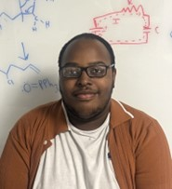

Israel A Bellinger



Chastity H Chisolm



Fisher A Cobb



Lily F Doyle

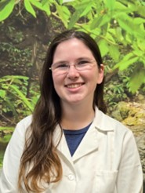

Hannah E Duncan

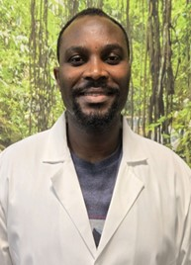

Papa Gyandeh



Madelynn P Harding



Joshua T Harkins

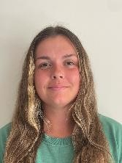

Erin A Hooper

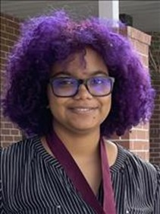

Amari R Johnson

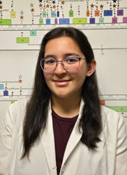

Rachel A Leek



Seth M Merritt



Ciarán L Murphy

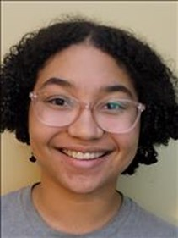

Gwendolyn R Tomlin

Decoding the Yorick Genome: Unveiling the Functional Architecture of a Cluster F1 Temperate Phage

Janaija A Beckham, Israel A Bellinger, Chastity H Chisolm, Fisher A Cobb, Lily F Doyle, Hannah E Duncan, Papa Gyandeh, Madelynn P Harding, Joshua T Harkins, Erin A Hooper, Amari R Johnson, Rachel A Leek, Seth M Merritt, Ciarán L Murphy, Gwendolyn R Tomlin, Jessica E Morgan, Kathryn P Kohl, Victoria J Frost

Discovered in 2021 by SEA-PHAGES students at Winthrop University, Yorick is a Cluster F1 temperate phage. Its genome consists of 99 genes, 57 of which have no known function. Through the SEA-GENES program, current Winthrop students are utilizing molecular cloning and phenotypic assays to study the function of each Yorick gene individually. In the initial phase of this project, Yorick genes are amplified via PCR, and amplicons are size-verified and purified. Subsequently, the amplified genes are inserted into the pExTra cloning vector using isothermal assembly and then transformed into competent *Escherichia coli* cells. Transformed plasmids are verified through colony PCR and agarose gel electrophoresis. Following verification, plasmids are purified and individually transformed into *Mycobacterium smegmatis*, the Yorick bacterial host, for cytotoxicity analysis. In this assay, the phage gene is overexpressed and the growth and survival of *M. smegmatis* observed. A phenotypic response to the Yorick gene expression suggests an interaction between the Yorick gene product and the host proteome. The ongoing investigation of Yorick may provide valuable insights into phage biology and further elucidate their interactions with bacterial hosts.