CONSIDER FOR TALK

2025 SEA Symposium Abstract

University of Southern California

Los Angeles CA

Corresponding Faculty Member: Christa Bancroft (cbancrof@usc.edu)



Ryan Buckner



Karina Chang



Caroline Chavex



Ethen Chen



Leon Chen



Owen Chen



Noah Cheng



Isabelle Chiang



Rena Hwang

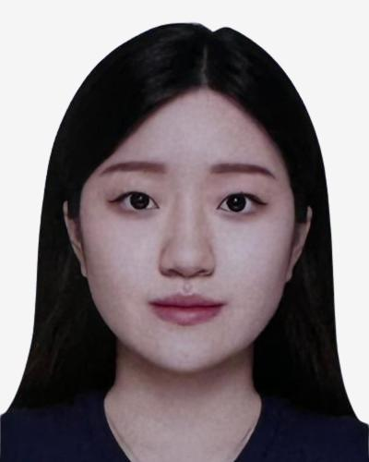

Jenny Jung



Alyssa Kim



Cadence Liang



Ryan Moinazad



Rumaysha Momen



Ella Ren



Amy Yao



Christa Bancroft

Analysis of the Phylogeny and Structure of Endolysin gene, Pham 224547, in Phage IsHungry (FF) with other Pham-containing clusters

Ryan Buckner, Karina Chang, Caroline Chavex, Ethen Chen, Leon Chen, Owen Chen, Noah Cheng, Isabelle Chiang, Rena Hwang, Jenny Jung, Alyssa Kim, Cadence Liang, Ryan Moinazad, Rumaysha Momen, Ella Ren, Amy Yao, Christa Bancroft

Found abundantly in the world, bacteriophages, or phages, infect bacteria host cells to reproduce. During our lab’s 2024 fall semester, we isolated twelve putative temperate phages from the Los Angeles area using bacterial host Arthrobacter globiformis B-2979. After we isolated, purified and amplified the bacteriophage, we used Transmission Electron Microscopy (TEM) images to evaluate their specific structures. We then extracted and sequenced the DNA of phage IsHungry. The length of IsHungry’s genome, a cluster FF phage, is 40,628 base pairs. We used several software programs to predict the open reading frames (ORFs) and assign each gene a start codon, including DNA Master, Starterator, Phamerator, GeneMark, Glimmer, Phagesdb BLAST, and BLAST. We determined the putative function of each gene using evidence from HHPRED, NCBI BLAST, and Synteny. Our preliminary results show that IsHungry has 61 ORFs and 3 tRNAs.   
  
Because there are currently only eight other bacteriophage characterized and annotated in the FF cluster on the Actinobacteriophage database, Phages.db (11 more are in draft form), we are interested in the evolution of the putative endolysin gene, Pham 224547, that is present in all but one FF phage, but which contain somewhat different amino acid sequences. We hope to compare the amino acid sequences of this ORF with other clusters that contain this Pham, such as AY, FA and AP2. To this end, we have conducted phylogenetic analysis of specific, highly conserved phage proteins to see if their amino acid relatedness within and between clusters mirror how similar they are at the genomic nucleotide level. We have used phylogenetic tools, Phylogeny.fr and Splitstree4, to compare amino acid sequence of the endolysin between FF phage and clusters AY, FA and AP2. To evaluate how amino acid sequence differences relate to structural changes, we have input the sequences into Alpha-Fold to determine how the structures different at the 3-dimensional level. Finally, we analyzed genome nucleotide sequence similarity to determine if intra and inter cluster relatedness is consistent when comparing amino acid sequence of specific proteins and relatedness of the genomic sequence, at the nucleotide level.