DO NOT CONSIDER FOR TALK

2025 SEA Symposium Abstract

Mesa Community College Dobson Campus

Mesa AZ

Corresponding Faculty Member: Luke Mumaw (luk2038681@mesacc.edu)

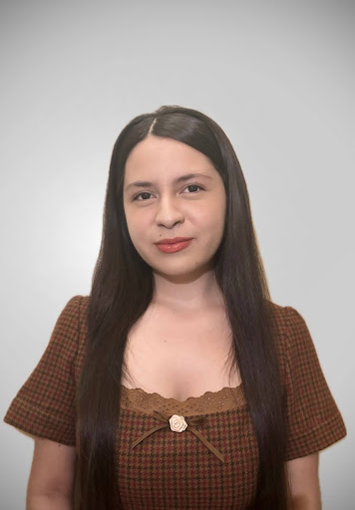

Christina I Hernandez

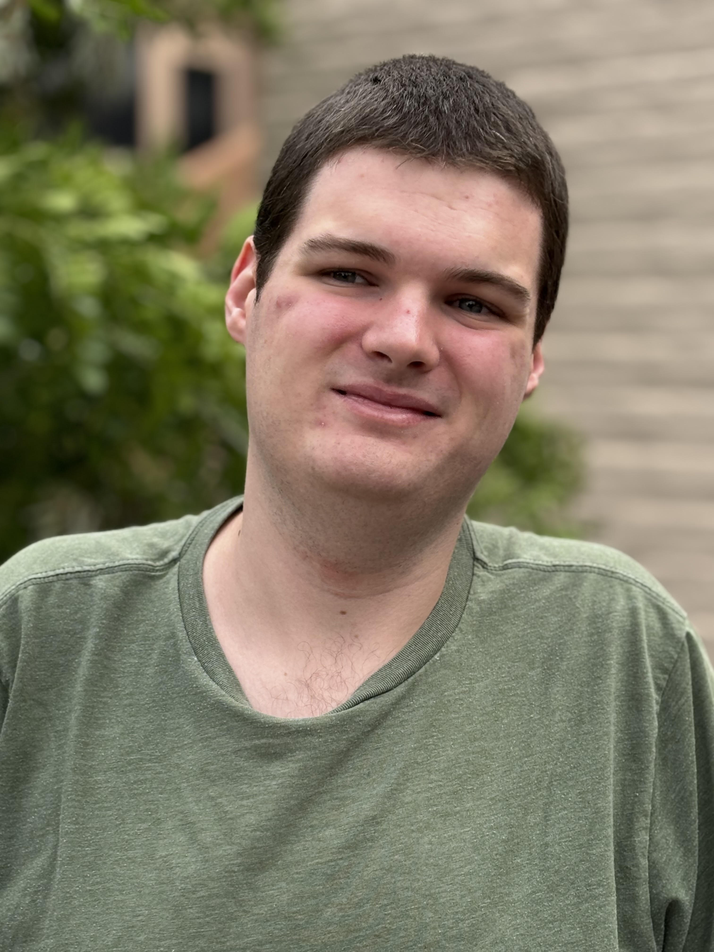

Tyler J Potter

Genome annotation of bacteriophage TrixiePhattel (Cluster AU6)

Christina I Hernandez, Tyler J Potter, Luke T Mumaw

Our annotation team has looked at the genes of bacteriophage TrixiePhattel and compared them to genes of other bacteriophages within its cluster (AU6) to determine their function. We were given 93 confirmed genes by a program called DNAmaster, which uses two other programs (Glimmer and Genemark) to help give a potential “best start” for each gene. However, it is then the job of the annotating team to check the accuracy of these programs. We did this by looking to see if the Genemark graphs capture the start of coding potential, then checking the start positions in Starterator. After this, we compared our genes to those of the other bacteriophages in our cluster on Phamerator to look for their predicted functions. Once we collected all of our information, we had to determine if DNAmaster gave us the best possible start or if we should change it to a better start. If a new start was decided upon we would then put our new amino acid sequence into the NCBI blast to check out alignment with other bacteriophages. We found three possible “hidden gene” ;however we are still working on annotations. As of now the genes of TrixiePhattel match the closest to two other phages in its cluster, Zenia(AU6) and Uzumaki(AU6).