CONSIDER FOR TALK

2025 SEA Symposium Abstract

La Sierra University

Riverside CA

Corresponding Faculty Member: Arturo Diaz (adiaz@lasierra.edu)

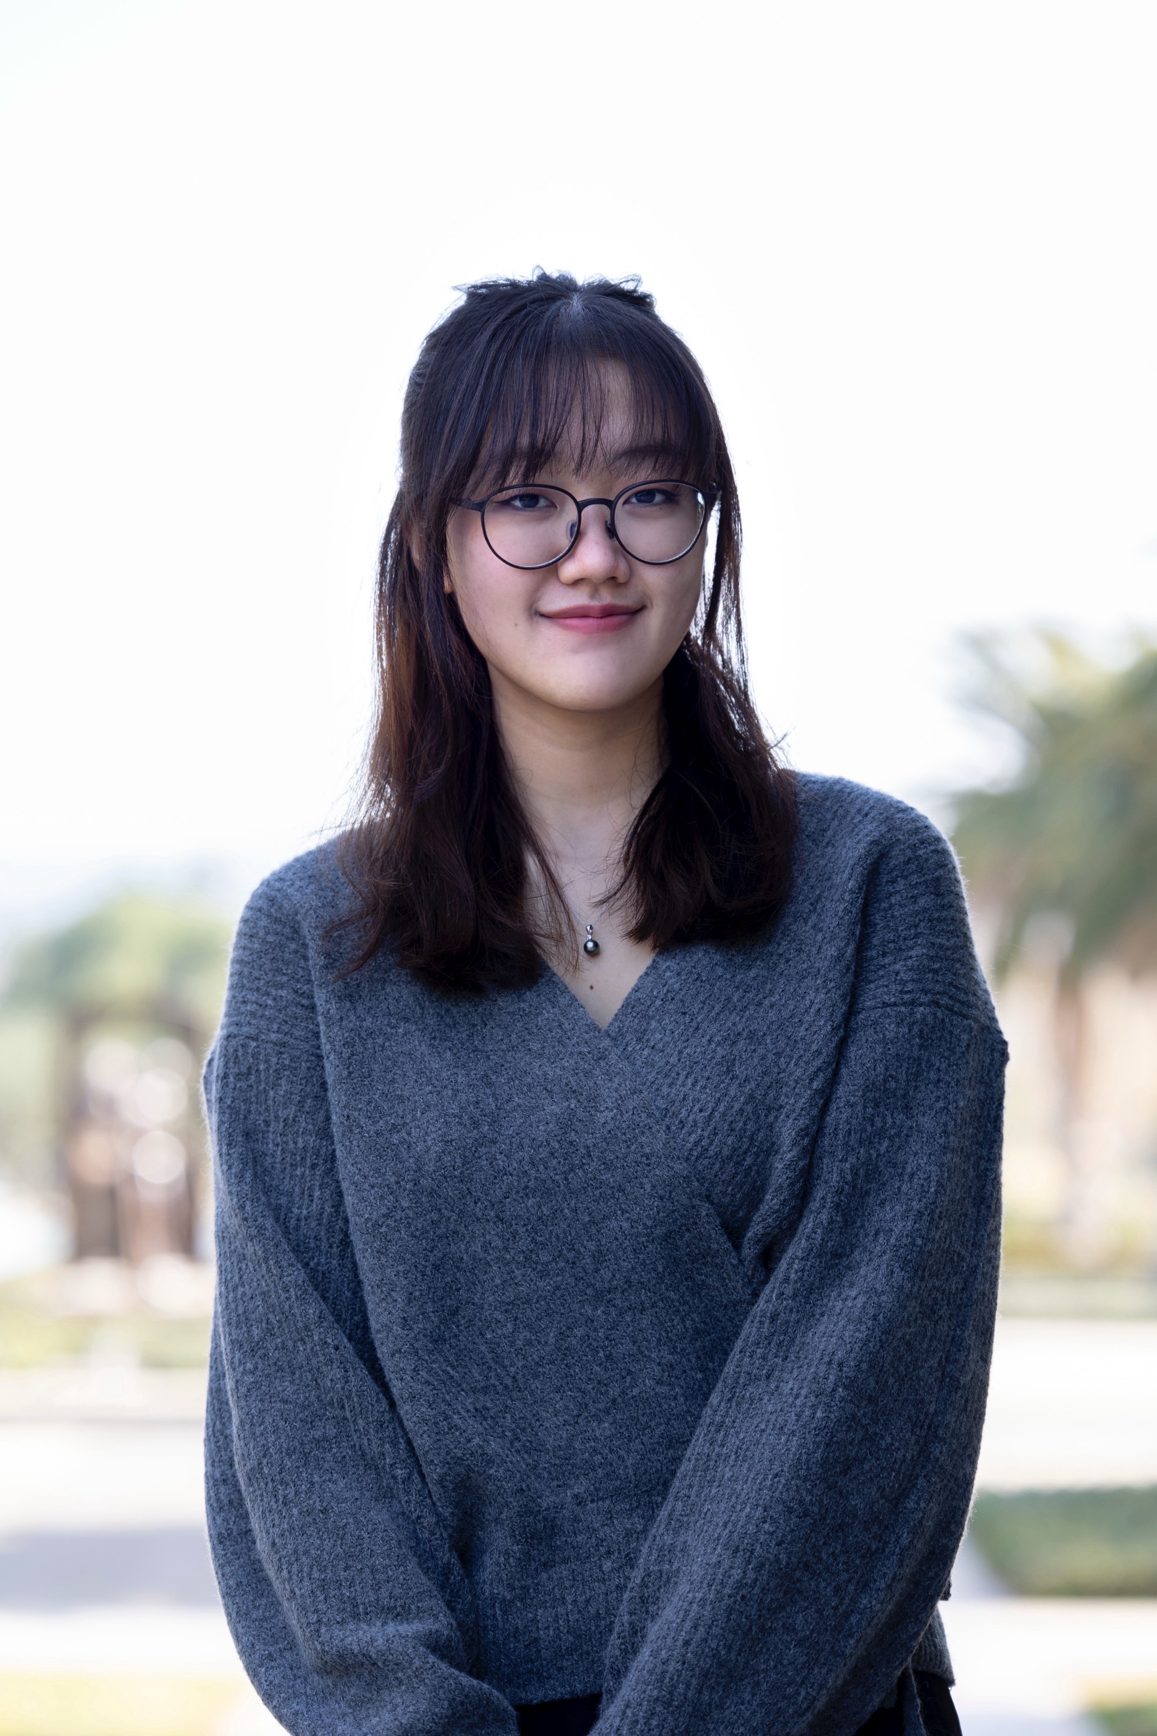

Yehee Cho

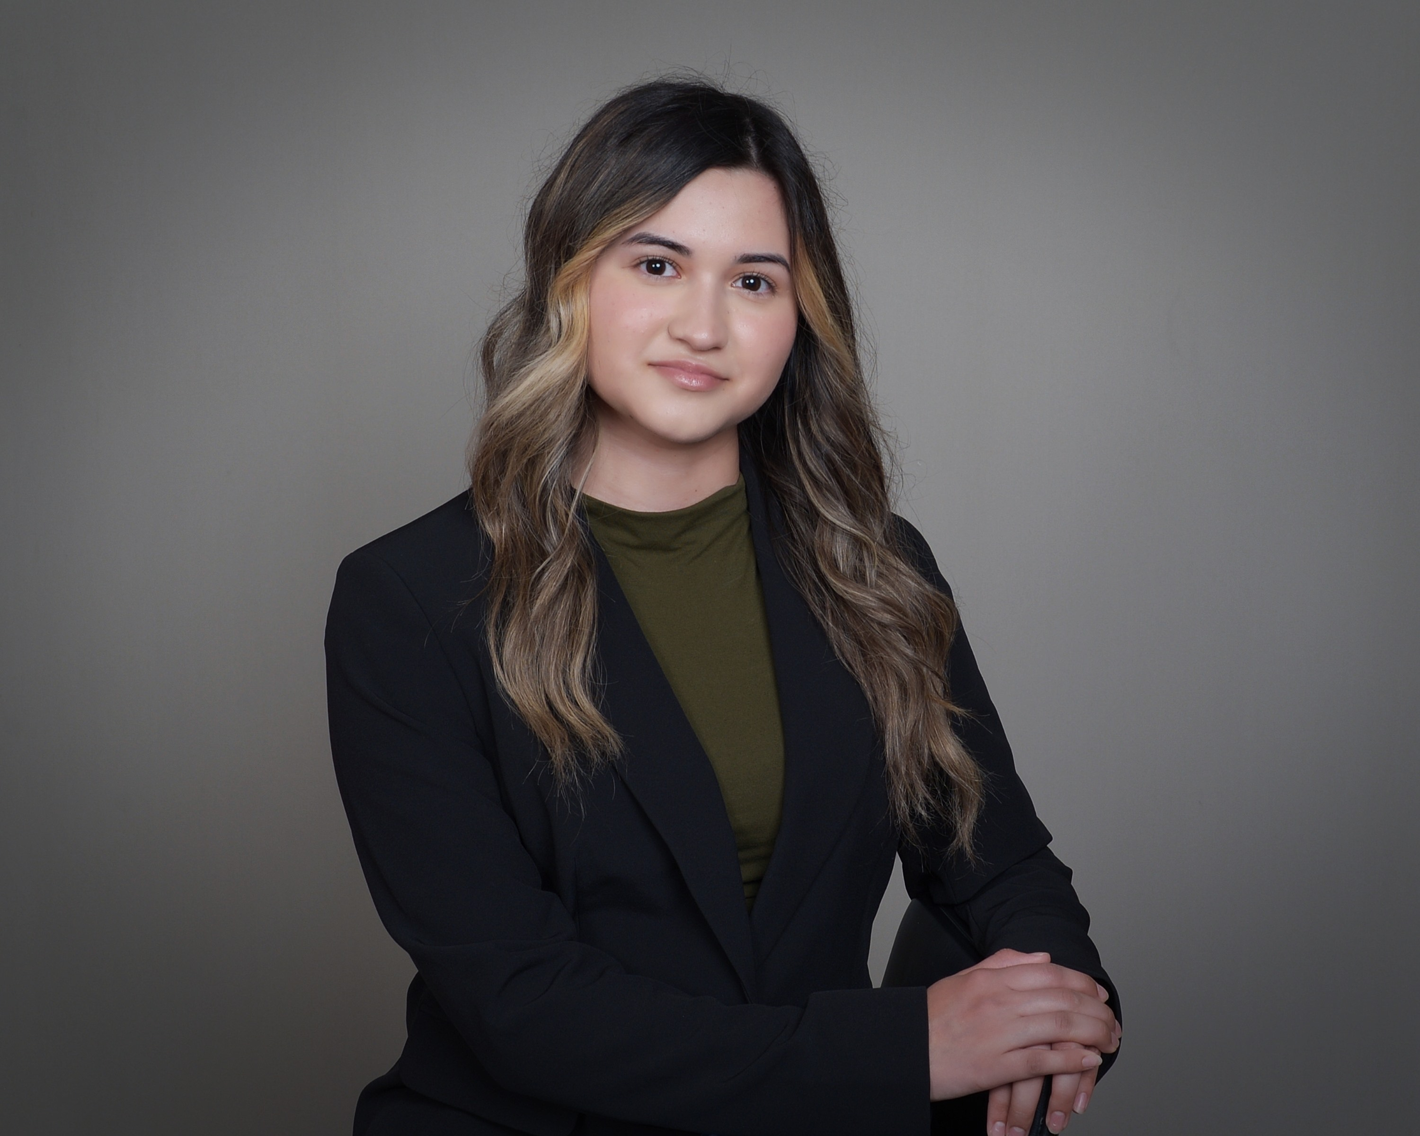

Lauren Michel

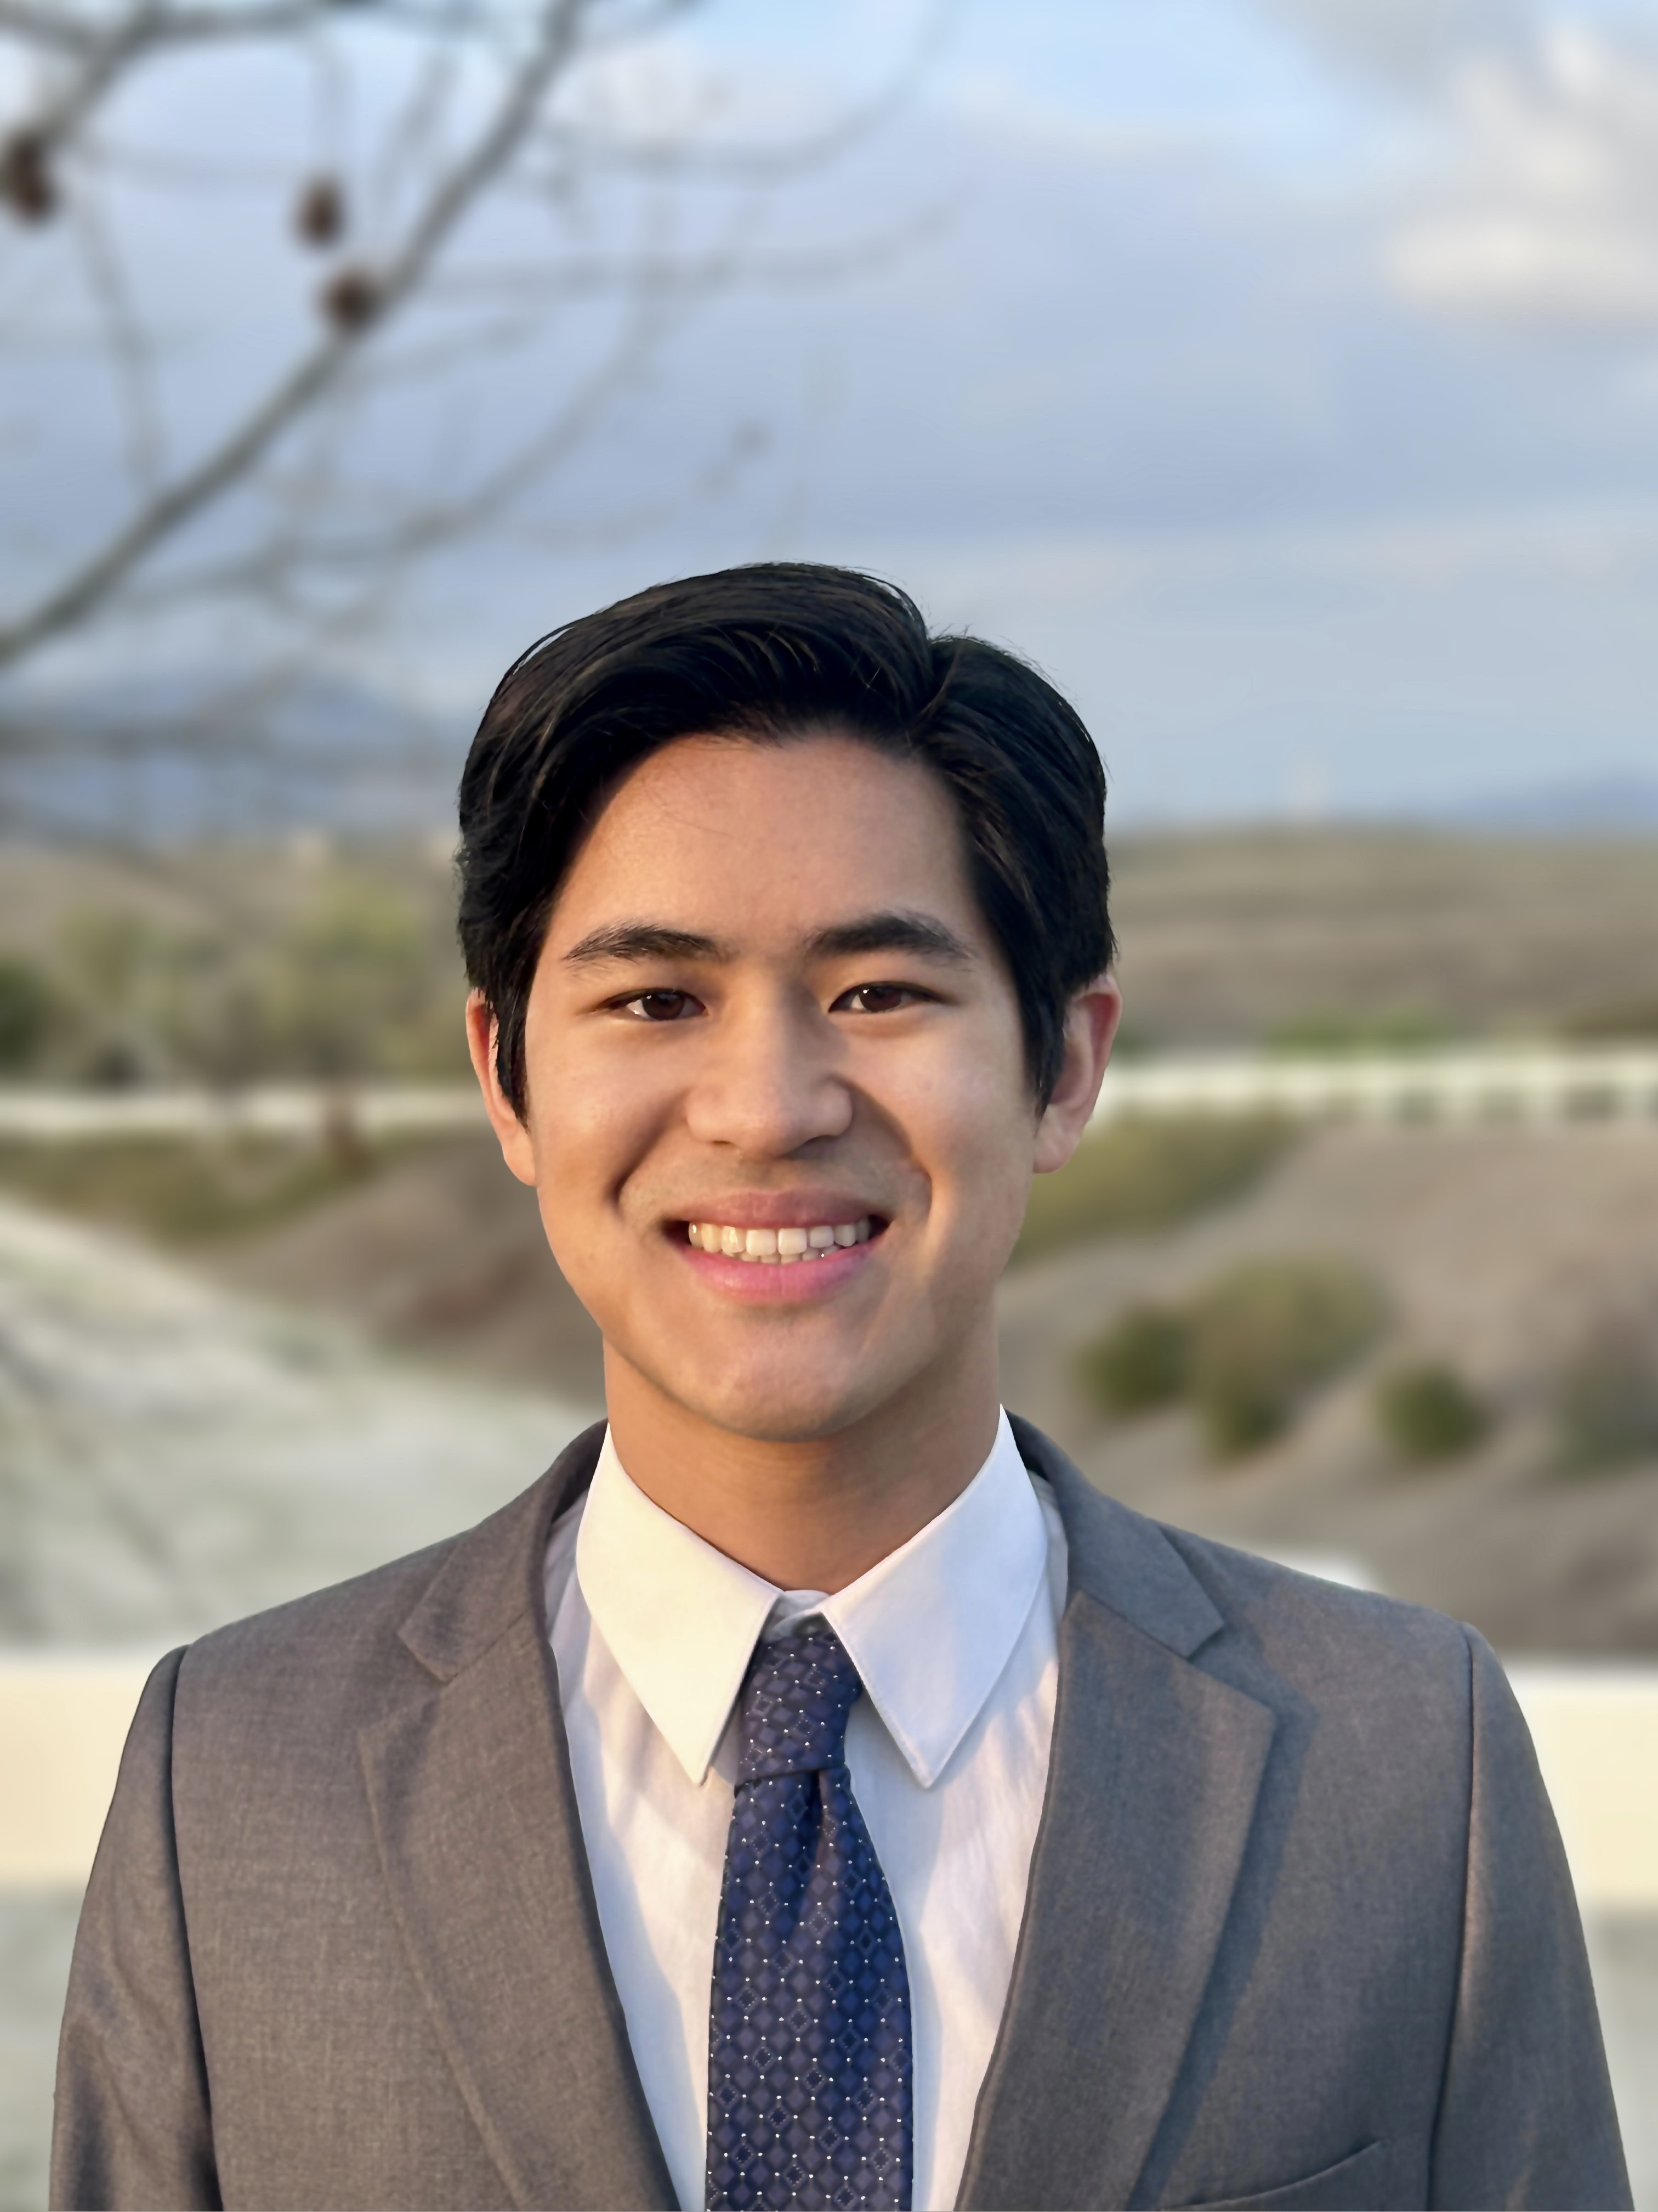

Ethan Nguyen-Khoa

Beyond Sequence Similarity: Exploring Phylogenetic and Functional Convergence in Mycobacterium smegmatis Bacteriophages

Yehee Cho, Lauren Michel, Ethan Nguyen-Khoa, Natasha Dean, Arturo Diaz

In the Actinobacteriophage Database, bacteriophages are conventionally organized into “clusters” of closely related phages based on having at least 50% sequence similarity as detailed by Hatfull et al. (2010). However, in the context of evolutionary biology, it is important to consider how bacteriophages may vary in terms of non-sequence-based characteristics. Minute genetic changes can cause drastic structural and functional changes in proteins, yet extreme genetic differences can still result in some similar adaptations. The study of divergence and convergence requires investigating how bacteriophages relate to each other both phylogenetically and functionally, as well as in terms of environmental selective pressures that drive such patterns. Thus, this research explored the variation in non-sequence data between bacteriophages that infect *Mycobacterium smegmatis* by comparing the traditional sequence-based clusters with a non-sequence data of Multiple Factor Analysis (MFA) in context of microenvironmental data representative of selective pressures. Non-sequence data included morphotype (Siphoviridae / Myoviridae), temperance, genome length, and GC content. Microenvironmental data included the moisture content and temperature of the environmental sample from which bacteriophages were collected. No notable trends in any of these microenvironmental metrics were found in the phylogeny, meaning that the microenvironmental factors measured did not significantly influence the evolutionary relationships or history of the species. However, this research demonstrated that *M. smegmatis* phages show consistent grouping, whether via conventional, sequence-based clusters or non-sequence-based clusters. Evidence further suggested that within *M. smegmatis* phages, the group of Myoviridae phages, the group of temperate phages, and certain clusters and subclusters defined by the Actinobacteriophage Database are all polyphyletic, indicating convergence. Additionally, results indicated that multiple lineages of low and high GC content developed convergently.