CONSIDER FOR TALK

2025 SEA Symposium Abstract

University of Ibadan

Ibadan

Corresponding Faculty Member: Olubusuyi Moses Adewumi (adewumi1@hotmail.com)

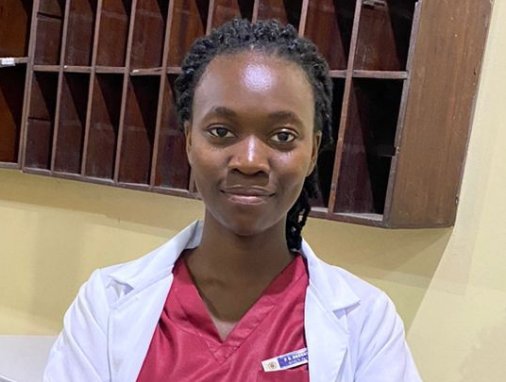

Peace O Okunade

Annotation and Characterization of Mycobacterium Bacteriophage Jayhawk

Peace O Okunade, Abdulmujeeb D Opatola, David O Adams, Emmanuel O Adebayo, Adedoyin Q Adedamola, Adesubomi A Adegbite, Ridwan A Agboola, Praise L Alabi, Zainab O Kuku, Mercy A Ojediran, Mayowa A Olaomito, Marvellous R Olatoye, Oluwaseyi J Oludipe, Williams T Owoeye, Daniel Ranti, Jesutofunmi A Taiwo, Muideen Raifu, Ini Adebiyi, Veronica I Ogunleye, Temitope O Faleye, Jesutofunmi A Taiwo, Muideen Raifu, Ini Adebiyi, Veronica I Ogunleye, Temitope O Faleye, Adeleye S Bakarey, Olubusuyi M Adewumi, John I Anetor, Olusegun G Ademowo

Bacteriophage Jayhawk belongs to cluster K and subcluster K1, with 104 members. Members have an average genome size of 59,926 base pairs and an average GC content of 66.8%. Bacteriophage Jayhawk was originally isolated from an enriched soil sample by LeTourneau University in 2021. It was grown on Mycobacterium smegmatis mc 152 bacterial host. Sequencing by Illumina technique reveals an approximate coverage of 21X, G-C content of 66.6%, and genome length of 59,732 base pairs. Like every other member of the subcluster K1, Jayhawk exhibits a temperate life cycle.  
 Auto-annotation was carried out using Glimmer and Genemark in-built gene predictors in DNA Master and RAST server and both predicted 97 gene features. Visual inspection and start site refinement were carried out using conserved start site predictions from Starterator index, gene synteny on Phamerator and six-frame translation inspection on Artemis Comparison Tool. Assignment of putative functions was done on NCBI protein Blast, HHPred databases. The phylogenetic nucleotide identity of the cluster was generated using the Orthologous Average Nucleotide Identity Tool.  
Of the ninety-seven manually validated protein features, ninety-two were forward-transcribed genes, one transferRNA, and four reverse-transcribed genes. The assignment of putative functions was carried out using the NCBI Blastp algorithm, Pharmerator, and HHPred. This revealed about 44.33% assigned features with only one reversed gene with putative function – Transcriptional repressor, others were assigned to forward oriented genes. Forward oriented genes with putative functions include Terminase, portal protein, Head maturation protease, Head scalfolding, major capsid protein, and the presence of lytic cycle proteins such as endolysin, lysin, and holin was also recorded.