DO NOT CONSIDER FOR TALK

2025 SEA Symposium Abstract

Northwestern College

Orange City IA

Corresponding Faculty Member: Sara Tolsma (stolsma@nwciowa.edu)



Randi Childress

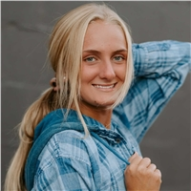

Mallory Gramstad

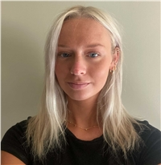

Ayda Maassen

Phinding Phages

Peyton Abraham, Gabriel Andres, Princess Bola-Lawal, Mary Britten, Randi Childress, Abby Flanagan, Mallory Gramstad, Tark Griebel, Hayden Groos, Sharon Huffman, Korver Hupke, Corbin Kleis, Jenna Kluxdal, Ayda Maassen, Caden Meyer, Elsa Meyer, Logan Miller, Emma Steinhardt, Travis Sweeney, Alexa Trover, Dane Shoenborn, Sara S Tolsma

Antibiotic resistance is a growing problem. Understanding the genetics of individual phages is important in discovering viable candidates for phage therapy. Research reveals their complexity. There is much to learn. We used bioinformatics to better understand four phages discovered by Northwestern College students: Exploradora, IndiRoo, Red Raider, and Frizzle. We published our results in GenBank. In this poster we will discuss notable features of each phage. Our work contributes to the future of medicine by forming a more complete understanding of phage genomes.