DO NOT CONSIDER FOR TALK

2025 SEA Symposium Abstract

New Mexico Institute of Mining and Technology

Socorro NM

Corresponding Faculty Member: Kaarin Goncz (kaarin.goncz@nmt.edu)

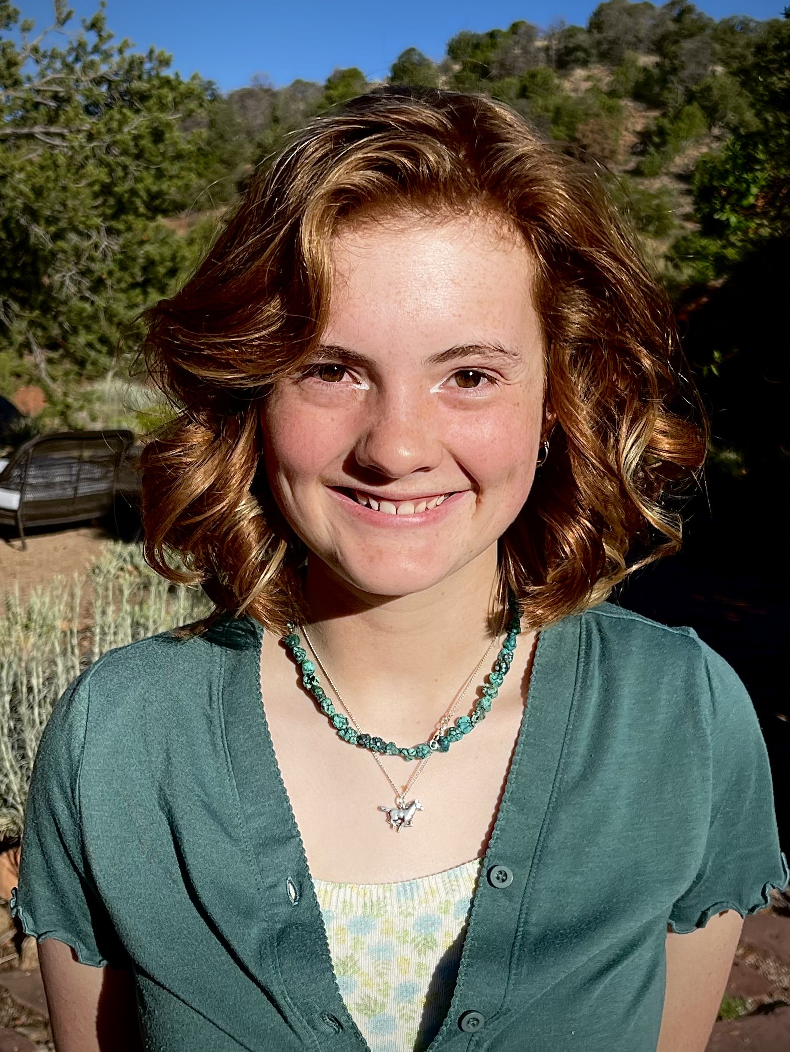

Violet Kirk



Rebecca Merchant

Phages of the Desert

Violet Kirk, Rebecca Merchant, Meghan Ferrara, Luke Garcia, Isabella Mcclish, Kaarin Goncz, Nathaniel Jobe

Bacteriophages (phages) are viruses that infect bacteria and exist in all corners of the world that target specific bacterial hosts. Through SEAPHAGES, a worldwide program where undergraduate students isolate and characterise phages, two phages were isolated from the campus of NMTech from a partly shaded flower bed where the soil was dark and moist. The phages, RustyBoy and Natasha, were isolated using the soil bacterium Arthrobacter globiformus B-2979. Both phages developed small plaques on A. globiformis; Natasha’s were clear, while RustyBoy’s were opaque. Through TEM, the phages were both identified as siphoviruses with a capsid head diameter (Natasha: 65.32nm; RustyBoy: 69.534 nm) and tail length (Natasha: 230.88nm; RustyBoy: 237.714 nm). These were sent to be sequenced by Illumina sequencing. The phages belong in the AW cluster, which are lytic siphovirus phages. The genome sequences of the two phages are similar (98% identity). They have a 3’ sticky overhang with a sequence of CGCCGGCCT and 51.4% GC content, and 90 genes have been identified; Rustyboy’s genome is 54635 bp long, and Natasha’s is 54436 bp long. However, in the 199 bp gap between the phages, there is a unique gene and an additional orpham in RustyBoy not found in Natasha. The closest relative of these phages besides each other is Sporto (92% identity to RustyBoy and Natasha). These results contribute to our understanding of the AW phage cluster and will contribute new information with the unique gene.