CONSIDER FOR TALK

2025 SEA Symposium Abstract

Saint Joseph's University

Philadelphia PA

Corresponding Faculty Member: Julia Lee-Soety (jlee04@sju.edu)

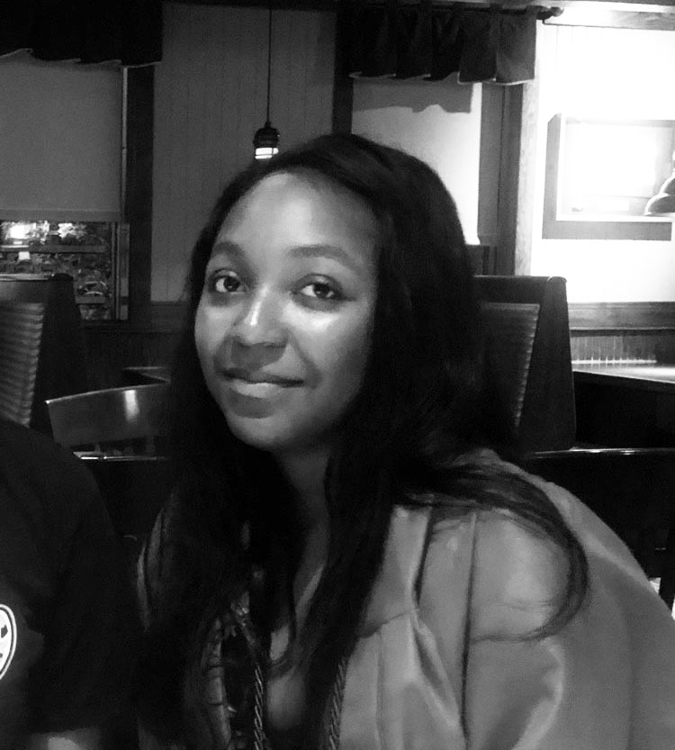

Seamus Powers



Ciara Hutchinson

Similarities in genes encoding the tail assembly chaperone in different phages

Sarah Koh, Melanie Hernandez Di Domenico, Alyssa Bloxton, Seamus Powers, Ciara Hutchinson, C Nicole Sunnen, Julia Lee-Soety

The tail assembly chaperone (TAC) is a unique protein that assists the proper assembly of the phage tails. TACs guide tape-measure proteins during the assembly of tail tubes. Most phages express two different TACs – long and short – using an intentional frameshift. Our goal was to compare the similarities of TAC genes among different clusters of phages. We analyzed genetic similarities within Phams (or phamilies). Extracting data from PhagesDB, PECAAN, and Phamerator, we selected and compared theTAC genes in phages representing different clusters (grouped according to full length genomic similarities): GlutenPhree (C1), PhesterPhotato (F1), Winky (L2), FoulBall (O), and BPBiebs31 (A1). When Pham and cluster assignments were compared (Phams 84889, 221041, 85361, 84650, and 84609), we found that Pham 84889 is almost exclusively found in C1 phages (97%); however, other Phams were more inclusive and had a more diverse distribution of representative clusters and subclusters. This suggests that the TAC gene in the C1 phages is more exclusive than those in other Phams. In addition, we analyzed and compared the sequences for the TAC genes among representative phages for each Pham. We built a phylogenetic tree and found that the TAC genes in the C phages were most closely related to each other compared to any other phages. This uniqueness in C cluster phages could be because they are the only Mycobacterium phages that have the short tail morphology.