DO NOT CONSIDER FOR TALK

2025 SEA Symposium Abstract

LeTourneau University

Longview TX

Corresponding Faculty Member: Fred Baliraine (fredbaliraine@letu.edu)

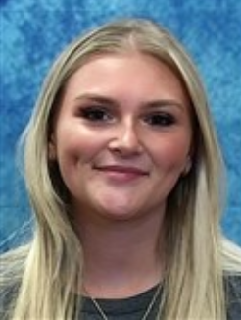

Jillian D Childs

Isolation and Characterization of a Soil-Dwelling Bacteriophage Athanasius

Jillian D Childs, Alana K Mumphrey, Cheyenne D Aleman, Mary E Fortune, Josh D McLoud, Frederick N Baliraine

Bacteriophage Athanasius was isolated from a soil sample collected in Longview, Texas (32.465077 N, 94.727987 W) on August 27, 2024. Following the SEA-PHAGES Phage Discovery Guide, we utilized the enriched method with Middlebrook 7H9 medium and *Mycobacterium smegmatis* mc2 155 as the bacterial host. Phage presence was confirmed using a spot test, where turbid plaques appeared on the top agar in the areas where 5 µL, 10 µL, and 100 µL of 0.22 µm-filtered samples were applied. We selected a plaque from the 5 µL area and performed 4 rounds of ten-fold serial dilutions with plating on Middlebrook 7H9 top agar and incubating at 37°C for 48 hours. Individual plaques were chosen during purification to ensure a minimum distance of 2 cm from neighboring plaques. The plaques were relatively large, averaging 4.7 mm (range, 3.0 - 6.0 mm, n = 15). The final selected plaque was mixed with 100 µL of phage buffer and used to create 8 webbed plates. Each plate was subsequently flooded with 5 mL of phage buffer to achieve a high titer lysate. The resultant titer was 4.0 x 1010PFU/mL, from which gDNA was extracted and yielded a total of 6.84 µg with a 57 µg/ml titer. Athanasius’s gDNA awaits sequencing. TEM image analysis of 4 virus particles showed Athanasius to have a Siphovirus morphotype with an isometric capsid (diameter, ~48.2 to 55.6 nm) and a flexible tail (length, ~108.0 to 152.4 nm). Athanasius’s lysates were archived at LeTourneau University and at the University of Pittsburg.