DO NOT CONSIDER FOR TALK

2025 SEA Symposium Abstract

LeTourneau University

Longview TX

Corresponding Faculty Member: Fred Baliraine (fredbaliraine@letu.edu)

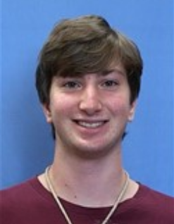

Jackson L Rotello

Isolation and Characterization of a Novel, Pond Bank-Sourced Phage Raddgar

Jackson L Rotello, Josh D McLoud, Frederick N Baliraine

Bacteriophages, or phages, are important in research, sanitation, and medical practice worldwide. Phage Raddgar was isolated from a soil sample collected at the bank of a pond in Longview, Texas (32.4635 N, 94.72586 W) on August 27, 2024, using the enriched method. The soil sample was mixed with Middlebrook 7H9 and *Mycobacterium smegmatis* m2 155 and incubated at 37°C with shaking at 210 rpm for 4 days, then filtered (0.22 µm). The filtrate was used on a spot test to confirm phage presence, evidenced by the appearance of turbid plaques. Plaques picked during purification were ≥ 5 cm from neighboring plaques. Two rounds of 10-fold serial dilution and plating with incubation at 37°C for 48 hours were done to ensure phage purity. The plaque picked from the final round of purification plating was mixed with 100 µL of phage buffer and used to make 8 webbed plates. Each webbed plate was flooded with 5 mL of phage buffer to prepare a high titer lysate. The lysate titer was 2.1 x 1010 PFU/ml. The lysate was used for gDNA extraction, TEM imaging, and sample archiving. Raddgar’s gDNA awaits sequencing. Based on plaque morphology and TEM image analysis of 6 virus particles, we can conclude that Raddgar is a temperate phage having a siphovirus morphotype with an isometric capsid (average diameter 47.5 nm, range ~48.2 to 55.6 nm) and a flexible tail (average length 136. 3 nm, range ~108.0 to 152.4 nm). Raddgar’s lysates were archived both at LeTourneau University and at the University of Pittsburg.