DO NOT CONSIDER FOR TALK

2025 SEA Symposium Abstract

LeTourneau University

Longview TX

Corresponding Faculty Member: Fred Baliraine (fredbaliraine@letu.edu)



Heather J Shaw

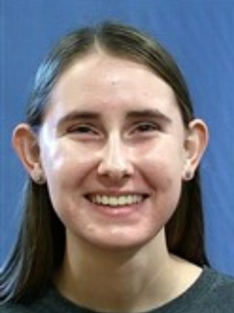

Reagan L Chastain

From a Squishy Soil to Complete Genome Characterization: The Story Bacteriophage Izel

Heather J Shaw, Reagan L Chastain, Lindley I Vickers, Esther E Hord, Jenna M Rosson, Josh D McLoud, Frederick N Baliraine

Bacteriophages are viruses that infect bacteria and are important in developing treatments for antibiotic-resistant bacterial infections. Phage Izel was isolated from a squishy soil sample collected at LeTourneau University in East Texas on August 28, 2024. The bacterial host used in isolating Izel was *Mycobacterium smegmatis* mc2 155, and the medium was Middlebrook 7H9. After confirming phage presence using a spot test, Izel was purified via 10-fold serial dilutions and 2 rounds of plating with a 48-hour incubation at 37 °C. Izel produced small, round, turbid plaques with an average diameter of 1.02 mm (range 0.7-1.4 mm; n =15). Amplification yielded a high titer lysate of 6.0 x 1010 PFU/mL. The lysate was used for gDNA extraction, TEM imaging preparation, and archiving. Izel displayed a Siphoviridae morphotype with an isometric capsid (average diameter ~55.5 nm) and a flexible tail (average length ~338.8 nm). The gDNA was sequenced using the Illumina method, with a shotgun coverage of ~2340. Izel’s genome was annotated using a range of software and databases, including DNA Master, Genemark, Phamerator, Starterator, HHPred, NCBI, PhagesDB, DeepTMHMM, ARAGORN, and tRNAscan-SE. Using PhagesDB's gene content similarity (GCS) tool, Izel was assigned to subcluster M1, based on ≥35% GCS to other mycobacteriophages in the database. Sequence data showed Izel to belong to subcluster M1 with an 11 bp 3’ sticky overhang (ACCTCCTGCAA), genome length 80,037 bp, 61.6% G+C content, 137 genes, 19 tRNAs and no tmRNAs. Functions, including serine integrase, could be assigned to only 40% (52/137) of Izel’s putative genes. Izel was confirmed to be a temperate phage, evidenced by having a serine integrase gene, but notably lacking other key lysogenic genes, namely the immunity repressor and excise. Izel adds to the pool of phages with potential for future use in therapy and research.