DO NOT CONSIDER FOR TALK

2025 SEA Symposium Abstract

LeTourneau University

Longview TX

Corresponding Faculty Member: Fred Baliraine (fredbaliraine@letu.edu)

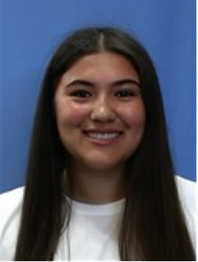

Alexandra M Gutierrez

Discovery and Characteristics of Isolation Lunsford, a Novel Temperate Mycobacteriophage

Alexandra M Gutierrez, Megan T LeBlanc\*, Emily G Shea, Carter S Horton, Josh D McLoud, Frederick N Baliraine

\* Baylor University, Waco TX

Phage discovery and characterization is important because antibiotic-resistant bacteria are becoming a threat to human and animal health. Phage Lunsford was isolated in August 2023 from a soil sample collected at LeTourneau University in Longview, Texas (32.4691 N, 94.72279 W). The enrichment method was used with Middlebrook 7H9 medium and *Mycobacterium smegmatis* mc2 155 as the host. After observing plaques formation from the sample using the spot test, Lunsford was purified using 10-fold serial dilutions and 3 rounds of plating. Lunsford displayed large, clear plaques with an average diameter of 3.2 mm (range 2.5 – 4.0 mm, n=10) after 48 hours of incubation at 37°C. Webbed plates were used to amplify the titer of the pure phage. A high titer lysate of 1.9 x 1010 PFU/mL was used for DNA extraction using the Promega Wizard DNA cleanup kit, negative-stain transmission electron microscopy (TEM) imaging, and archiving. Genome sequencing was done using an Illumina MiSeq sequencer. Annotation was done using DNA Master, PhagesDB, NCBI, HHPred, Phamerator, Starterator, and DeepTMHMM. Sequence data showed Lunsford to belong to subcluster A4 with a 10 bp 3’ sticky overhang (CGGCCGGTAA), genome size 51,364 bp, and 63.8% G+C content. 90 putative protein-coding genes were identified. Functions could be assigned to only 52% (47/90) of the genes. Despite showing clear plaques, Lunsford had the lysogenic life cycle-associated serine integrase and immunity repressor genes. Lunsford adds to our archive of bacteriophages with potential for treating antibiotic-resistant bacteria infections, industrial pathogen biocontrol, and bioremediation.