DO NOT CONSIDER FOR TALK

2025 SEA Symposium Abstract

LeTourneau University

Longview TX

Corresponding Faculty Member: Josh McLoud (JoshMcLoud@letu.edu)

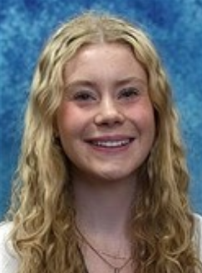

Lindley Vickers

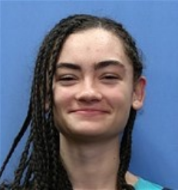

Esther Hord

Isolation, Purification, and Characterization of Phage Senorclean and Genome Annotation

Lindley Vickers, Esther Hord, Thomas Lackman, Ashkahn Safarimaryaki, Josh D McLoud, Frederick N Baliraine

Phages have many uses including therapy for antibiotic resistant strains and investigation of phages being transformative agents to circumvent climate change. Our team isolated SenorClean, an A4 Mycobacteriophage, at 32.568397 N, 94.725734 W with the enriched method that used Middlebrook 7H9 complete medium and the host *Mycobacterium smegmatis* mc2 155. A spot plate was created to test if our incubated medium isolated a phage. After positive confirmation, a 10x serial dilution was performed through 2 rounds of purification, this produced small, cloudy plaques (average diameter 3.40 mm, range 3.00 – 4.00 mm; *n* = 15). An initial lysate was made with a titer of 1.1 X 1011 pfu/mL and the lysate was amplified by flooding additional webbed plates. We extracted DNA from the high-titer lysate, resulting in a DNA extract with a concentration of 171 µg/ml and we used a gel electrophoresis to confirm gDNA was intact. The genome of SenorClean had a GC content of (61.5%), genome length of (48,724 bp), overhang length of (10 bp), and overhang sequence of (CGGTCGGTAA). We observed product sequence differences of minor tail proteins. SenorClean has the possibility of becoming a valuable phage for future research.