CONSIDER FOR TALK

2025 SEA Symposium Abstract

Rowan University

Glassboro NJ

Corresponding Faculty Member: Marina Bogush (bogush@rowan.edu)



Paige Baldwin



Michael Bennett



Evangelia Buonamici

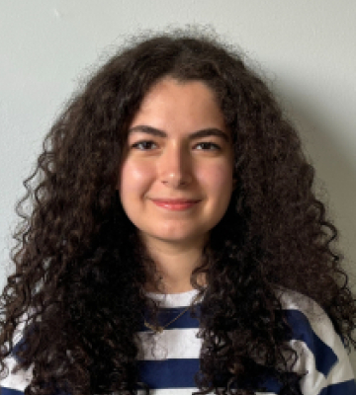

Hanan Isik

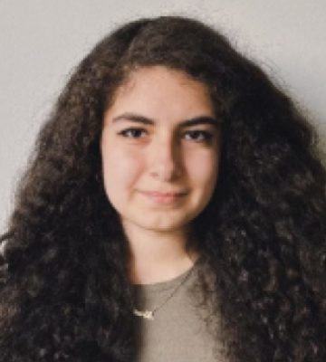

Niran Isik

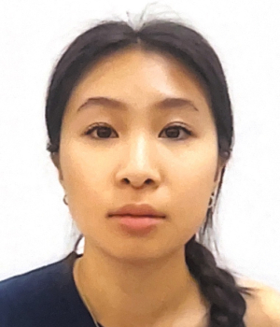

Vienna Li



Mia Mazakas



Aaryan Modi



Nikita Muppoor



Kylie Oliver



Vidhi Patel



Kylie Tabak



Laura Weber



Jamie Yu

Discovering and Characterizing Novel Temperate Bacteriophage Infecting Arthrobacter globiformis B-2979

Paige Baldwin, Michael Bennett, Evangelia Buonamici, Hanan Isik, Niran Isik, Vienna Li, Mia Mazakas, Aaryan Modi, Nikita Muppoor, Kylie Oliver, Vidhi Patel, Kylie Tabak, Laura Weber, Jamie Yu, Matthew Farber, Marina Bogush

Bacteriophages are viruses that infect bacteria, with potential applications in agriculture, food safety, and phage therapy. This study presents the discovery of a novel bacteriophage, AmiCi24, extracted from soil in Sewell, NJ, using the bacterium Arthrobacter globiformis. AmiCi24 was isolated through enriched isolation of a soil sample, purified through two rounds of serial dilutions and plaque assays, and amplified to collect phage lysate. Transmission electron microscope images revealed that AmiCi24 is a Siphoviridae phage with a long 60 nm tail and a 120 nm icosahedral head.  
The AmiCi24 genome is composed of double-stranded DNA. It is 38,466 bp in length with 66.1% GC content and 68 putative proteins, including two terminase proteins, a major tail protein, and a portal protein. Based on this analysis, AmiCi24 was classified as a cluster AS3 temperate phage.  
In conclusion, this research successfully characterized the newly discovered bacteriophage AmiCi24, contributing to the growing body of knowledge on bacteriophages.