DO NOT CONSIDER FOR TALK
2024 SEA Faculty Meeting Abstract
Emory University
Atlanta GA
Corresponding Faculty Member: Nic Vega (nic.vega@emory.edu)
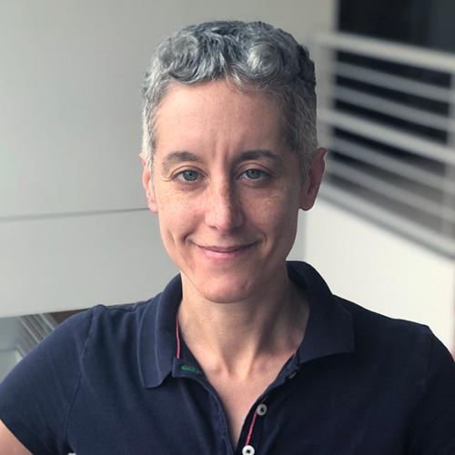
Nic M Vega
Programming skills development in GENOMES
Nic M Vega
There is increasing student demand for training in coding and informatics fundamentals. The GENOMES curriculum could be augmented with the goal of developing these skills, using the current workflow of specialized user-friendly software to introduce sequence analysis concepts while developing coding fundamentals using a scripting language (Python/R). The proposed schedule, which is inverted from canonical coding or sequence analysis classes, is potentially more accessible and motivating to biological science students.

